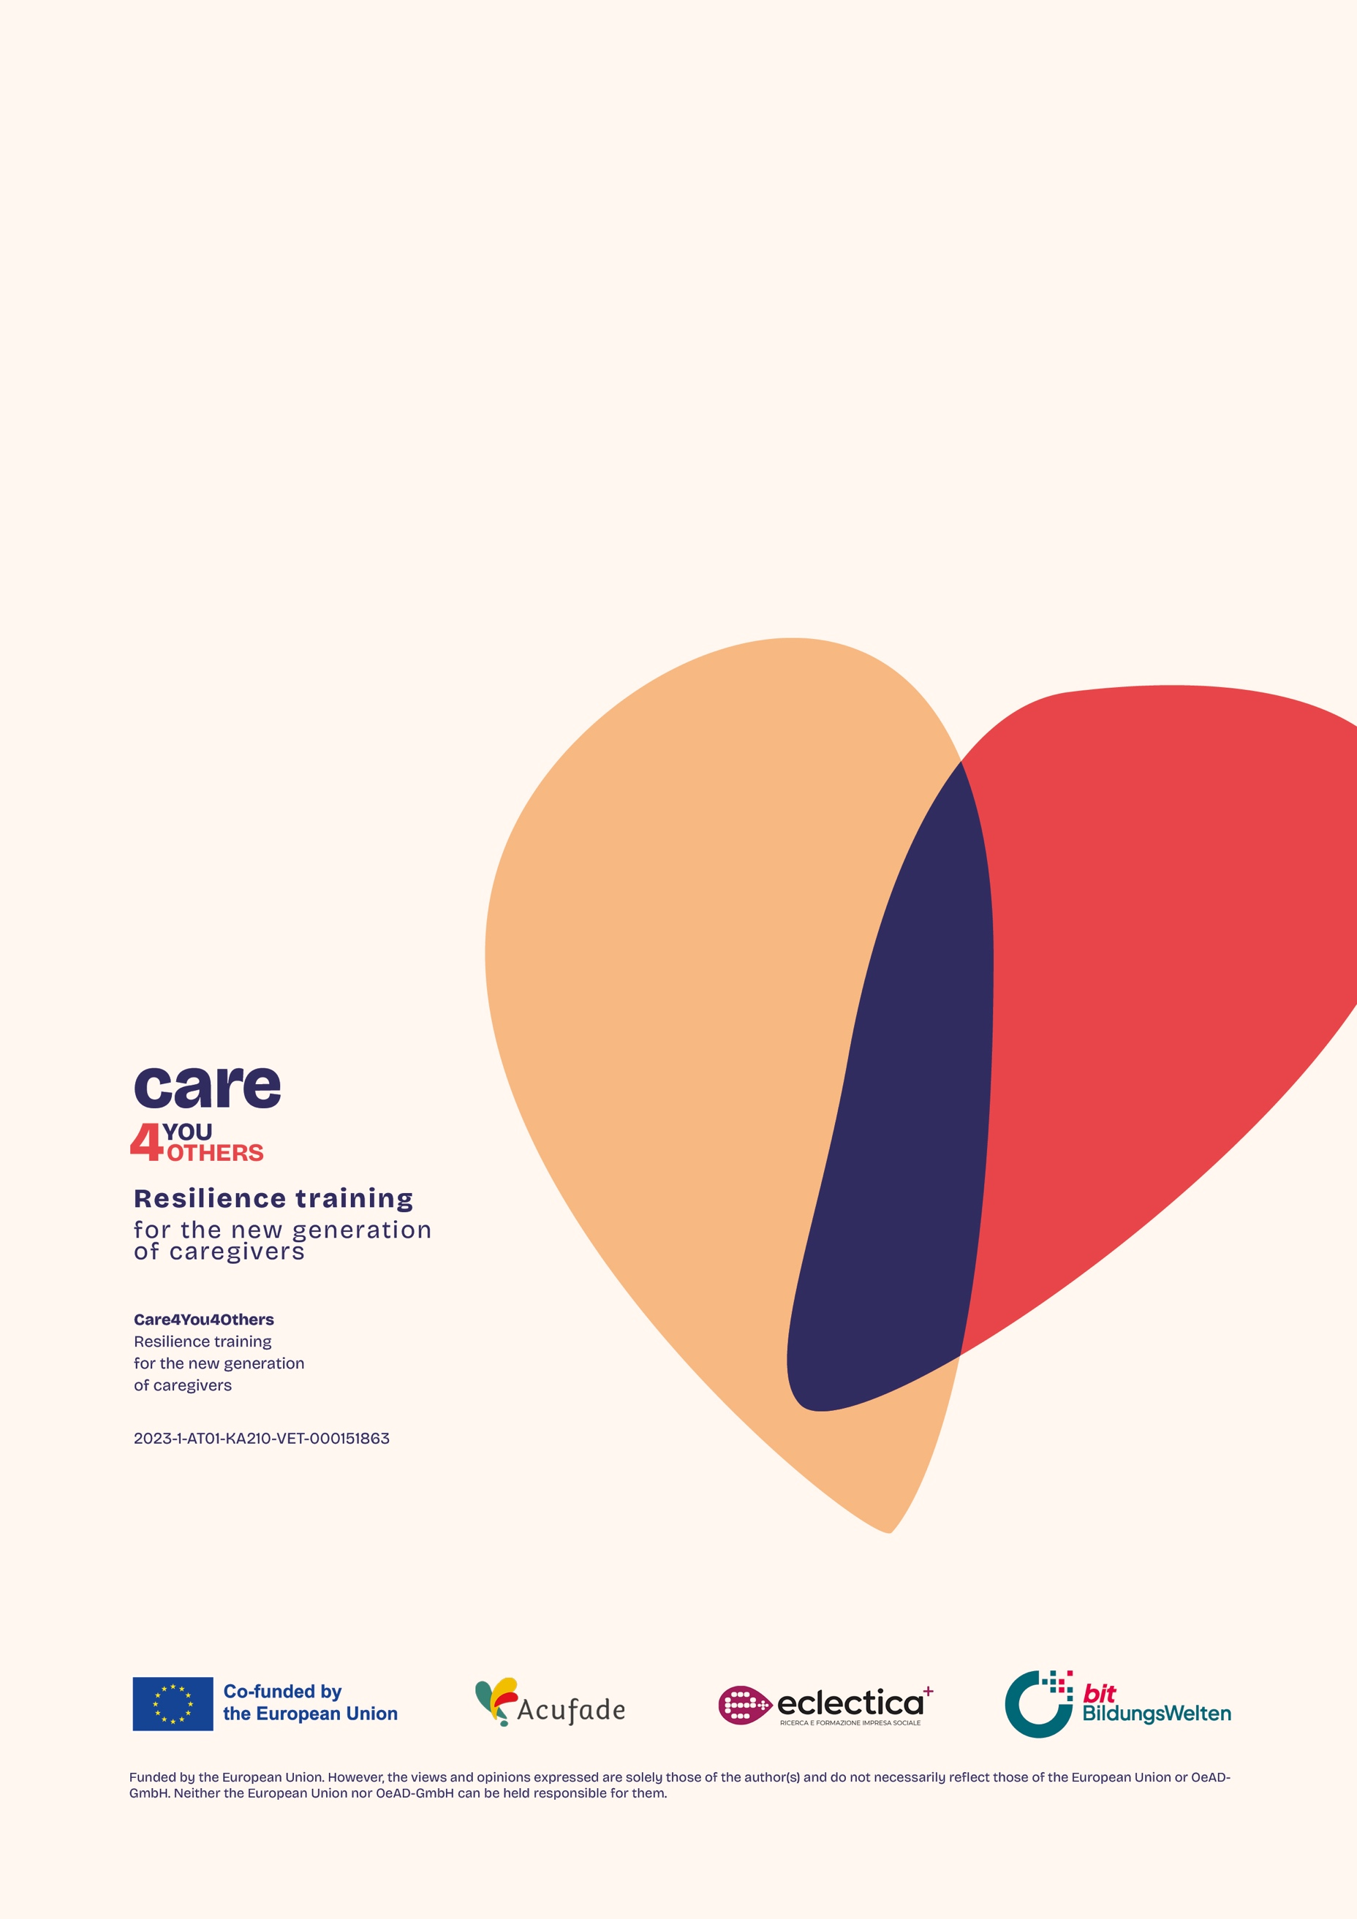
Care4You4Others
Resilience training for the new generation of caregivers

Learning material

Responsible partner: bit BildungsWelten GmbH
Supporting partners: Acufade, Eclectica+

Published: November 2024


This work is licensed under CC BY-NC 4.0. To view a copy of this license, visit https://creativecommons.org/licenses/by-nc/4.0/

Find more information about the Erasmus+ project Care4You4Others, please check out the website: www.care4you4others.eu





Funded by the European Union. Views and opinions expressed are however those of the author(s) only and do not necessarily reflect those of the European Union or OeAD-GmbH. Neither the European Union nor the granting authority can be held responsible for them.
Table of contents
1 Care4You4Others – Resilience training for the new generation of caregivers 7
1.1 Nice to have you here! 7
1.2 Course structure 8
1.3 Learning objectives 10
1.4 How to Approach This Course 11
2 Resilience in care 12
2.1 Introduction 12
2.2 Introduction to the topic of resilience 13
2.3 Challenges in the life of a caregiver 16
2.4 The role of self-care and the 7 pillars of resilience in care work 21
2.5 The importance of resilience in our world 24
2.6 Maintaining resilience in care work in the long term 25
2.7 Summary 27
3 Risks and protective factors for dealing with stress 28
3.1 Introduction 28
3.2 What is stress? 28
3.3 Risk factors for carers 30
3.4 The importance of strengthening life skills as a protective factor 32
3.5 Self-awareness as a resilience factor 33
3.6 Problem-solving skills as a resilience factor 34
3.7 Critical and creative thinking as a resilience factor 35
3.8 Decision-making ability as a resilience factor 35
3.9 Stress management 36
3.10 Emotional awareness and effective communication as resilience factors 37
3.11 Empathy as a resilience factor 38
3.12 Social and relationship-related protective factors 39
3.13 Strategies for strengthening the protective factors 39
3.14 Summary 41
4 The 7 pillars of resilience 42
4.1 Introduction 42
4.2 An overview of the 7 pillars of resilience 42
4.3 The 7 pillars of resilience and their importance 44
4.4 Summary 53
5 The 7 pillars of resilience in practice 55
5.1 Introduction 55
5.2 Practical application of the 7 pillars of resilience 55
5.3 Integrate the 7 pillars of resilience into your daily life 59
5.4 Strengthening the seven pillars in day-to-day care 63
5.5 Summary 66
6 Perspective on fragility in the context of resilience in care 68
6.1 Introduction 68
6.2 Understanding fragility 68
6.3 Strengthening resilience and preventing fragility in the care sector 69
6.4 Health promotion and prevention of physical fragility 72
6.5 Summary 74
7 The importance of resilience in care teams 75
7.1 Introduction 75
7.2 Strengthening resilience in teams 75
7.3 Communication as a key factor for resilient teams 81
7.4 The basics of good communication 84
7.5 Summary 90
8 Exercises to strengthen resilience and self-care 91
8.1 Introduction 91
8.2 The optimism diary 91
8.3 The importance of daily goals 93
8.4 Learning acceptance 95
8.5 Mindfulness meditation 97
8.6 Acting instead of waiting 98
8.7 Turning away from bad habits 100
8.8 Summary 101
9 21-day challenge for resilience 102
9.1 Introduction 102
9.2 The 21-day challenge for resilience - Week 1 104
9.3 The 21-day challenge for resilience - Week 2 109
9.4 The 21-day challenge for resilience - Week 3 113
9.5 Summary 117
10 Importance of self-care, especially for informal caregivers 119
10.1 Introduction 119
10.2 Understanding the challenges of informal caregivers 119
10.3 Practical approaches to self-care for informal caregivers 125
10.4 Summary 131
11 The importance of self-care, especially for (formal) caregivers 133
11.1 Introduction 133
11.2 Understanding the challenges of care professionals 133
11.3 Practical approaches to self-care for care professionals 135
11.4 Summary 141

Legend

 | Important  Wichtig / Importante / Important / Importante / Belangrijk / Viktig / Tärkeä / Σπουδαίος
 | Hint  Hinweis / Insinuación / Indice / Suggerimento / Tip / Antydan / Vihje / Ιχνος
 | Remember  Merke / Recordar / Se souvenir / Ricordare / Onthouden / Kom ihåg / Muistaa / Θυμάμαι
 | Definition  Definition / Definición / Définition / Definizione / Definitie / Definition / Määritelmä / Ορισμός
 | Example  Beispiel / Ejemplo / Exemple / Esempio / Voorbeeld / Exempel / Esimerkki / Παράδειγμα
 | Practical relevance  Praxisbezug / Relevancia práctica / Pertinence pratique / Rilevanza pratica / Praktische relevantie / Praktisk relevans / Käytännön merkitystä / Πρακτική συνάφεια
 | Digression  Exkurs / Digresión / Digression / Digressione / Uitweiding / Avvikelse / Poikkeama / Παρέκβαση
 | Citation  Zitat / Citación / Citation / Citazione / Citaat / Citat / Lainaus / Παραπομπή

Care4You4Others – Resilience training for the new generation of caregivers

Nice to have you here!
Welcome to the Care4You4Others Resilience Training for Caregivers course, specifically designed to equip you with the skills, knowledge, and tools to thrive in your caregiving role. Whether you are an informal caregiver living far away from home taking care for someone who needs support, a family carer looking after a loved one or a formal caregiver working in a professional setting, the challenges you face are significant. This course is here to provide you some information about resilience and equip you with tools to build the emotional, physical, and social resilience necessary to meet those challenges head-on while maintaining your well-being.
Caregiving is both rewarding and demanding. It is one of the most demanding professions, both physically and emotionally. Caregivers face long hours, intense responsibility, and the emotional toll of supporting individuals in their most vulnerable moments. Despite the immense dedication and compassion required, caregivers often do not receive the recognition they deserve. Their contributions are frequently overlooked, even though they provide essential care that sustains the well-being and dignity of others. This lack of acknowledgment can lead to feelings of burnout and isolation, making it even more crucial to prioritize resilience and self-care in their daily lives.

Why this course matters
Caregivers often prioritize the needs of others while neglecting their own. This can lead to emotional exhaustion, physical burnout, and a decline in the quality of care provided. By building resilience, caregivers can better manage the demands of their roles, recover quickly from setbacks, and continue providing compassionate, high-quality care over the long term.
This course offers a holistic approach to caregiving, ensuring that you, as a caregiver, are not only equipped to support those in your care but are also empowered to take care of yourself.
Probably this course will not be perfect for everybody: it would have been impossible to design and realize a course which would be on the one hand exhaustive and in-depth, so as to meet the expectations of those who, like professional caregivers, have a more scientific outlook, and on the other hand would be simple and suitable for everybody and thus also for caregivers who do not have knowledge and experience of resilience.
The suggestion is to open one's mind and rely on a curious attitude: following the course in its entirety will certainly provide useful stimuli for different targets.

Course structure
The course is divided into 10 units, each focusing on key aspects of resilience and self-care within the caregiving context. The topics covered range from understanding the importance of resilience, identifying risk factors, and developing protective skills to practical applications such as self-care routines and team resilience.
The course is designed to take approximately 8-10 hours to read through the material, but the actual time required will vary based on how much time you choose to spend on the practical exercises. While some may move quickly through the content, others may benefit from taking additional time to fully engage with the exercises and reflections, which are essential for building real-life resilience skills. We encourage you to pace yourself and take the time needed to apply the concepts in ways that best fit your caregiving experience and personal growth!

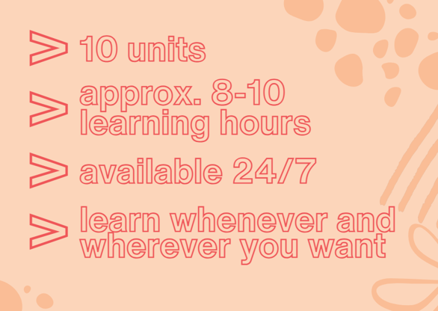
The course is available 24 hours a day, 7 days a week, providing you with the flexibility to learn at your own pace, any time and anywhere you want. Whether you have a few minutes between caregiving tasks or prefer to dedicate longer sessions during quieter moments, the course is designed to fit into your schedule. You can access the material whenever it’s convenient for you, ensuring that your learning experience is as flexible and accessible as possible.

Here's what you'll learn:
- Unit 1: Resilience in Care
Introduction to the concept of resilience and its significance in caregiving.
The role of self-care in building long-term resilience.
- Unit 2: Risks and Protective Factors for Dealing with Stress
Identify stress risk factors in caregiving and explore strategies to mitigate them.
Strengthen your protective factors to reduce the impact of stress.
- Unit 3: The 7 Pillars of Resilience
Discover the 7 pillars that form the foundation of resilience and their importance in caregiving.
- Unit 4: The 7 Pillars of Resilience in Practice
Practical exercises to apply the 7 pillars in day-to-day caregiving activities.
- Unit 5: Perspective on Fragility in the Context of Resilience in Care
Understand fragility and how to strengthen resilience to prevent emotional and physical burnout.
- Unit 6: The Importance of Resilience in Care Teams
Explore how teamwork and communication can build resilience within care teams.
- Unit 7: Exercises to Strengthen Resilience and Self-Care
Hands-on exercises to help caregivers develop self-care habits and resilience.
- Unit 8: 21-Day Challenge for Resilience
A 3-week structured plan to build and reinforce resilience through daily activities.
- Unit 9: Importance of Self-Care Especially for Informal Caregivers
Focus on the unique challenges faced by informal caregivers and strategies for maintaining resilience.
- Unit 10: Importance of Self-Care Especially for Formal Caregivers
Practical approaches to self-care for professional caregivers facing demanding work environments.

Throughout the course, the theoretical content will be complemented with "One-Minute Wonder" Setcards—simple, practical exercises designed to be completed in just a minute or two. These setcards offer quick, actionable strategies that you can immediately integrate into your daily routine. Whether it’s a breathing exercise, a short reflection, or a quick mental reset, these easy practices will help lighten up the learning process and ensure that you can apply resilience-building techniques in real-time, no matter how busy your day is.

At the end of the course, you will have the opportunity to take an optional assessment to test your understanding of the material. Successfully completing this assessment will earn you a certificate of completion, recognizing your commitment to building resilience and enhancing your caregiving skills. The assessment will cover key concepts from the course and provide a way to demonstrate your knowledge and practical application of resilience strategies. This certificate can serve as a valuable addition to your personal or professional development portfolio.

Learning objectives
By the end of this course, you will have gained:
- A deep understanding of resilience: You will learn what resilience means, its importance in caregiving, and how to develop it.
- Identification of stress risk factors and protective mechanisms: You will be able to recognize the factors that lead to burnout and understand how to strengthen your mental, emotional, and physical resilience.
- Mastery of the 7 Pillars of Resilience: Through both theory and practice, you will apply key pillars such as optimism, acceptance, and solution-orientation in your daily caregiving role.
- Practical self-care skills: Learn how to integrate essential self-care habits into your routine, preventing exhaustion and maintaining your health while caring for others.
- Team resilience skills: If you're part of a caregiving team, you’ll be able to contribute to team dynamics that foster resilience and improve overall care.

What You’ll Be Able to Do
By completing this course, following the exercise instructions and trying to train some of the suggested behaviors for a reasonably long time (at least for a month), you quill be able to:
1. Manage Stress and Prevent Burnout
Recognize early signs of stress and burnout and use effective coping strategies to prevent them.
2. Develop a Resilience Mindset
Apply resilience-building techniques, such as focusing on solutions, practicing optimism, and embracing acceptance, to handle challenges with greater confidence.
3. Enhance Your Self-Care
Incorporate practical, simple self-care routines into your daily life, including exercises for mental, emotional, and physical well-being.
4. Strengthen Your Support Networks
Build and maintain strong social and professional networks that support you in times of need.
5. Contribute to a Resilient Care Team
Foster better communication, collaboration, and mutual support within caregiving teams, improving the resilience of the whole group.
6. Thrive in Your Role as a Caregiver
Whether you are a formal or informal caregiver, you will develop the skills to care for others while protecting your own well-being.

How to Approach This Course
- Stay engaged: As you go through each unit, try to apply what you learn to your daily caregiving practice.
- Reflect on your experiences: Take time after each lesson to consider how the principles of resilience relate to your personal and professional life.
- Use the exercises: The practical activities in this course are designed to help you actively build resilience, so take full advantage of them.
- Stay committed: Building resilience is a continuous process. Stay patient and consistent as you practice the strategies taught in this course.
Let’s begin the journey toward stronger, healthier, and more resilient caregiving.

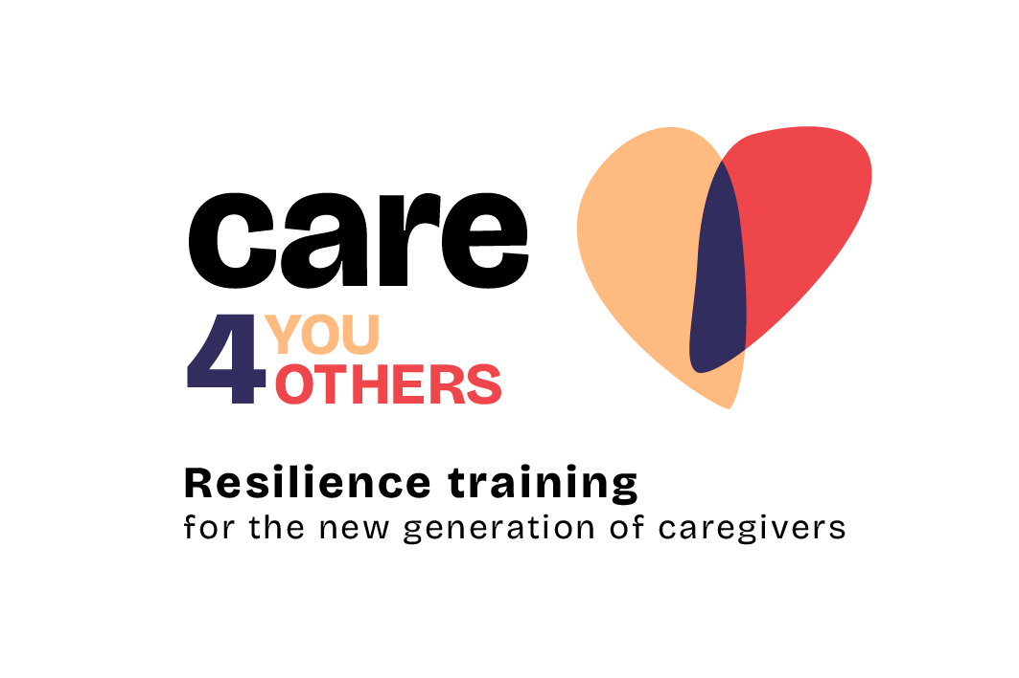

Resilience in care

Introduction
Please remember a day in your life when you felt that you simply couldn't go on. This may have been due to a work situation, for personal reasons or perhaps many challenging situations have piled up and are now weighing heavily on you. Can you still remember how you dealt with it? Were you able to shake it off and move on or did it take you a long time to get rid of the terrible feeling?
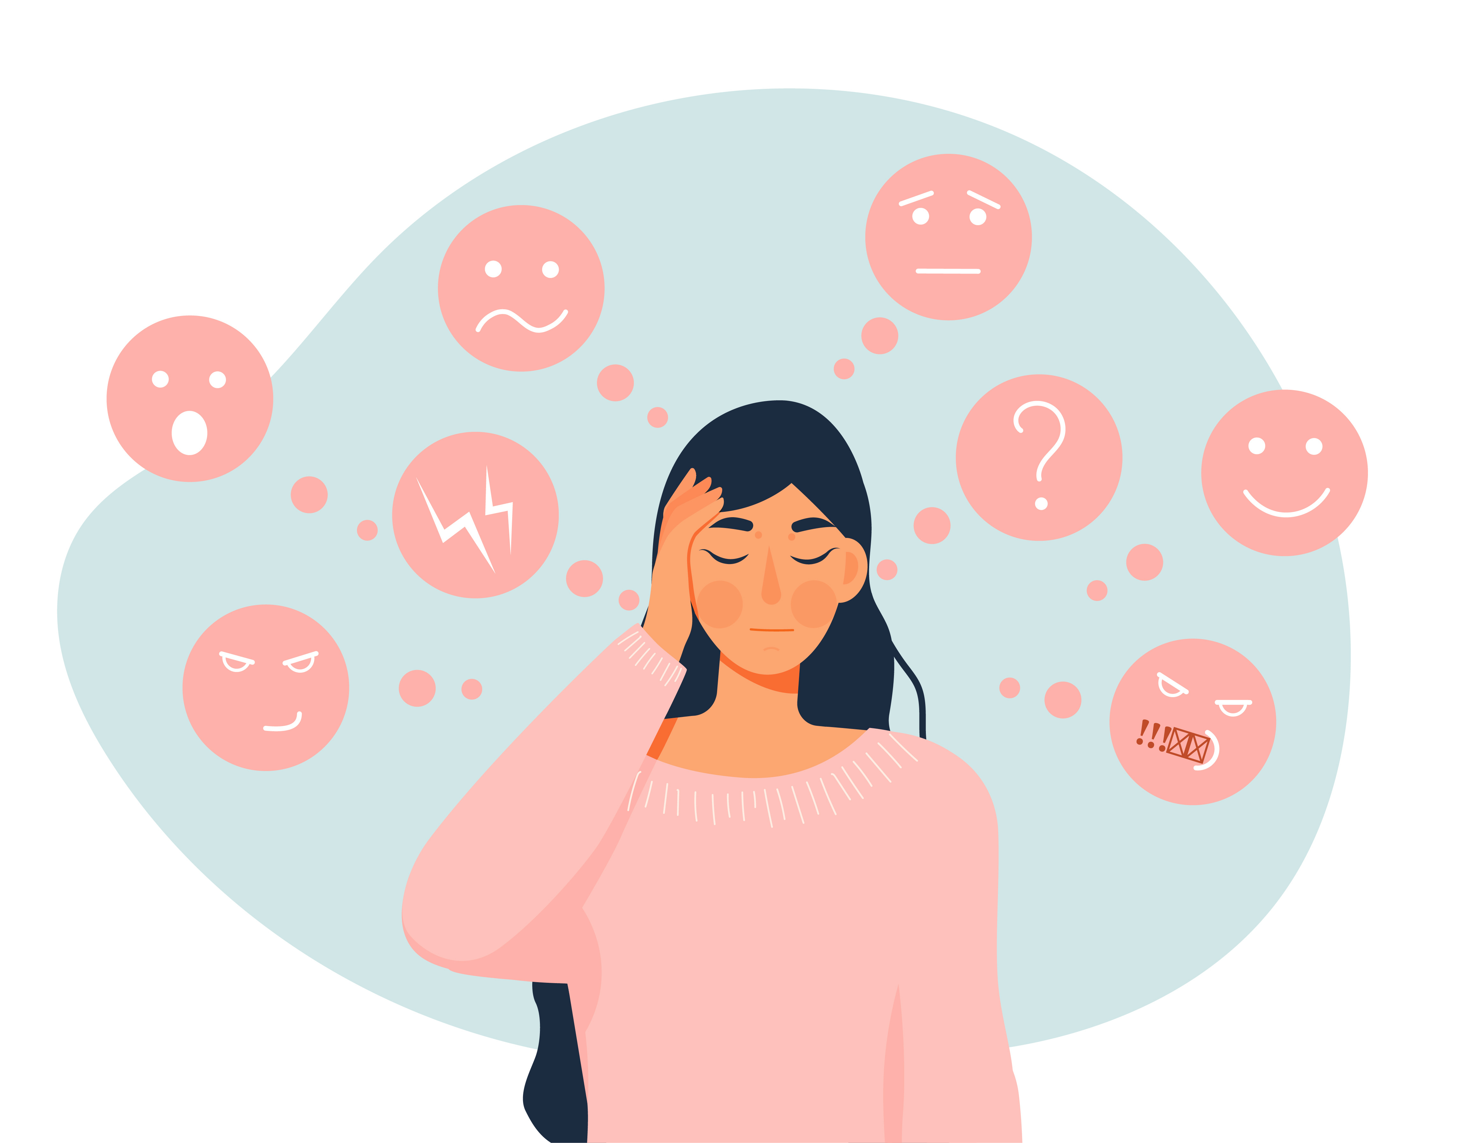

A person is not what happens to him, but what he makes of it.
(Viktor Frankl)
A wonderful quote from Viktor Frankl, who gets to the point that we are not victims of circumstances but should focus on our options for action. You're probably wondering how this is supposed to work. Especially in the stressful day-to-day care routine, there tends to be less time to think about anything other than care. And you might even forget about yourself completely. But in order for you to be there for the person you are caring for, it is important that you take care of your health and well-being. You may roll your eyes or laugh derisively as you read this, because although it all sounds good, it is difficult to put into practice in day-to-day care. That's exactly why you're here.
Let me tell you one thing in advance: The secret behind (most of) it can be summed up in one word - resilience. On the following pages, you will find out exactly what resilience is, how you can build it up and incorporate it into your everyday care routine in the long term. Of course, resilience is not the miracle cure for all difficult situations, but it will certainly help you to better deal with challenging situations.

Introduction to the topic of resilience
The word resilience may not be part of our everyday language, but it affects us all on a daily basis. Do you know people around you who feel they emerge even more balanced from difficult situations? This is probably also due to their resilience.

Resilient people are able to better sustain the stressors in a flexible, agile and situationally appropriate way by drawing on internal and external resources and protective factors, to change and transform themselves and to emerge more balanced from crises and use them as an opportunity for personal growth and individual development.
However, don't think that resilient people don't sometimes stumble. They do recognize that they are currently in an unpleasant situation. The difference, however, lies in how they deal with the situation. Resilient people approach events in a new way and have the skills to experience events in an acceptable way.
And again: much easier said than done. The first resilience research was carried out back in 1955 and is still in the focus of various scientists. They deal with the question of which circumstances contribute to our ability to cope well with the challenges of everyday life and find a balance between the demands and resources we have. The 7 pillars of resilience, for example, can provide more information on this. These were derived from various areas of psychology and resilience research and offer you practical guidance on how to nourish your own resilience. You can find out more about this in the unit "The 7 pillars of resilience".

Forms of resilience
Let's now explore the various dimensions of resilience. It is important to understand that resilience is a holistic competence, not divided into separate types. These dimensions include working on oneself through the body, mind and emotions (which are interconnected as emotions are closely tied to our thoughts), and relationships. Additionally, a crucial aspect of resilience is the spiritual dimension, which relates to the ethical and value-based aspects that underpin our motivation. Remember, these dimensions do not exist in isolation; they influence and support each other.
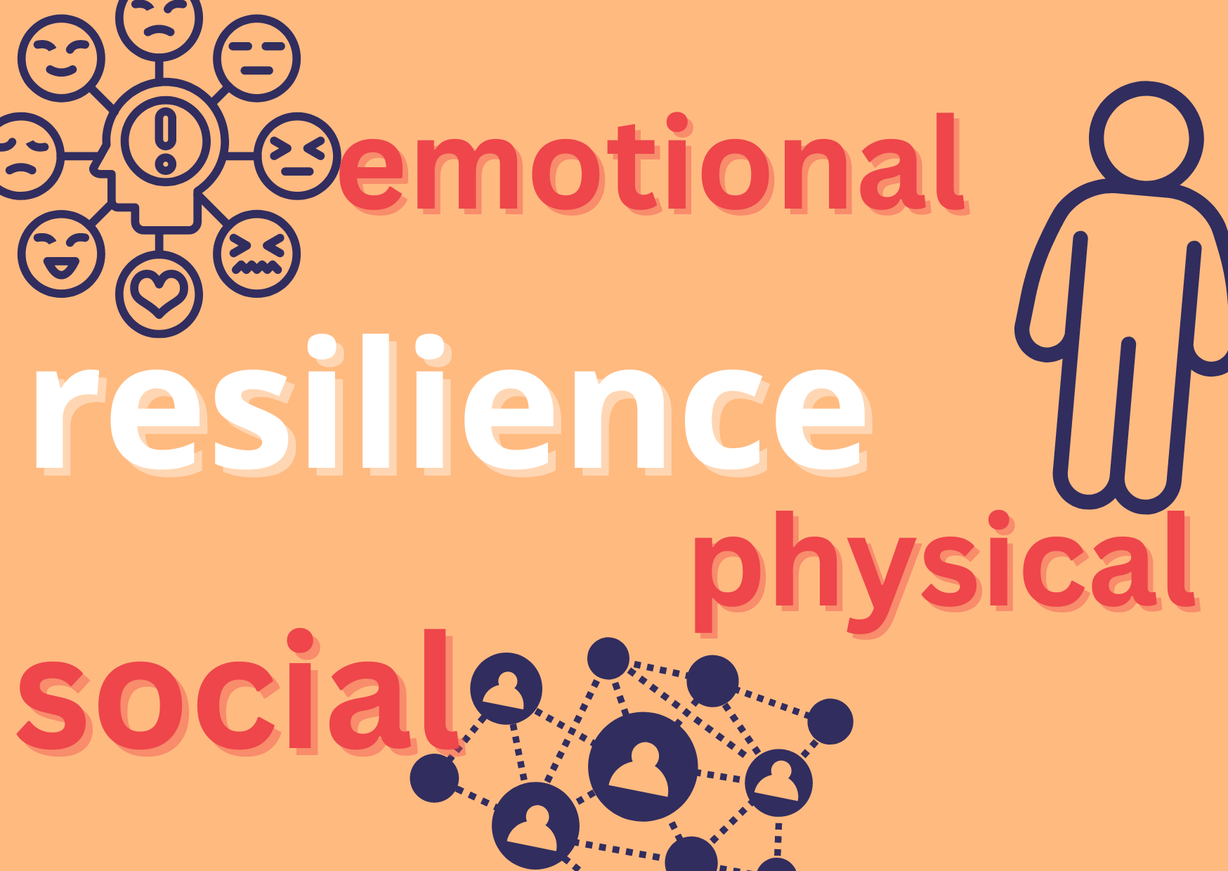

- Physical resilience: This refers to your body's ability to adapt to external stress, recover and regenerate. This includes, for example, your immune system, your fitness and your physical health.

Lukas is a geriatric nurse in a nursing home. The work is physically demanding, as he has to lift residents every day, help them bathe and spend long hours on his feet. One day, he injures his shoulder while lifting a resident. The injury restricts his mobility and causes pain.
Lukas decides not to let the injury discourage him. He seeks medical help and begins physiotherapy to rehabilitate his shoulder. During the recovery period, he works with his colleagues to ensure that the residents continue to receive the care they need. He delegates heavy tasks, takes on lighter activities and uses ergonomic aids to protect his shoulder.
Alongside the physiotherapy, Lukas does special exercises at home and makes sure he eats a healthy diet to support the healing process. After several months of intensive therapy and adapting his way of working, Lukas returns fully recovered. He still uses his ergonomic aids to protect his shoulder, in order to stay healthy. He listens to his body and reacts quickly as soon as he feels that his body needs support.
- Emotional resilience: Mental and emotional resilience is the ability to cope with stressful events by activating an analysis and a representation of the event favorable to emotional management. It means to learn to look at events in a more objective way, to focus on emotions that events are arising and to deal with them in order to bring out awareness of one's needs.
Maria takes care of her mother with Alzheimer's at home. The whole situation is very demanding, as she also works in an office part time and has to do the care work beside her job as an accountant. Especially the days when her mother is in a bad mood are challenging for Maria.
Maria knows that she needs to be there for her mother, but she also knows that she needs to take care of herself in order to be as supportive as possible for her mum. She started integrating mindfulness meditation and breathing-excercises in her daily evening routine and quickly felt that she felt better, also after challenging days. Maria also focuses on the positive moments and manages the emotional and physical demands of caregiving effectively.
- Social resilience: You have social resilience if you can build, maintain and sustain relationships. This also includes accepting help from others when you find yourself in difficult life situations. This means you have a strong social network to fall back on and you are able to engage in interpersonal relationships.
A new job and a new team are waiting for you as you move to a new city. At first you feel a little alone and lonely because you don't know anyone yet. So, patiently, every now and then, you try to approach some colleagues and talk about your integration difficulties, discovering that others too had felt the same as you at the beginning. This makes you feel less alone and helps you, day after day, to look for new moments in which to get closer to others.
Self-care as part of resilience
Caring for and looking after others is almost second nature to you as a caregiver, isn't it? Please take a moment and think about how often you take care of yourself? How often do you consciously take time for yourself and your needs? Probably far too little, right? When we prioritize our needs and recharge our energy reserves, we are talking about self-care. This is essential if you want to stay healthy and motivated in the long term. It is important that you take the time to look after your own needs so that you can continue to fully perform your care activities.

Self-care can be simply defined as the concept of "taking good care of yourself". It is a process of awareness about your needs which enables you to take care of yourself, which is a basis for caring for others and at the same time for actively contributing to society. At the same time, self-care is essential for maintaining our mental and physical health and contributes to improving our resilience.
Resilience in care
I'm sure you're familiar with this: As a caregiver, you face very demanding and challenging tasks on a daily basis. You find yourself in situations that are unpleasant, stressful or emotionally draining. Keeping balance and looking after the person you are caring for is not always easy, is it?
One of the important factors is to build resilience.. Because we already know that you then have the ability to adapt to different challenges and recover more quickly from stress and setbacks. You will also be able to take better care of the person entrusted to your care and yourself at the same time, despite the circumstances. If you now think one step further, it is logical that your resilience also has a positive effect on the people you care for, isn't it?

Challenges in the life of a caregiver
Caring for others is a wonderful task. However, as you know, this activity also brings with it many challenges and burdens. Regardless of whether you work in care as a professional (formal care) or care for a relative or someone entrusted to you (informal care), you all have to deal with some of the same problems. It is important to recognize them. Here is an excerpt for you of common challenges in care work:

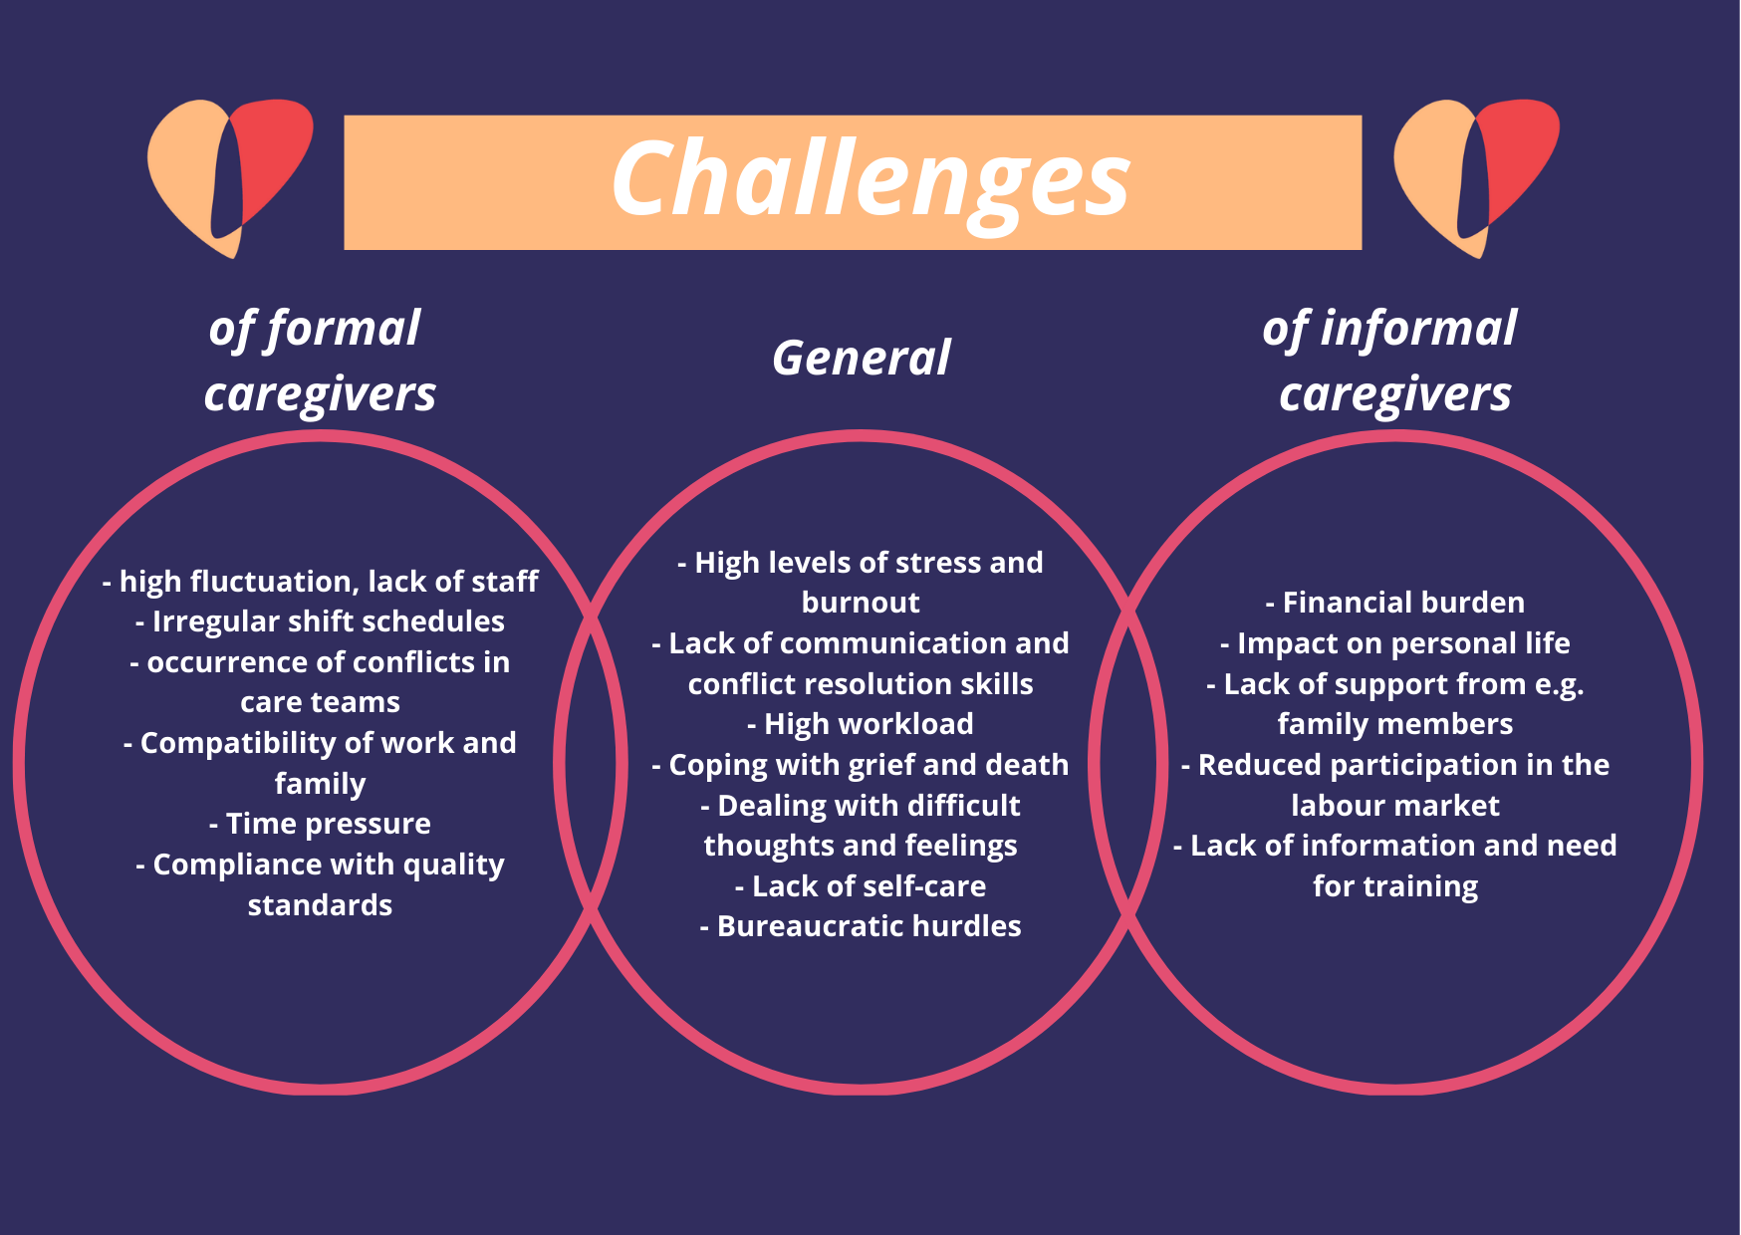

Recognizing and mastering stressful situations
We are sure that all the challenges we mentioned are nothing new to you, right? It would be interesting for you to take a moment to reflect on what other challenges, (maybe not mentioned above) you experience in your care work. You are probably already so used to some stressful situations that you no longer even notice them, or perhaps only in retrospect. At this point, let us remind you that every moment you care for others, you are important too! So how can you develop skills to cope well with the challenges you face in your caring role? Let us demonstrate with an example:
Emma had always loved working in the residential home in her city, where she cared for the elderly with kindness and patience. However, recently, she had been feeling overwhelmed. The increasing workload, emotional demands of caring for residents like Mr. Thompson, who had severe dementia, and the strain of long hours were taking a toll on her.
One particularly challenging day, Mr. Thompson became agitated and confused, refusing to eat and lashing out. Emma felt her patience wearing thin. She was exhausted and on the verge of tears. Seeing her distress, Sophie, her ward manager, took Emma aside and told her to take a short break.
During her break, Emma sat in the quiet staff room, taking deep breaths to calm herself. She remembered a workshop on emotional resilience that the team attended a few months ago. Emma decided to apply the techniques she had learned.
Emma took five minutes to meditate, focusing on her breathing. She felt the tension in her shoulders release. She promised herself to make time for these short breaks daily. Returning to the floor, Emma approached Mr. Thompson with renewed patience. She smiled and spoke to him in soothing tones. Gradually, he calmed down and accepted his meal. Emma felt a surge of accomplishment and focused on this positive moment.
How would you have reacted as a ward manager? What other ways are there to deal with challenges? Here are some more measures:
- Training courses and workshops: Resilience, communication
- Development of self-care strategies
- Implementation of crisis intervention measures: Protocols and procedures for managing crises
- Build up a support network: People in the environment who support
- Self-reflection
This is just an excerpt of the options available to you. In the unit "Exercises to strengthen resilience and self-care", you will learn more and how you can apply the exercises.

Dealing with stress and the importance of resilience
John, a 55-year-old man, is the primary caregiver for his wife, Linda, who has advanced Parkinson's disease. John juggles his part-time job with caregiving duties, including helping Linda with mobility, medication management, and daily activities like bathing and eating. One morning, John wakes up to find Linda has fallen out of bed. She is uninjured, but was unable to get back in the bed, but did not say anything because she did not want to wake John. John feels a surge of panic and guilt for not having heard her earlier. He carefully helps her back into bed, but the incident leaves him shaken. His mind races with worries about her safety and his ability to care for her.
Can you put yourself in John's shoes? Have you been through something similar or felt this emotional stress? In care work, you will always face challenges that will put you under emotional strain. It is therefore a good idea to prepare yourself for such situations. This course will give you some knowledge and small tools to be able to manage similar situations so that you can overcome them well.
But how do you manage to cope with emotional stress, as in the case of John, for example? There are various stress management strategies (coping strategies) that have already been the focus of research. Of course, it is difficult to schematize the behaviors adopted by an individual in such a "rigid" way. In fact, when faced with conflicting and stressful events, a person can also adopt different coping strategies, starting from one type and then moving on to another; or may even adopt multiple coping strategies at the same time.
Coping strategies can either be functional or dysfunctional. Functional coping strategies help you to manage the stressors in a positive, effective way and have long term positive effects. Dysfunctional coping strategies may provide short-term relief but are harmful in the long term and often make the original problem worse rather than solving it.

Functional coping strategy | Description of the strategy | Johns options for action
Problem-orientated coping | When you use this strategy, you focus on tackling the problem directly and finding practical solutions to deal with it. | After a short period of agitation, John considers what options he has. He considers asking his sister-in-law or a professional care service for help, so that he does not have to do the whole care work on his own beside his job.
Emotion-orientated coping | This strategy is about being able to regulate and control your emotions by focusing on processing feelings and stress rather than solving the problem itself. | John regularly practices breathing techniques that help him to keep a clear head in stressful situations. He also uses them on this day to get and stay calm so that he can be there for his wife.
Social coping | In this strategy, you have social support from friends, acquaintances, family or colleagues to help you deal with stress. | John takes a deep breath and thinks about who might have time to come round and just spend some time together with him and his wife. His brother comes round and just by chatting and not being alone, John already feels a bit better.
Acceptance-orientated coping | In this strategy, you accept the reality of the situation and focus on accepting it and adapting rather than fighting it. | John doesn't think much about how the rest of the day might turn out or what it would be like if he had had a better start in the day. He accepts the situation and makes the best of it.
Religious or spiritual coping | This strategy involves using faith or spirituality to help you find comfort, hope and meaning in difficult times. | John believes in God and prays regularly. It helps him to draw strength from within. On this day, John also drew strength from prayer to cope with the day in the best possible way.

Dysfunctional coping strategies | Description of the strategy | Johns options for action
Addiction-related coping | Here you resort to unhealthy coping mechanisms such as alcohol, drugs or overeating to deal with stress. | As John feels stressed due to the stressful situation, he goes out to smoke a cigarette and feels that it calms him down.
Avoidant coping | If you choose this strategy, you avoid or ignore the problem to get short-term relief without addressing the problem in the long term. | After helping his wife back to bed John made himself a coffee and took a walk in the garden to avoid thinking about the whole situation.
Aggressive-reactive coping | In this strategy, the person tends to get overwhelmed by emotions, losing clarity and ability to control the situation. | John feels a lot of anger at this difficulty he finds himself experiencing. He places the blame on his wife because she did not wake him immediately and behaves aggressively towards her. This only makes the situation worse and it gets out of hand.

Which of these stress management strategies, apart from addiction-related coping, are effective cannot be said in general terms, but depends heavily on the situation. For example, if a situation is changeable, problem-focused coping is more likely to be a successful strategy. Think of a challenging situation in your life and try to find out which of the coping strategies you used. Would a different coping strategy have worked better?
In addition to the strategies mentioned, building resilience is a good long-term strategy for dealing with stress. Because if you are resilient, you are better able to withstand challenges. This also has a positive long-term effect on your health and well-being. As a resilient person, you are not only better able to cope with stress, you are also more emotionally stable, have better physical health and your job satisfaction is higher.

If you as a caregiver are in good health, this also has an effect on the person you are caring for. You will be able to provide better quality care, show more empathy and compassion and convey a sense of stability and reliability. You can also have a positive influence on recovery if you create a supportive and motivating care environment.

Communication in care work
You cannot not communicate. – Paul Watzlawick
Do you know the well-known quote by Paul Watzlawick? He wanted to say that all behaviour, whether verbal or non-verbal, is a form of communication. What is your body language, facial expressions and gestures like? You can even communicate through silence.
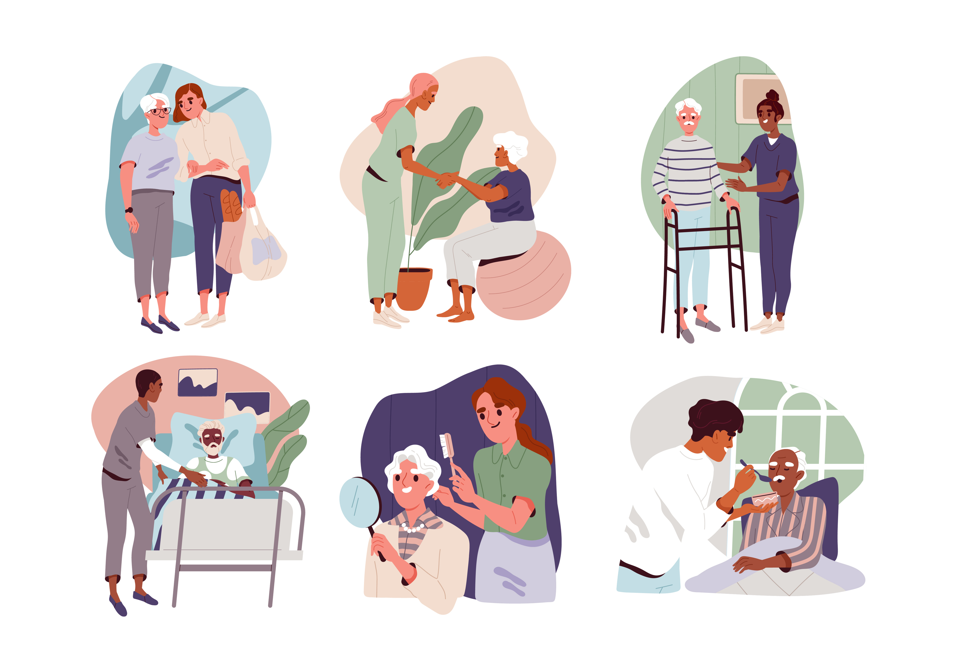
Communication with the people entrusted to your care is particularly important, as it can influence the quality of your relationship both positively and negatively. You should be aware that communication is not just about passing on information, but also takes on other factors, such as:
- Showing concern or interest: Through your communication, you can demonstrate to those you care for that you are interested in their well-being.
- Attention & disinterest: Your facial expressions and gestures communicate whether you are attentive or disinterested, significantly influencing the nursing relationship.
- Politeness & curiosity: Friendly and respectful communication fosters a positive environment, while curious questions can enhance understanding and build trust
- Expression of closeness and distance: Your communication can establish closeness or distance, depending on what is appropriate in the given situation.
- Expression of empathy: Show empathy to better understand and respond to the emotional state of those you care for.
- Motivating the person being cared for to: Motivating communication can positively influence collaboration and the healing process.
If you can understand the individual needs of the person you are caring for in your communication, you will be able to actively support the patient in coping with their illness.
You are a nurse attending to Mr. Smith, who has recently undergone surgery. He expresses dissatisfaction with the pain management and feels his concerns are not being addressed adequately.
What could be possible communication strategies?
· Active Listening and Empathy: Show understanding of Mr. Smith's pain and frustration, validate his feelings, and reassure him that his concerns will be addressed promptly.
· Clarification and Information Sharing: Ask specific questions to clarify Mr. Smith's concerns about pain management. Provide detailed information about the pain management plan and potential adjustments.
· Problem-Solving Approach: Collaborate with Mr. Smith to identify possible reasons for his dissatisfaction and propose solutions or alternative pain management options.
If using active listening and empathy, Mr. Smith might feel heard and understood, leading to increased trust and cooperation in the treatment plan. Clarification and information sharing could alleviate Mr. Smith's concerns through transparency and detailed explanation. A problem-solving approach might empower Mr. Smith by involving him in decision-making and enhancing his satisfaction with the care received.
However, communication in your care work is not limited to you and the person you are caring for. The exchange with individual colleagues, relatives or your social environment is also particularly important. How you communicate within the team is also essential. The unit ‘The importance of resilience in care teams’ will give you a deeper insight into this.

The role of self-care and the 7 pillars of resilience in care work
Self-care in care work
If you go on holiday by car and have at least 500 km ahead of you, you will fill up your car with petrol beforehand, right? What happens if you don't? You run out of petrol and if you don't notice it in time, the car even gets damaged. Fuelling the car is like taking care of ourselves. If we don't take care of ourselves, we will eventually run out of petrol. It is therefore important that you take precautions and look after yourself.
To summarize, the aim of self-care is to be mindful of yourself. There are different strategies that you can use for your self-care. These are very individual from person to person. Try them out for yourself to see what is good for you, how you can switch off and recharge your batteries. Here are some examples of self-care strategies for you:
•Relaxation exercises (meditation, breathing exercises, progressive muscle relaxation),
•Sufficient sleep or power naps,
•Psychological counselling, mental training, supervision, coaching,
•Sport or regular exercise,
•Healthy, balanced diet,
•Cultivating hobbies and interests,
•Setting boundaries (‘saying no’),
•Writing a diary (journaling, gratitude diary),
•Consciously plan small breaks
This list could go on indefinitely and is not exhaustive. These examples are merely intended to give you food for thought. It's also clear that you can't spend all day on self-care and only dedicate yourself to positive activities. It is therefore important that the measures for your self-care can be easily integrated into your routines. It should not cause you any additional stress. After all, you have everyday and professional obligations that you have to fulfill and that may be less fun. But if you act in a self-caring way, you will create a balance between the more unpleasant and more enjoyable activities. This in turn can help you to develop more resilience. You can therefore look forward to the ‘Exercises to strengthen resilience and self-care’ unit, which will help you do just that.
Only those who take care of themselves can also take care of others. So it's best to start with yourself!

The 7 pillars of resilience in care work
At the beginning, we have already learnt that the 7 pillars of resilience serve as a practical guide to strengthening your resilience. You can think of these pillars like the scaffolding of a house. Each one helps to keep the building stable, whatever the weather conditions. Whether it's bright sunshine or a terribly raging storm. The aim is to identify your 7 resources, strengths and skills that will help you become more resilient to the challenges of your care work.

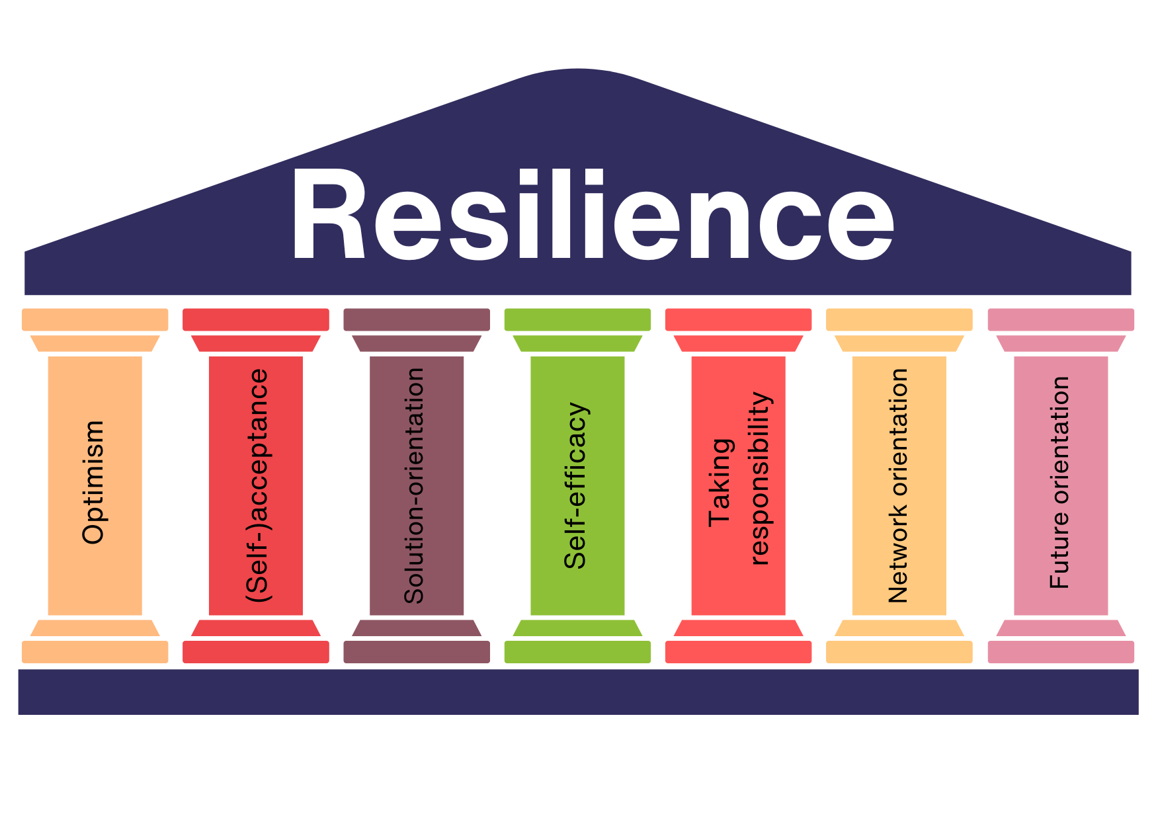
Let's take a brief look at the pillars at this point, in order to get an overview aboz what the 7 pillars are about. Content units 4 and 5 will focus on the 7 pillars of resilience, so please also have a look at those units to get a deeper understanding of the concept.
1.Pillar: Optimism
If you find yourself in a difficult situation during care work, you may find yourself focusing on the negative aspects. This can take a lot of strength from you. This pillar is about believing that your crisis is temporary and can be overcome. This does not mean that you gloss over your problems, but rather that you are confident that you can influence the course of events yourself.
Focus on the positive aspects of a situation, not the negative ones.
2.Pillar: (Self-)acceptance
You know when you're stuck in a traffic jam on the way to work and you're annoyed because you're probably going to be late? You're annoyed even though there's nothing you can do about the situation, right? It is important for your resilience that you learn to accept what is beyond your control. Some things we simply can't change or control and that's okay. One particular form of acceptance is self-acceptance. This is about accepting yourself as you are. With all your strengths and weaknesses.
Accept circumstances and situations that you cannot change and, above all, accept yourself as you are.
3.Pillar: Solution-orientation
How do you manage to get out of a crisis? Certainly not if your thoughts only revolve around the problem. In a situation like this, it is much more important that you think about what the solution could be. When you are faced with a crisis or challenge again, try not to fall into a ‘problem trance’, but rather orientate your thoughts towards a solution.
Find solutions to crises and don't dwell on the problem - that won't get you anywhere.
4.Pillar: Self-efficacy
You have probably already been in a situation where you felt paralysed, as if you were a victim of circumstances and couldn't do anything about it. ‘That's just the way it is. What am I supposed to do?’ Does that sound familiar? When we see ourselves as victims, we are unable to act effectively. This means that we have the feeling that there is nothing we can do to change the situation. Learn to recall past situations in which you have already mastered difficult situations. Move away from the role of victim and become self-effective.
Remember your strengths and abilities. You are in control and can change the situation.
5.Pillar: Take responsibility
It is much easier to point the finger at others than at ourselves. However, it is important to take responsibility and not blame other circumstances or people. Of course, this does not mean that you should always take all the blame. Nevertheless, you should learn to accept events, take responsibility for them and at the same time decide how you want to deal with them.
Take responsibility and thus control over your life.
6.Pillar: Network orientation
Do you remember a moment in your care work that really affected you? Who did you want to talk to about it? We all need a network of people in our lives with whom we can share both positive and negative moments. People who give us comfort and offer us security. These can be friends, family or acquaintances. The feeling of belonging is one of the basic human needs and is therefore also important for our resilience.
A social network offers you a safety net that catches you when you fall.
7.Pillar: Planning for the future
Of course, you don't yet know what your future will look like. However, you can help to shape it positively. It is important that you don't constantly dwell on the past and brood over what went wrong when you experience setbacks. Self-reflection is good so that you can learn from what has happened. But it is also important to put the past behind you and look to the future.
Learn from the past for your future and live in the present.

The importance of resilience in our world
Does it sometimes feel like one bad news story follows the next when you open the newspaper, listen to the radio or watch the news on TV or social media? It's not just the coronavirus pandemic that has taken its toll on our society. Political chaos and climate catastrophes also make for uncertain times. It seems as if we are in the age of chaos.

The age of chaos: the BANI world
It is precisely in chaos that structure is needed. Have you ever heard of the BANI world? It describes a world characterised by change, chaos and unpredictability. The BANI world model can help you to better understand the challenges of our times.
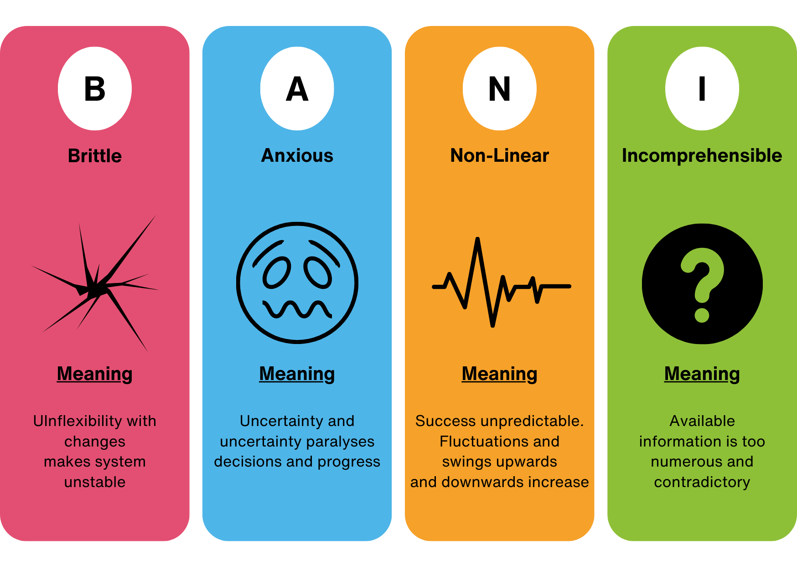
If you are operating in a BANI world, this requires a rethink. The RAAT strategies are particularly suitable for meeting the challenges, recognising them and developing skills and strategies:
1.promote Resilience: Managing crises effectively and seeing challenges as learning opportunities
2.practising Awareness: consciously dealing with information, e.g. recognising fake news
3.prioritise Adaptation: Flexibility - take advantage of new opportunities and situations
4.create Transparency: create clear information structures

An era of general discontent: Age of Malaise
In addition to the BANI-World, it seems as if a general dissatisfaction prevails. This is also called the ‘Age of Malaise’. You may recognise it when you feel alienated, stressed and dissatisfied, even if you enjoy material prosperity. This dissatisfaction or discomfort can manifest itself in different forms, such as a lack of purpose, a loss of confidence or a feeling of being overwhelmed. According to the WHO, in 2030 depression will be the most widespread disease in our world.

The world is becoming increasingly fast-paced
What changes have you noticed in your private and professional environment? The fact that everything is becoming more fast-paced has been apparent for some years now. In addition, there are financial burdens due to world events and various social challenges. Unfortunately, you have not been spared in your care work either. You have no doubt already experienced the staff shortages at first hand. The increasing number of people requiring care can no longer be glossed over.
How do you feel when you are faced with all these changes and challenges? Do you perhaps feel uneasy or even scared? That's completely ok. A lot of people feel that way. You are on the right path to strengthening yourself for these uncertain times. Because more than ever, everyone is talking about resilience - and rightly so. Because armed with resilience, you will be able to get through this time well and adapt well to the changes.

Maintaining resilience in care work in the long term
We have already established at the beginning that strengthening our resilience is significantly depending on how many resources we have. Think of your resilience as a protective shell that bounces off anything negative. You can strengthen this protective layer with resources, for example in the form of self-care. However, it can be weakened by negative situations, crises as well as negative attitude and behavior.

Exercise: resilience in everyday care
In order to become more aware of what fuels your resources and what weakens them, we invite you to take part in an exercise: Think about your everyday life as a caregiver and note down for yourself what could weaken your protective shell. At the same time, find out where your sources of strength lie and how you can strengthen yourself again despite all the challenges. Put the note in a place where you often pass by and remind yourself of your thoughts regularly. Especially the resources that strengthen you. You can repeat this exercise regularly.

Training and support resources to promote resilience
At this point, we are sure you have understood how important it is for you, but also for the person you are caring for, to build your resilience in a sustainable way. However, understanding it and putting it into practice are two different things. This is why training courses or workshops are particularly useful for increasing your knowledge, promoting awareness and making you take small steps to train resilience. You can consciously allow yourself time for this and at the same time engage in dialogue with other people.
How would you react if the person entrusted to you did not accept any support, even though you realize that they need help? You might be very surprised or think to yourself that there is no shame in accepting help, is there? Think about this when you need support yourself! Resources that can support you are, for example, your social environment or the aforementioned exchange with other people. However, you can also build up and find these support resources within yourself. You can do this by recognizing stress factors or, for example, by acquiring coping strategies to deal with difficult situations.
You are used to helping others. But it's also okay to take advantage of support yourself!

Summary
We live in a time characterized by uncertainty and chaos. You are not only faced with challenges in your day-to-day care work, but also in your private life. This is precisely why resilience has become increasingly important. This is because resilient people have mental and psychological resilience and strength. There are three forms of resilience: physical, emotional and social resilience. The 7 pillars of resilience model offers you practical guidance on how to strengthen your resilience.
It is important to identify the challenges you face in your day-to-day care work. For example, how you deal with stress. You can utilize various stress management strategies, also known as coping. Self-care also plays an important role. This involves being mindful of yourself. There are different strategies that you can use for your self-care. These are very individual from person to person. You could try them out for yourself to see what works for you, how you can switch off and recharge your batteries. Because please remember: you can only take good care of others if you take good care of yourself.

Risks and protective factors for dealing with stress

Introduction
"I'm so stressed" is a statement that I'm sure everyone has said at some point. It feels like stress is omnipresent and is currently a major social phenomenon and problem. This chapter will explain exactly what stress is, what two types of stress there are and what the risk and protective factors are for dealing with stress.
Working in the care sector is a particularly stressful job. Night shifts, weekend duties and staff shortages create an environment in which you can quickly feel the stress. In addition, you often encounter difficult fates, serious injuries or illnesses, which represent a major challenge for those affected and their families. If the person you are caring for is also a member of your own family, the stress of caring for them is also added to your private life.

What is stress?
But let's start with a definition. What exactly is stress?
Stress (from the Latin "stringere" = to tense) is the term for tension, strain, pressure. Stress is an unpleasant situation experienced by a person that has negative consequences.
We are used to seeing stress as something negative. But stress, in reality, is nothing more than a psychological and physiological response that the organism enacts in the face of tasks, difficulties or life events that are assessed as particularly challenging. Stress in itself is a useful mechanism for adaptation and evolution. We could say that it is neither negative nor positive, but it depends on each of us: the perception of stress is different from person to person.
However, for simplicity, we can say that we can experience two types of stress. The so-called "eustress" and the so-called "distress". Eustress leads to peak physical and mental performance, it challenges you briefly and thus activates your system. Distress does the same, only over a much longer period of time. Eustress is characterized by the fact that it alternates with periods of rest and has a motivating effect. Distress, on the other hand, is continuous without allowing breaks and has an exhausting effect.
The distinction between eustress and distress is strictly related to how we perceive events. If we see something as a threat, this ends up provoking a greate pressure and anxiety response (this is what we call distress), while perceiving a situation as a challenge may suggest that we are more excited and even have more fun with it (this is eustress). Therefore, training positive thinking, optimism and a solution-oriented approach to problems helps us to increase eustress levels. You will find more about this in the module where we talk about the 7 pillars of resilience.
This graphic shows the differences between eustress and distress:
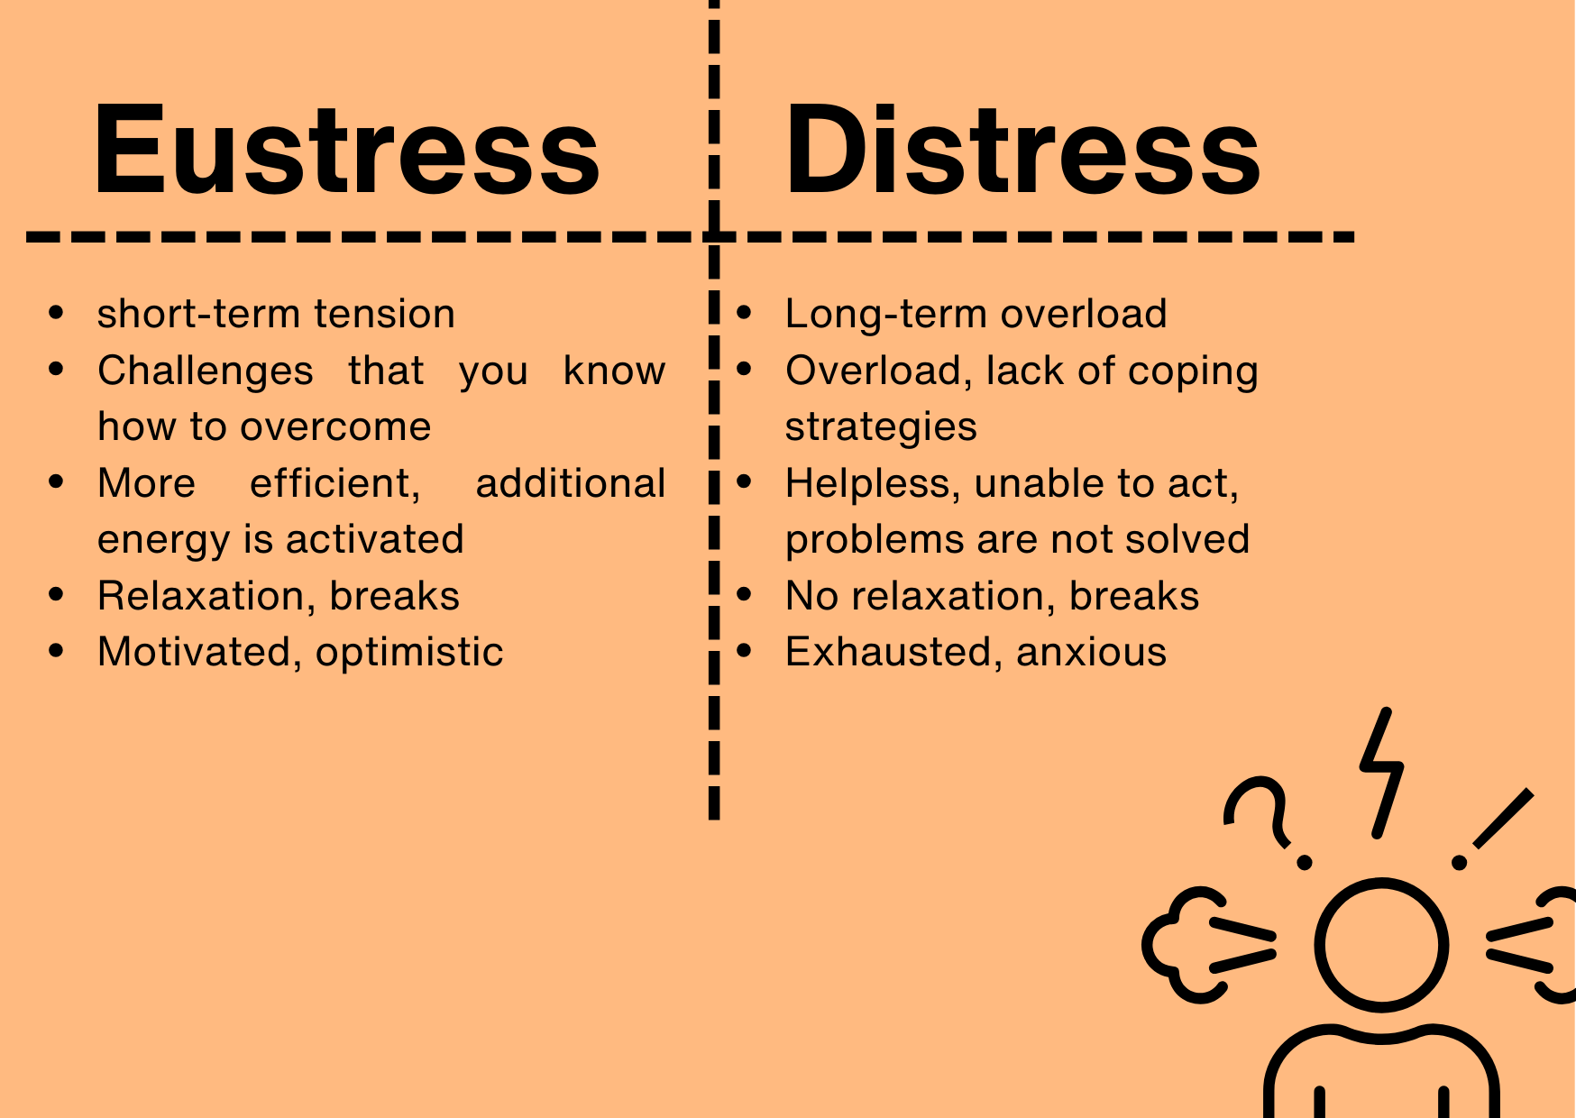
Can changing the way we view stress make us feel better? Can stress also have a positive side?
Kelly McGonigal, a health psychologist and lecturer at Stanford University, proposes an unusual view of a phenomenon, stress, that is usually considered in its negative and problematic sense. She invites us to change our mindset and to see stress as a sign of vital drive, energy and preparation for a challenge and not (only) as an enemy to be eliminated. Check out the video to see how stress could also be our friend.
https://www.ted.com/talks/kelly_mcgonigal_how_to_make_stress_your_friend?subtitle=en&geo=it&trigger=5s
When we talk colloquially about stress, we are always referring to negative stress, i.e. distress. This is what causes us problems and sweating in everyday life and prevents us from sleeping well. If the body can't get out of the stress state, this leads to an increased pulse and blood pressure. Blood clotting is increased and this is damaging to the blood vessels in the long term. This increases the risk of heart attacks and strokes and other cardiovascular problems are also fuelled by this. If this is the case permanently, it favors the development of diabetes
Distress is a mode of response mediated by several hormones and neurotransmitters. In particular, cortisol, a hormone produced by the adrenal glands at the instigation of the brain; it increases blood sugar and fats in the bloodstream to provide the energy the body needs to react.
Other substances that are released as a response to stress are the catecholamines: these include adrenalin and noradrenalin, which are responsible for the set of changes (i.e. accelerated heartbeat) that constitute the emergency reaction. It is clear that the emergency reaction depends very much on our perception. If a person perceives an emergency, a situation that is not really dangerous, as happens, for example, to people who are particularly anxious, the body lives in a state of alarm that generates and fuels stress reactions.
Stress also keeps the immune system permanently active, which means that the immune system cannot work as efficiently when it is needed, i.e. when a bacterium or virus enters the body.
What's more, people who are under a lot of stress are often more inclined to lead an unhealthy lifestyle. Exercise and a healthy diet are often less practiced and stressed people are more likely to turn to stress-reducing substances such as alcohol, fast food or (even more) cigarettes.
The risk of mental illness, such as depression or anxiety disorder, is also increased by high levels of stress.
Stress leads to a variety of negative effects on your body and your psyche. For this reason, it is very important to reduce stress and avoid prolonged stress.
The following pages look at the risk factors for stress in the care sector and the protective factors that can counteract them.

Risk factors for carers
As a family carer or a person working in the care sector, you are exposed to a number of risk factors that can cause you stress or have a negative impact on your mental health. But what does the term risk factors actually mean?
A risk factor is a characteristic, condition or behavior that increases the likelihood of contracting a disease or a bad habit.
This chapter focuses on the risk factors that have an impact on the mental health of formal or informal carers.

What risk factors for carers are there that have an impact on mental health?
- High workload
- Dealing with illness and death
- Conflicts in the interpersonal sphere
- Lack of appreciation
- Shift work and overtime
You have probably nodded your head in agreement at this list. The individual points are examined in a little more detail below.
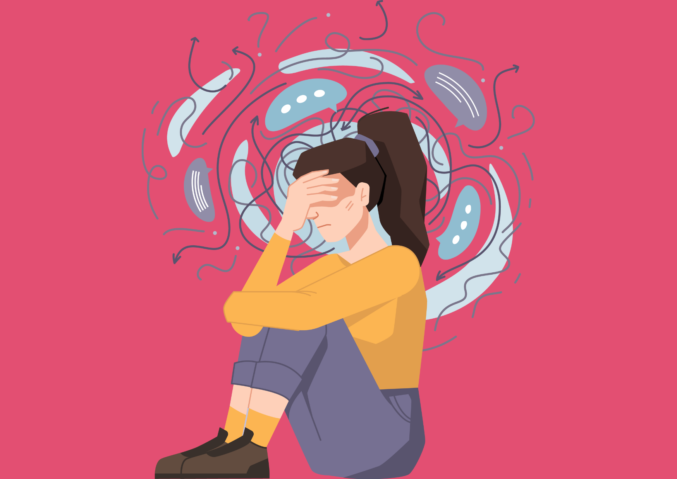

1. high workload
There has been a shortage of skilled caregivers in the care sector for years. At the same time, people are getting older and older and demographic change means that there are more and more people in need of care. In addition to this imbalance in the ratio of carers to people who need care, the tasks of individual carers have increased significantly in recent years.
2. dealing with illness and death
There is hardly any other professional field where you come into contact with illness and death more than in caring. Constantly having to deal with people losing their fight against an illness, only surviving an accident with very serious injuries or not surviving at all, accompanying people to their death and seeing grieving relatives can be very stressful and continue to have an effect even after the working day is over. It makes us more vulnerable because it forces us to face the greatest dilemma of existence: human pain and precariousness.
3. interpersonal conflicts
Depending on the work context, carers and their relatives are usually in an exceptional situation. This leads to intense emotions, which can sometimes turn into difficulties in relationships. The daily challenges, the coping difficulties, the strong emotions that caring work entails, sometimes make us unable to have a good emotional management: this has negative consequences and bad impacts on the relations around us. Patients may feel that they are not getting enough care time, relatives may think that they have discovered a better treatment method on Google and that the hospital, care home, etc. is generally not good enough. In addition, there are disputes with superiors and colleagues due to the prevailing pressure.
4. lack of appreciation
The fact that carers work hard every day for the health of other people is unfortunately seen and appreciated far too little in society. Daily balcony clapping, such as during the Covid pandemic, is simply not enough.As the report of the International Labour Organization has highlighted, the absence of monetary compensation and the idea that care work may not require special skills and abilities are often at the root of the low valorization of care tasks and the frustration of millions of people who perform such work.
Despite its importance in the economies of all countries, care work is often not adequately recognized for its economic and social value, although it makes a fundamental contribution to social progress.
5. shift work and overtime
People in need of care do not keep office hours; they require round-the-clock care. This requires night and shift work and irregular working hours. This puts a strain on the body because the sleep rhythm is disrupted. Due to the labor shortage in the care sector, many people who work in the care sector have to work overtime to cover the workload. But we have to be aware that, due to the characteristics of care work, the load of hours is always also a load of emotions, of thoughts, of relational challenges. This overload often cannot be compensated in terms of time and of energies.

The risk factors mentioned above place an enormous burden on you and your colleagues. According to a study, six out of ten people who work in the care sector do not believe that they will be able to make it to retirement in their current job.
Do you recognize yourself? Or are you still part of the minority of people who can imagine staying in their job until retirement? Even if this applies to you, it is important that you take good care of yourself and your mental health so that it stays that way and you can and want to stay in your job for a long time to come.
To achieve this, it is important for you to be able to counterbalance the risk factors. Something that balances out the risk. This is where the so-called protective factors come into play.

The importance of strengthening life skills as a protective factor
When people develop and maintain mental health despite stressful life circumstances and crises, this is because they have trained life skills that correlate with resilience. Protective factors, which reduce the likelihood of disorders occurring in the presence of stress, have a significant influence on the development of resilience.
As you can see, this is the link to resilience. As you already know from the previous chapters, resilience is a key factor in maintaining your mental health. Protective factors reduce the likelihood of developing a mental discomfort, general malaise, sometimes even mental or physical illness and therefore make a significant contribution to a person's resilience.
But what are protective factors? The World Health Organisation (WHO) speaks of so-called "life skills".
According to the WHO, a person is competent in life "if they know and like themselves, are empathetic, think critically and creatively, can communicate and build relationships, make well-considered decisions, solve problems successfully, and manage emotions and stress."
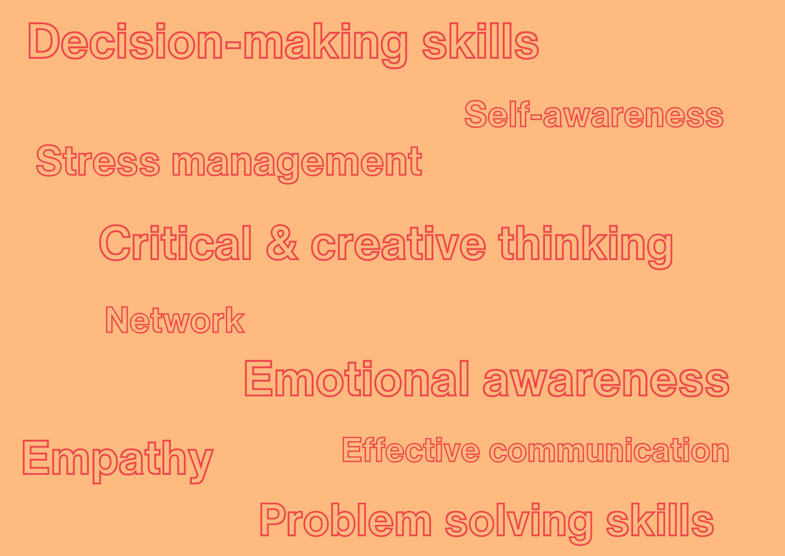
The following points take a closer look at individual protective factors, each of which represents a resilience factor and thus stands in contrast to the risk factors.

Self-awareness as a resilience factor
Self-awareness is the perception of the self, i.e. of one's own person.
Self-awareness is the cornerstone of being able to build resilience in the first place. You have to be aware of yourself, i.e. feel yourself, in order to even realize what you need.
Self-awareness is the ability to feel oneself; Daniel Goleman, the great American psychologist, describes it as 'the ability to recognise a feeling as it arises'. In other words, it is the objective awareness of one's moods, which is often referred to as the faculty of 'looking down' on oneself.
To make self-awareness a little more tangible, try the following: Concentrate on your body, go through all parts of your body in your mind. Start with your feet. Then focus on your legs, your thighs, your hips, your stomach, your chest, your back, your arms, your head and your face. What do you feel? Is there an area that pinches or hurts? Is a part of your body heavy or tired? What else do you notice? Perhaps a certain emotion?
All you have felt in this short exercise is self-awareness. The better your self-awareness is, the better your resilience can be developed.
Self-awareness is therefore closely connected with the ability to understand our needs.
Needs awareness starts with self-awareness. This means that you perceive a certain movement in your body or feel an emotion. If you have needs awareness, you are able to translate these perceptions into consciousness. Moreover, if you have needs awareness, you are also able to transform needs into demands, either on yourself or on others.
You've had a long day. You feel tired and stressed at the same time. You realize that many thoughts are running around in your head. You feel some physical distress, like headache, and also emotional and mental discomfort: you have mild anxiety, bad mood and need to be alone. You decide to go for a walk to sort out your thoughts and clear your head. Then you take a relaxing bubble bath. You feel much better because you have recognized and satisfied your need for relaxation and rest.

Problem-solving skills as a resilience factor
Another important resilience factor is the ability to solve problems. This is easy to understand if you think about it for a moment. Anyone who has experienced being able to solve their own problems without needing outside help gains the confidence to be able to stand up for themselves and get themselves out of difficult situations. Having this security in mind contributes significantly to resilience.
But how do you solve a problem? In theory problem solving can be divided into five steps.:
- Recognizing the problem: if you don't recognize that there is a problem, you won't be able to solve it. It is therefore important to recognize where there is a problem and to name it precisely. The more concretely a problem can be named, the better it can be solved.
- Analyze the problem: As a next step, it is important to recognize how and where the problem arose, when it first occurred and why it was not recognized earlier. However, it makes no sense to look for culprits here
- Develop possible solutions: Now it's time to find solutions. You can be quite creative in doing so
- Actively solve the problem: In this step, a solution is actively pursued in order to solve the problem.
- Evaluate whether the problem has been solved: After solving the problem itself, you should take another concrete look to see whether the problem has really been solved. If not, the problem-solving process starts all over again.
But these steps can only be implemented when, in parallel, we know how to recognise and manage our emotions well. This, in turn, depends on our self-awareness: we therefore begin to realize that life skills are closely related: we will become able to successfully apply the 5 steps described previously as we will be training the other life skills.
Life skills are like a "psychological body". we cannot be strong only in the right leg or the left arm: to be able to withstand a challenge we must be trained as a whole.
In line with what was previously mentioned, we have now understood that in order to solve problems we need various skills; the main ones are:
- Analytical thinking: Analytical thinking means solving problems by thinking logically and breaking them down into smaller parts.
- Personal initiative: Personal initiative is when you complete tasks on your own initiative without someone else having to ask you to do so.
- Emotional intelligence: Emotional intelligence is the ability to understand and deal with one's own feelings and the feelings of others.
- Emotional stability: Emotional stability means remaining calm and balanced even in stressful or difficult situations.
- Results-orientation: Results-orientation is the focus on achieving goals while working effectively and efficiently.
- Hands-on mentality: A hands-on mentality means taking a practical and active approach and solving problems directly.
- Conflict skills: Conflict skills are the ability to resolve differences of opinion constructively and respectfully.
- Creativity: Creativity is the ability to develop and realise new and original ideas.
- Self-confidence: Self-confidence is the trust in one's own abilities and decisions.
- Self-reflection: Self-reflection is thinking about one's own behaviour and thoughts in order to better understand and develop oneself.

Critical and creative thinking as a resilience factor
In addition to problem-solving skills and a sense of control, the ability to think critically and creatively is another important resilience factor. Critical and creative thinking helps people to look at problems and challenges from different perspectives and find unconventional solutions. They think outside the box and find ways that they would not have thought of without critical or creative thinking.Surely now you can understand how this skills can be related to problem solving.
Creative and critical thinking is required, especially when you are often confronted with unexpected or complex situations. And you know best of all that this is often the case in the care sector.
Selina cares for her mother, who has dementia, at home. A few days ago, Selina realized that her mother was getting worse, even though the doctor had just changed her medication.
Critical thinking: Selina checks the information on the medication again and discusses the situation with the doctor. She also considers getting a second opinion after the first doctor assures her that nothing more can be done than to continue to administer the medication she already knows.
Critical thinking and finding creative solutions contribute to the feeling of having life "under control" and being able to make a difference. For this reason, this ability is categorized as a resilience factor.

Decision-making ability as a resilience factor
In the care sector, you are confronted with making important decisions every day. Choosing the order of patients, putting together the right medication, deciding whether someone should be hospitalized or not are just a few examples of your decisions.
However, many daily decisions don't feel like decisions at all. For example, going to work every day. You may have chosen your job years ago. In reality, you are still doing it by going every day and not reorienting yourself or training in a different direction.
The ability to actively and consciously make decisions is an important one. Once again, it is about taking control of your own life. Being aware that no decision can also be a decision also plays a role here.
Let's take the example of your job. If you don't decide to quit, you are indirectly deciding to stay in this job. Surely decisions are influenced by many factors. What is important is to be well aware of the reasons why we choose or do not choose to do something. This awareness becomes the very motivation for the choice (or non-choice),legitimating it and making us feel more confident in our decision. It feels better to actively decide to stay in your job. Perhaps have a quiet minute to think about it and make a conscious decision to stay in your job. You will see that your daily commute may feel a little easier.
Even those who don't actively decide, decide. It feels good to have a choice. Vote actively!

Stress management
In a job as difficult as that of caregiver, the sources of stress are many: To manage stress, it is necessary to recognise the causes of tension and stress in daily life and in the exceptional situations that life throws at us. And therein lies the awareness. But then it is essential to take action: managing stress also means finding strategies to change the state we are in, either by intervening in the environment or by ourselves and adopting behaviors that can give us 'fuel'. One of the key elements of stress management is thus the ability to adopt habits or make choices that fuel our energy.
Anyone who has now raised an eyebrow: Don't worry! It doesn't get esoteric at this point. The word "energies" is not meant to be supernatural, but in this case refers to the personal (mental, emotional, spiritual and physical) resources that a person has at their disposal. You may be familiar with the situation when someone robs you of your "energy". This is the kind of energy that is meant.
To be a resilient person, it is important to actively look after your own energy and surround yourself with positive things. This is done by focusing on positive things, cultivating positive relationships and activities that are good for you and fun. Being able to see the beauty in everyday life, having people around you who are good for you and filling your free time with hobbies makes it easy to reduce stress, improves your mood and increases your mental and emotional resilience. The pure resilience booster.
Focus on positive things: You notice the positive little things in your everyday life: Patient 1 smiled at you or the words of thanks from a relative.
Maintaining relationships: You maintain a good relationship with your colleagues. The lunch break together is always fun and relaxing.
Balancing activities: You are an absolute bookworm. You regularly take an hour in the evening to continue reading your current book.

Healthy body - healthy mind
If you like to put on sportswear and comfortable shoes and exercise outside in the fresh air after a long day at work, you will know that you feel better afterwards - even in your head. It has been scientifically proven that some mental health disorders can be alleviated through exercise and sport. Exercise can even help prevent anxiety and depressive moods and the like. But why is this the case?
Exercise and sport lead to greater self-acceptance, self-esteem and resilience. All important resilience keywords. In addition to exercise and sport, you can do your body - and therefore your mind - a lot of good in other ways:
- Stress balance - Avoid constant stress and make sure you regularly reduce your stress levels.
- Relaxation exercises - Help you to reduce your stress and relax the muscles in your body.
- Sufficient sleep - Your brain processes stimuli and information when it is completely at rest, and people urgently need this. It is not for nothing that sleep deprivation is a method of torture.
- A balanced diet - There are studies that indicate that fast food can increase depression. Eat a balanced diet and choose unprocessed foods wherever possible.

Emotional awareness and effective communication as resilience factors
How are you doing? Good? - Really well?
Do you even know how you feel? Have you actively thought about it? The hustle and bustle of everyday life often leaves us no time to think about how we are feeling and what exactly we are feeling. An emotion has to come to the fore for us to really notice it, between all the to-do's we are confronted with in everyday life.
It is important to know how you are feeling and what you are feeling. If you know what's going on emotionally, you can put it into words and tell those around you what you need and why your mood might be different than usual. Let's take an example to make this clearer:
Franz is very tired today. His daughter is ill, he has been looking after her during the night and therefore hasn't slept much. He is also worried because she had a high temperature. His thoughts keep wandering away from work and he finds it hard to concentrate. His colleague Susanne asks him why he is so distracted. Sensing his feelings and aware of how he is feeling, Franz replies: "My daughter is ill, I'm totally overtired and worried about her". Susanne is understanding and keeps glancing at Franz during the rest of the day and asks him if she can help him. Nevertheless, the two of them spend a relatively good day together.
Imagine that Franz is not aware of his emotions. The same example could then look like this:
Franz is very tired today. His daughter is ill, he has been looking after her during the night and therefore hasn't slept much. He is also worried because she had a high temperature. His thoughts keep wandering away from work and he finds it hard to concentrate. Everything is somehow more difficult for him today than usual. Franz is annoyed. The patients are very stressful today. When his colleague Susanne asks why he is distracted, his patience snaps: "What's wrong? There's nothing going on, leave me alone".
Susanne is annoyed and leaves. She avoids Franz that day. Franz and Susanne are annoyed with each other and are done with the day.
Which scenario do you think is healthier for Franz (and Susanne) in the long term? - Exactly! The first one, of course.
Being aware of ones feelings is one thing, being able to communicate about the feeling and also recognize the feelings of others is the other. The key therefore is being able to communicate effectively.
Effective communication is an essential life skill that fosters understanding, builds relationships, and enables individuals to navigate various social and professional settings successfully. It involves the clear, concise, and thoughtful exchange of information, ideas, and emotions between individuals. Effective communicators are adept at both expressing their thoughts and actively listening to others, ensuring that messages are accurately received and understood.
Key components of effective communication include clarity, active listening, empathy, and adaptability. Clarity ensures that the message is straightforward and unambiguous, reducing the risk of misunderstandings. Active listening involves fully concentrating on the speaker, understanding their message, and responding thoughtfully. Empathy allows communicators to connect with others on an emotional level, fostering mutual respect and trust. Adaptability enables individuals to tailor their communication style to suit different contexts and audiences.
Developing strong communication skills can lead to numerous benefits, such as improved relationships, enhanced problem-solving abilities, and greater professional success. It empowers individuals to express their needs and opinions assertively, negotiate effectively, and resolve conflicts amicably. In an increasingly interconnected world, mastering the art of effective communication is crucial for personal and collective growth.
If you know how you are feeling, you can communicate this and those around you can take you and your condition into consideration. The recognition and expression of emotions also allows you to make demands on those around you. This is a good step towards establishing sincere relationships!

Empathy as a resilience factor
This point deals with the same topic as the previous one - understanding emotions. However, understanding emotions here refers to the other person and not to your own feelings. Empathy describes the ability to recognize, understand and deal well not only with one's own feelings, but also with the feelings of others.
In the care sector, you have a lot to do with other people. It makes your work much easier if you recognize and understand the feelings of the person you are dealing with. Here is an example:
Carer Josef is looking after a patient who has just received a difficult diagnosis. The patient is very calm, his eyes are moving quickly and he is breathing deeply. Joseph recognizes the behavior as anxiety and expresses his observation clearly and empathetically. He could say: "I can see that you are worried. That's completely understandable. I'm here to help you and answer your questions".
Through this empathetic communication, Josef creates trust and enables the patient to express their feelings.
Empathy is then the ability to 'put oneself in the other person's shoes' thereby perceiving emotions and thoughts. It is the ability to see the world as others see it, to be non-judgmental, to understand the feelings of others while keeping them distinct from one's own.
It is a fundamentally important social skill and is one of the basic tools of effective and rewarding interpersonal communication. In interpersonal relationships, empathy is one of the main gateways to other people's states of mind and world in general. You can well understand then how crucial this life skill is in care work!

Social and relationship-related protective factors
Most of the previous points have highlighted factors that affect you as a person alone. The previous point has already included your counterpart. This point continues with that. Namely with your network.
A social network describes a person's integration into their surrounding social environment. This network includes friends, family, neighbors, work colleagues, companies and authorities. A complex framework of connections is created between them - a network.
You probably know the feeling: after a long day, it feels incredibly good to talk to your best friend and talk about the day. You can immediately feel your battery recharging. So it's easy to understand that your social network is an important resilience factor.
To build a strong network and have sustainable relationships, you need to be able to communicate well, empathies and resolve conflicts.
Befor you go on reading about how to strengthen the protective factor, check out this video about lessons learnt from a study about happiness: https://www.youtube.com/watch?v=8KkKuTCFvzI

Strategies for strengthening the protective factors
After naming and describing the individual life skills, which are all protective factors for you and strengthen your resilience, this section deals with how you can specifically strengthen these protective factors, what methods there are for this and how you can apply them.
The following strategies can help you to strengthen the protective factors mentioned and described above. You do not need any other people or outside help for these strategies. You can apply the strategies on your own:
- Self-awareness and awareness of needs: Practice self-reflection regularly. This means that you consciously take time each day to think about how your day was and how you felt. Make sure that you do not only think about your day, but really feel into your whole body.
- Emotional intelligence: Active listening and observation helps you to better recognize how other people are feeling. Try to listen behind the spoken words and ask questions to better understand your counterpart! Think about why the person you are talking to is anxious/nervous/angry and take the feelings of your counterpart into account as well.
- Problem-solving skills and creative and critical thinking: consciously take time to find solutions and be open to new ideas and proposed solutions. For example, write down all the ideas you have without immediately discarding them. You will see that you will come up with a lot.
- Control conviction: Make a list of all the things you can control. Think about your everyday life. Where are things that you can certainly influence? Write them down on the list.
- Decision-making ability: Take time to gather and evaluate relevant information before making decisions. Also think about the indirect decisions you make on a daily basis and actively make them for a change!
- Positive energy management: Collect things on a piece of paper that you know are good for you. The next time you are tired/exhausted/frustrated or similar, pick up the list and do one of the things on it.
- Social and relationship-related protective factors: Maintain your contacts actively. Approach those around you, call your girlfriend. Arrange a date with your partner.
- Healthy body: Take a critical look at your diet over the last two weeks. Optimize it if necessary. Haven't been out in the fresh air for a long time? Then put on your shoes and walk around your block. Even 5 minutes in the fresh air can work wonders!
In addition to the examples listed, there are also methods that you can use as part of your work or with colleagues, in team meetings or similar. Such methods are:
- Training, education or further training in the areas mentioned can improve your skills in the areas of self-awareness, problem solving, decision making and other areas mentioned.
- Supervision and coaching can help you to better recognize your needs and strengthen your social and relational skills.
- Teamwork and exchange helps with creative and critical thinking and promotes your social network
- Health promotion in the workplace, such as joint fitness courses or a fruit basket, contribute to your physical and therefore your mental health.
You can strengthen your protective factors both through programs offered by your employer and on your own at home. The important thing is that you take the methods and strategies seriously and practice the skills. Unfortunately, reading through this course once will not make you more resilient, but it is a good start.

Summary
In this chapter, you have dealt with stress, risk and protective factors. You have learnt what risk factors are in your field and why it is particularly important for you to strengthen your own protective factors and build up your own resilience.
Individual resilience factors were named and explained, followed by an explanation of exactly how you can strengthen your protective factors.

The 7 pillars of resilience

Introduction
In the previous chapters, you have already learned a lot about the word 'resilience' and its meaning. You have become familiar with many concepts, such as the BANI world and the Age of Malaise, and already know the importance of self-care and stress management for you. You have also read about risks and protective factors in dealing with stress and learned about strategies and methods for doing so.
So far, the chapters have provided an overview of much of the content. From this chapter onwards, the content will be described in more detail. This will give you an even deeper insight into the topics and allow you to deepen your knowledge in these areas, so that you are sure to take a lot away with you for your work in nursing.
The "7 pillars of resilience" have already been mentioned and briefly explained in the "Resilience in care" chapter. These 7 pillars will be discussed in more detail in this chapter.
Research has been focusing on the topic of resilience since the 1950s. In the last years various scientist have been proposing quite a substantial evolution of the concept of resilience, sometimes even calling it Antifragility. While at the beginning resilience was referred to an individual sphere, nowadays many evidences are focusing on a multidimensional and multidetermined resilience. Factors associated with resilience are not only personal characteristics and skills, but also family and environmental factors. Resilience is a dynamic competence that has much to do with the ability of the individual and his/her world to change and evolve. In the BANI world, what enables us to live well is to adopt, in our mindset and our behavior, the metaphor of the bicycle: generating balance through forward motion!

An overview of the 7 pillars of resilience
The 7 pillars of resilience were introduced in the early 2000s by two US scientists in their book "The Resilience Factor". Dr. Karen Reivich and Dr. Andrew Shatté conducted years of research themselves and also drew on the work of many different groups of researchers.
These 7 pillars are nothing other than seven skills that help us to cope better with difficult situations. Such difficult situations can be, for example, the following:
- Diseases
- Losses
- Overloads
- Problems in private life
- Problems in professional life
The seven sustainable skills that are referred to when we hear about the 7 pillars of resilience are as follows:
- Optimism
- Acceptance
- Solution orientation
- Self-efficacy / leaving the role of victim
- Taking responsibility
- Network orientation
- Future orientation

Imagine that these skills are each one pillar of your resilience. Each pillar supports a part of your resilience, like the walls that support your home. The more skills - i.e. pillars - you have, the better trained your resilience is and the better equipped you are to deal with the challenges described above. Of course, it also depends on how well trained each individual pillar is, i.e.how well balanced and trained the set of the 7 skills is. All pillars are interlinked with each other, if some are missing the walls of your home won’t be stable.
You can find examples of this below in the sub-chapters on each pillar.
Each of us possesses all the different pillars: some are already more ingrained, some need to be nurtured. To become resilient we need to find a dynamic and sustainable balance between the various pillars, knowing that the first step is to get to know ourselves and to become aware of our strengths and weaknesses. Then we can start by enhancing and expressing the pillars that are already solid, using them as a terrain on which to cultivate the weaker ones.
The importance of the 7 pillars for resilience theory
After these first few pages, you may be wondering why it is important for you to know the 7 pillars of resilience and what you should do with this knowledge.
Resilience is not a personality trait - it is not the case that people are either resilient or not, but that the various factors of resilience or the skills that contribute to resilience can be trained and learned even in adulthood. So regardless of how old you are and whether you have ever heard of resilience or the 7 pillars of resilience or you do not have any clue about the whole topic at all, you can start training the seven skills and thus improve your resilience.
Having the possibility, even as an adult, to work on yourself to improve the ability to live in the perspective of personal and relational well-being is a good news and a great opportunity, isn't it? Then let's take a closer look at the individual pillars.
The characteristics of the 7 pillars of resilience can also be trained in adulthood.

The 7 pillars of resilience and their importance
Pillar 1: Optimism
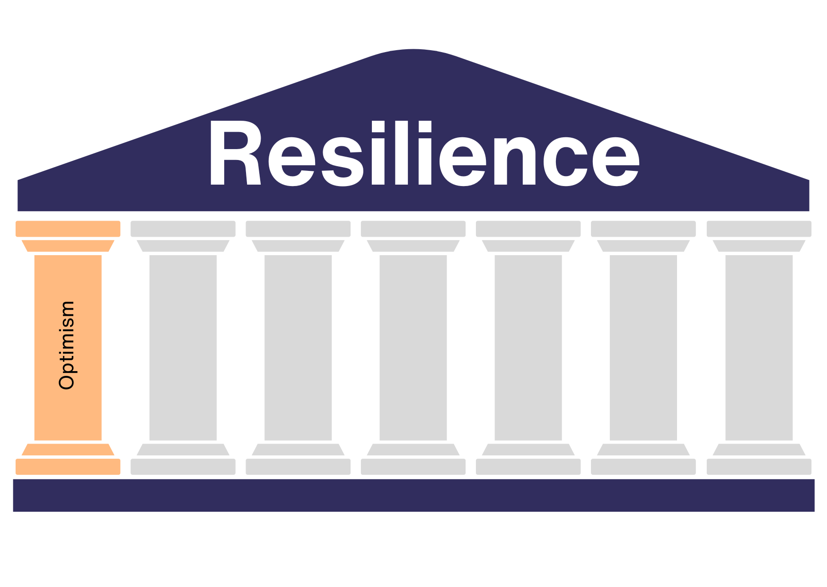
One of the leading experts on optimism is Martin Seligman, one of the founding fathers of positive psychology. His theory is that each of us experiences reality as we tell it. It's called attribution style: facts change depending on how we represent them. The first step is therefore to learn to look at what happens to us in a functional way: regaining the possibility of acting, of changing what is bad for us and consolidating what makes us feel good.
Optimism helps us to have a positive view of the world and of things. Especially in difficult times, this is important in order not to lose courage and confidence. By optimism, however, we are not talking about rose-colored glasses or a baseless "everything is fine" attitude, but about being able to have a realistic view with a positive attitude even in difficult situations.
We often tend to focus on negative things and often don't even notice the positive ones. This focus on the negative things takes a lot of energy. It seems impossible to change things and you can't believe that the difficult situation will ever improve. An optimistic attitude helps you to look at stressful situations with more ease. Optimism leads to the belief that all difficulties are temporary and can be overcome. This belief makes the stressful situation you are currently in feel less difficult.
You are caring for your mother, who is in need of care and has broken her femoral neck in a fall. Since being discharged from hospital, your mother has not yet been able to walk independently, cannot dress herself and also needs help in the bathroom and on the toilet. The situation is difficult for you. Even before your mother's femoral neck fracture, you had little time to care for her and now you need even more time. In addition, your mother has always been in a bad mood since the fracture, which also puts you in a bad mood.
In this situation, optimism and also humor can help you to cope with the situation more easily. Know that your mother will recover and that the increased time commitment is temporary. Focus on the progress your mother is making, not the setbacks. Celebrate the small advances each day, such as the improved mobility in her leg, or the pain your mother is finally feeling less. By focusing on the positive things (perhaps even together with your mother), you will find it easier to cope with the situation.

Pillar 2: Acceptance
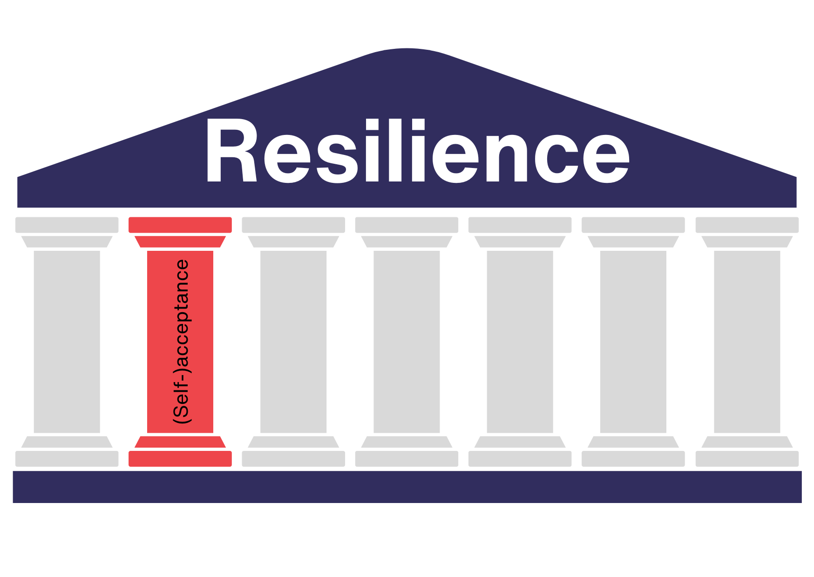
Some things can't be changed. You have to learn to accept that. No matter how much you get angry or how hard you try - it's not in your power to influence everything.
How easy is it for you to accept things as they are? The early morning traffic, the canceled hotel, the long line at the supermarket checkout? Do you manage to stay calm in such moments and not get angry, or do you feel the anger or frustration coming on and perhaps you immediately demonize the whole day? Well - got it? Maybe sometimes we can handle these situations better; other times, when we are more tired or under stress, we struggle more. Resilience helps us also to increase our ability to deal effectively with daily challenges.
Why is it so difficult to accept things that we can't change anyway? The answer to this question is quite simple if you take the time to think about it. We prefer to have things in our own hands. This gives us the feeling of being in control. When we accept things as they are, it feels like we are losing or giving up control over our lives. We admit to ourselves that we can't control everything, and that doesn't feel good at first.
Accepting things that we cannot influence initially feels like a loss of control. In the long term, however, acceptance leads to a happier life.It’s important to learn and know how to stand in the challenges with useful skills to make something positive out of them.
Once you have learned how to accept things that are beyond your control, you will feel better. It will feel like a release from many annoyances and frustrations. You will be calmer and more relaxed and perhaps even laugh at the queue at the supermarket checkout and learn to make the most of early morning traffic. This happens because constantly maintaining control requires a great waste of energy. When we let go, we feel a benefit in terms of physical, mental and even emotional energy. Our thoughts are clearer, our emotions less tiring, and even our bodies function better.
How you can learn acceptance is described in detail in the chapter "The 7 pillars of resilience in practice".
Imagine you work in a care facility and lovingly look after the residents there. You do your best every day to provide the best possible care for the people who live in the facility.
Mrs. Muster was always quite fit and independent. She needed very little help in her everyday life. You get on very well with Mrs. Muster and enjoy using your rare time slots to gossip with her. Suddenly, Mrs. Muster's health deteriorates and she has to be admitted to hospital. After a few days in hospital, she returns to the care facility, but she is no longer her old self. She needs much more attention and care than before and you feel very sorry for her.
If you can accept that Mrs. Muster's state of health is not something you can influence - after all, you do your best for all residents every day - it will be easier for you to deal with her deteriorating state of health.

Pillar 3: Solution orientation
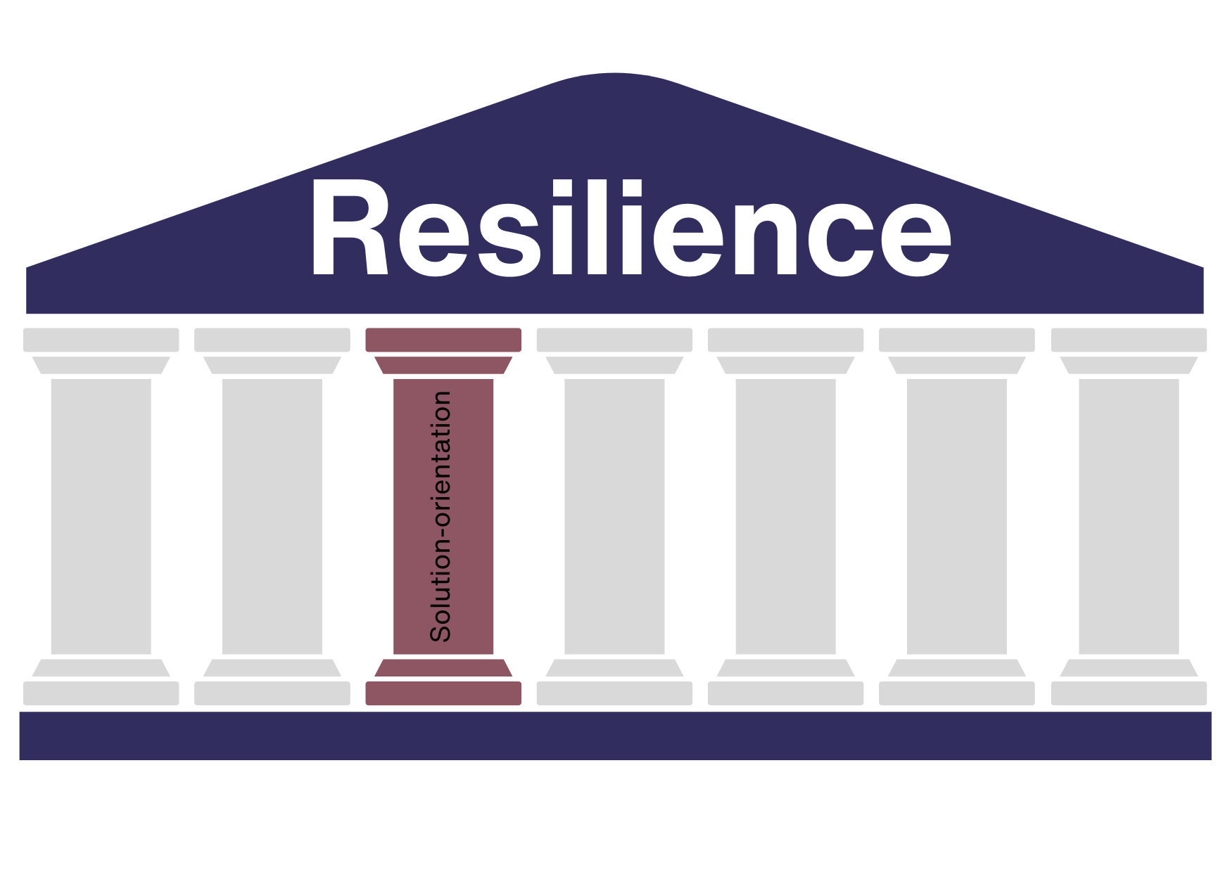
Problems make us dissatisfied. They prevent us from doing our work or achieving our goals. Problems also take up a lot of energy and time. Even if it is not always easy, it is better to tackle a problem and then solve it instead of staying in the problem. Always talking about a problem and not tackling the root of the problem doesn't help.
Unfortunately, this is exactly what we normally do. We toss the problem back and forth, think about it, even outside of working hours, and discuss it with colleagues, friends and family. We look at it from all angles and keep finding new reasons to talk about the problem and get angry about it. We enter a so-called "problem trance" - a state in which our thoughts only revolve around the one issue and we find it difficult to switch off and think about anything else.
When we are in such a "problem trance", it seems impossible to find a solution. It feels as if the problem will always remain and as if nothing will ever change.This also happens because we are often, unknowingly, more focused on finding fault and culprits instead of focusing on what we could do to find a solution.
Solution orientation interrupts this process. If you manage to think about solutions, you break out of the "problem trance". You manage to formulate goals and find ways to achieve these goals and solve the problem. Solution orientation is a very important pillar.
Imagine you work in a nursing home and have problems coordinating with your colleagues and exchanging important information. There are always disagreements about the working plans and duty handovers don't take place well. Instead of getting angry about poor communication and your colleagues, you could think in a solution-oriented way and look for simple ways to improve collaboration. This could mean suggesting to your boss that you have regular team meetings to exchange ideas or that you use digital tools to share information quickly. By taking this positive approach, you can help everyone on the team work better together and improve resident care.
Pillar 4: Self-efficacy / leaving the role of victim
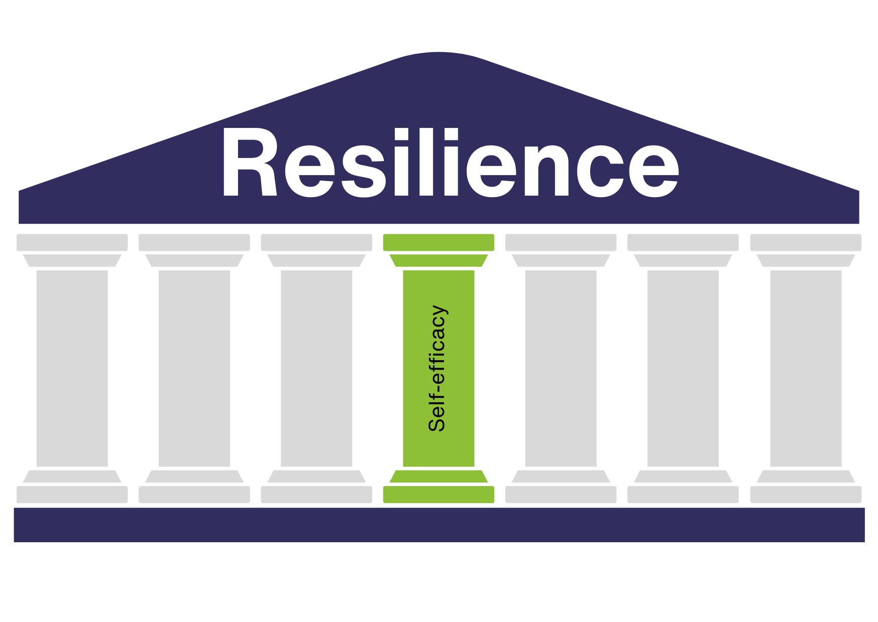
The fourth pillar of resilience is about self-efficacy. But what does that actually mean? What is effectiveness and how can you be effective yourself? And what does this have to do with being a victim?
Self-efficacy means the individual's own belief, feeling and awareness to successfully organize and execute a performance or a task. In other words, self-efficacy means feeling that you can do it, that you can complete a task and work, even if it is hard, feeling that you have the resources to tackle a challenge.
Albert Bandura
What is the link between self-efficacy and victim role? It is a complex discussion but let's try to explain it in simple words. The victim's attitude manifests itself through a variety of behaviors and attitudes such as: the tendency to complain frequently, perceiving situations with excessive pessimism, feeling treated by life and others unfairly, going in search of a culprit.
Self-efficacy, on the other hand, predisposes us to recognize ourselves as responsible in unfavorable situations which we feel capable of dealing with. When we develop such an attitude we don't waste precious time and energy complaining or assigning blame; instead we focus on solutions and resources we can deploy. It is clear that this is possible if we have followed a path of awareness, if we have learned to know and recognize our abilities and if we are able to interpret reality in a clear way. Difficult? Maybe yes, because, as you have seen, we are putting together different pillars. But let's stay calm and remember that everything is trainable.
Do you know moments when you have the feeling that you are always unlucky? Once again you've been given the shift that nobody wants, once again your colleague has passed the stressful patient onto you? Has the boss overlooked you again? This is the victim role. And not the fact that you have the difficult patient, but the feeling that your colleague has passed it on to you. In this situation, you see yourself as the "victim" and your colleague as the "perpetrator".
In this example, self-efficacy would mean that you don't see yourself as a defenceless victim and put up with everything, but that you are convinced that you can change something about your situation. You can say "no" to your colleague. After all, the patient is assigned to him today.
The ability to leave the role of victim is important, but also exhausting. After all, it is much easier to blame others instead of standing up for yourself. But: it pays off. If you are self-effective, you can more easily shape your life the way you want it to be. You are less of a bruiser for others and others are less likely to dump things on you.
The famous poet Johann Wolfgang von Goethe had a wonderful quote to say about this:
"Success has three letters: A C T " - Johann Wolfgang von Goethe

Pillar 5: Taking responsibility
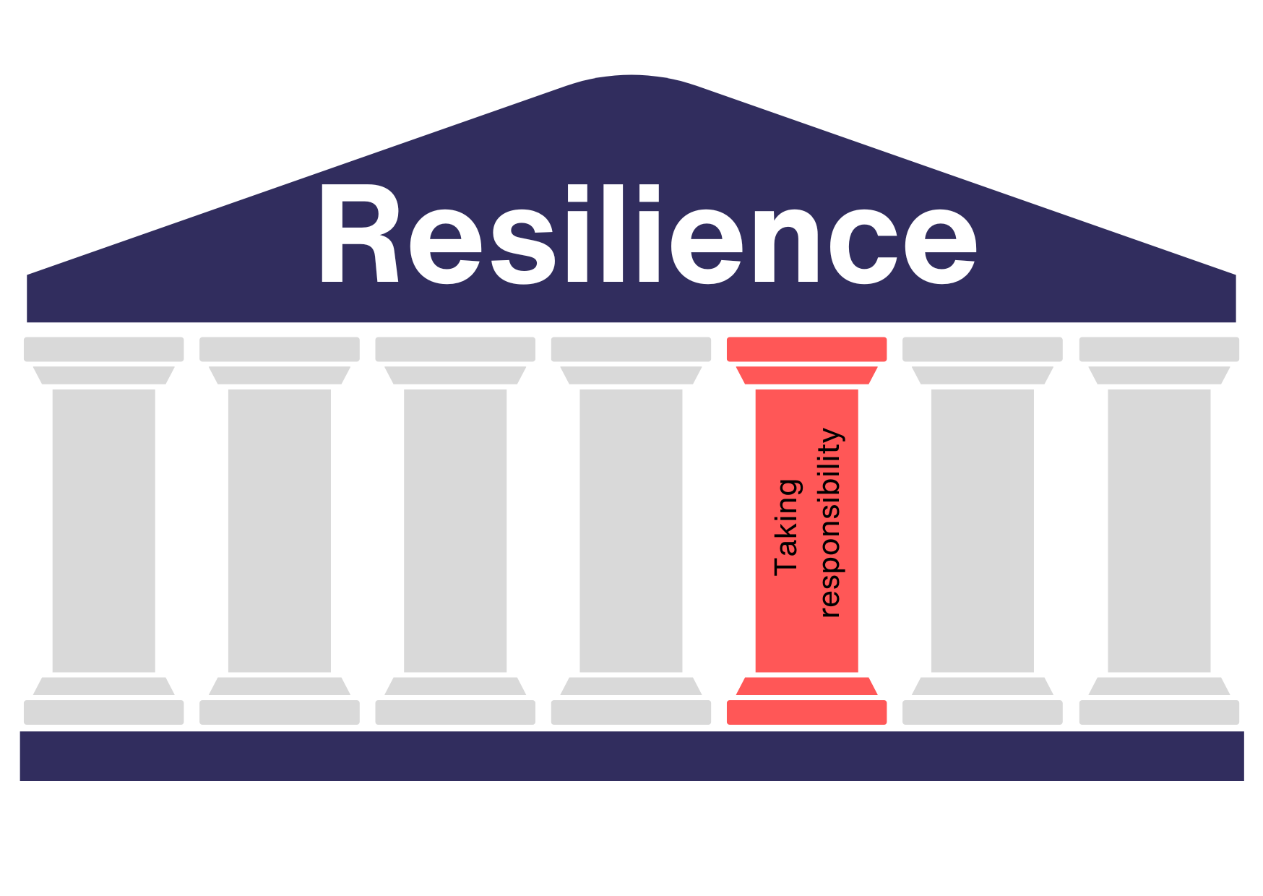
The fifth pillar is about taking responsibility. You could say it's about admitting that it's not always the fault of other people or circumstances that the current situation you find yourself in is not the one you would wish for. This doesn't mean that you should let others pass the buck or that you should blame yourself for everything. It simply means that you have to accept that some things are the way they are. It's up to you to decide how you want to deal with things and move on from here.
You and you alone are responsible for your life. You can decide for yourself how you want to deal with situations and move on. No one can take this responsibility away from you.
This may sound exhausting and not really inviting at first, but it has a great advantage for you. When you take responsibility for your life and don't leave it to others, you regain control over your life.
You are a care worker in a residential care home. Many of the residents are bedridden, so you often have to move them, which is very difficult. You notice that you often struggle with back pain and that you find it harder to get out of bed in the morning than you used to.
Instead of blaming your job or the home management for not hiring more staff or providing suitable aids, you take responsibility for your own health. You go to your doctor and find out what you can do to alleviate your back pain. On the advice of your doctor, you start weight training exercises to strengthen your back muscles. After just a few weeks, you notice that the back pain when moving the residents has become much less.

Pillar 6: Network orientation
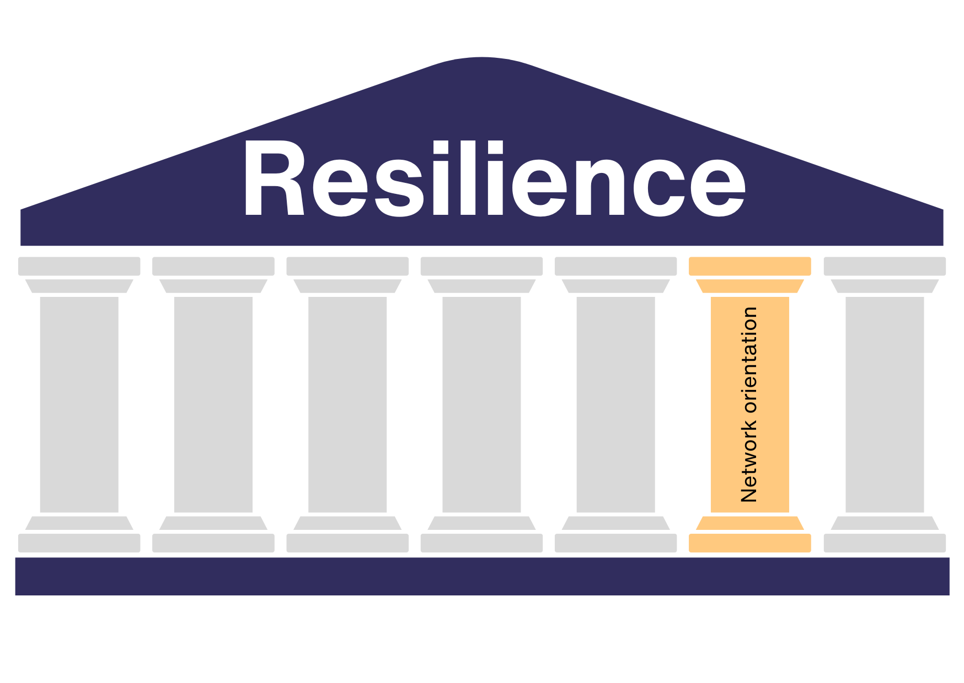
Network orientation means orienting yourself towards your network. In other words, turning to your network. This is typically a social competence that is closely influenced by the pillars examined previously. But what is a network? We are most familiar with this term from the professional world when it comes to "networking" with other people. But the term network also refers to your private network, i.e. the people you like, who you enjoy spending time with and who give you strength. These are your friends and family. Your network - i.e. your circle of friends, your partner and your family - is like a safety net that is stretched beneath you and catches you when you fall.
We can represent networks in different forms; one of the most common is the one shown in the picture. You can visualize your network as shown here. One line leads from you to another person in your circle of family and friends. The better the relationship with these people, the thicker the line. Thicker lines lead to a stable safety net.
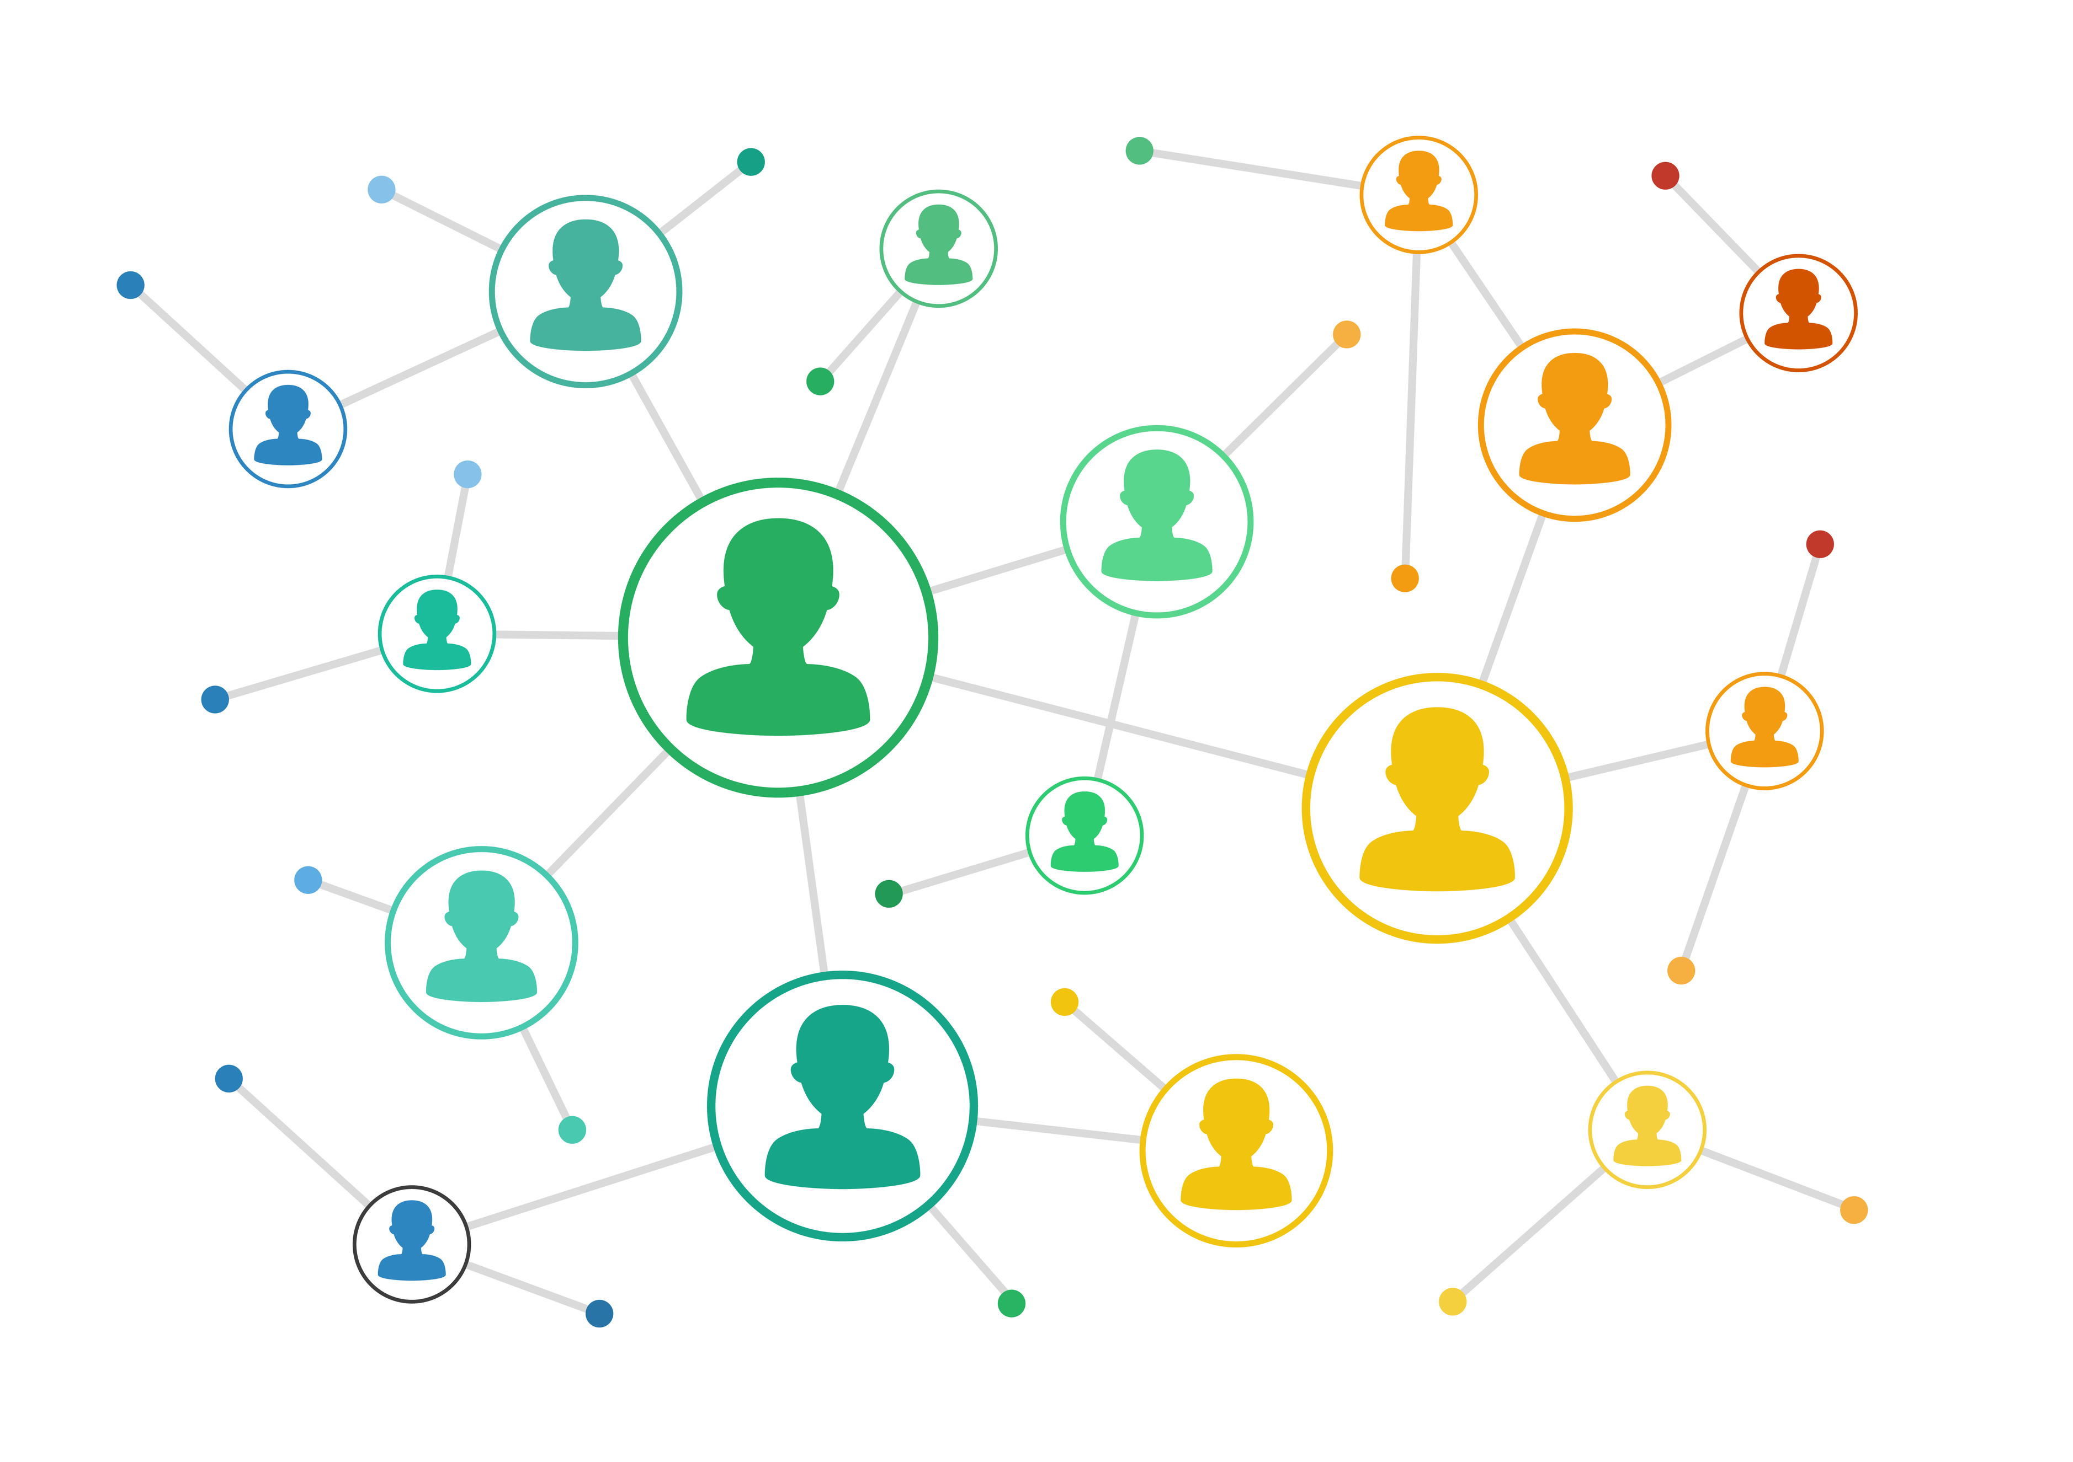
Your friendships and your family are your safety net that catches you when you need it. The better your relationships are, the more stable your safety net will be.
However, the pillar of network orientation not only describes that you should orient yourself to your network when you need it, for example when you need someone to talk to after a long, difficult day, but the pillar also means that it is important to build up a stable network. To build and strengthen your network, you need to invest time and energy in it.
You care for your grandma because she needs help with her everyday life due to her age. Actually, the time you spend with your grandma always goes quite well. Caring for your grandma - especially bathing her - is certainly not easy for you. After all, your grandma has always been a close and strong relative for you. Nevertheless, caring for your grandma is not actually as difficult for you as you expected.
But today was different: in conversation with your grandma, you noticed that your grandma didn't remember your brother's name. It was only after you mentioned the name that she remembered it again. Since then, you have been thinking about it and are worried that your grandma will also forget your name and you. "How will the care work then?" "How will it feel for your grandma?" These and similar thoughts are running through your head.
You call your best friend and ask if he has time for a walk together. During the walk together, you tell him what happened with your grandma today and what your fears are. Your friend listens to you, takes you seriously and finally cheers you up. When you return home after the walk, you feel much better and look ahead with confidence. Your social network has helped you on this difficult day.
To ensure that your network is stable enough to support you when you are not feeling well, you need to strengthen your relationships and keep building new ones. How to strengthen your network is described in more detail in the chapter "The 7 pillars of resilience in practice".

Pillar 7: Future orientation
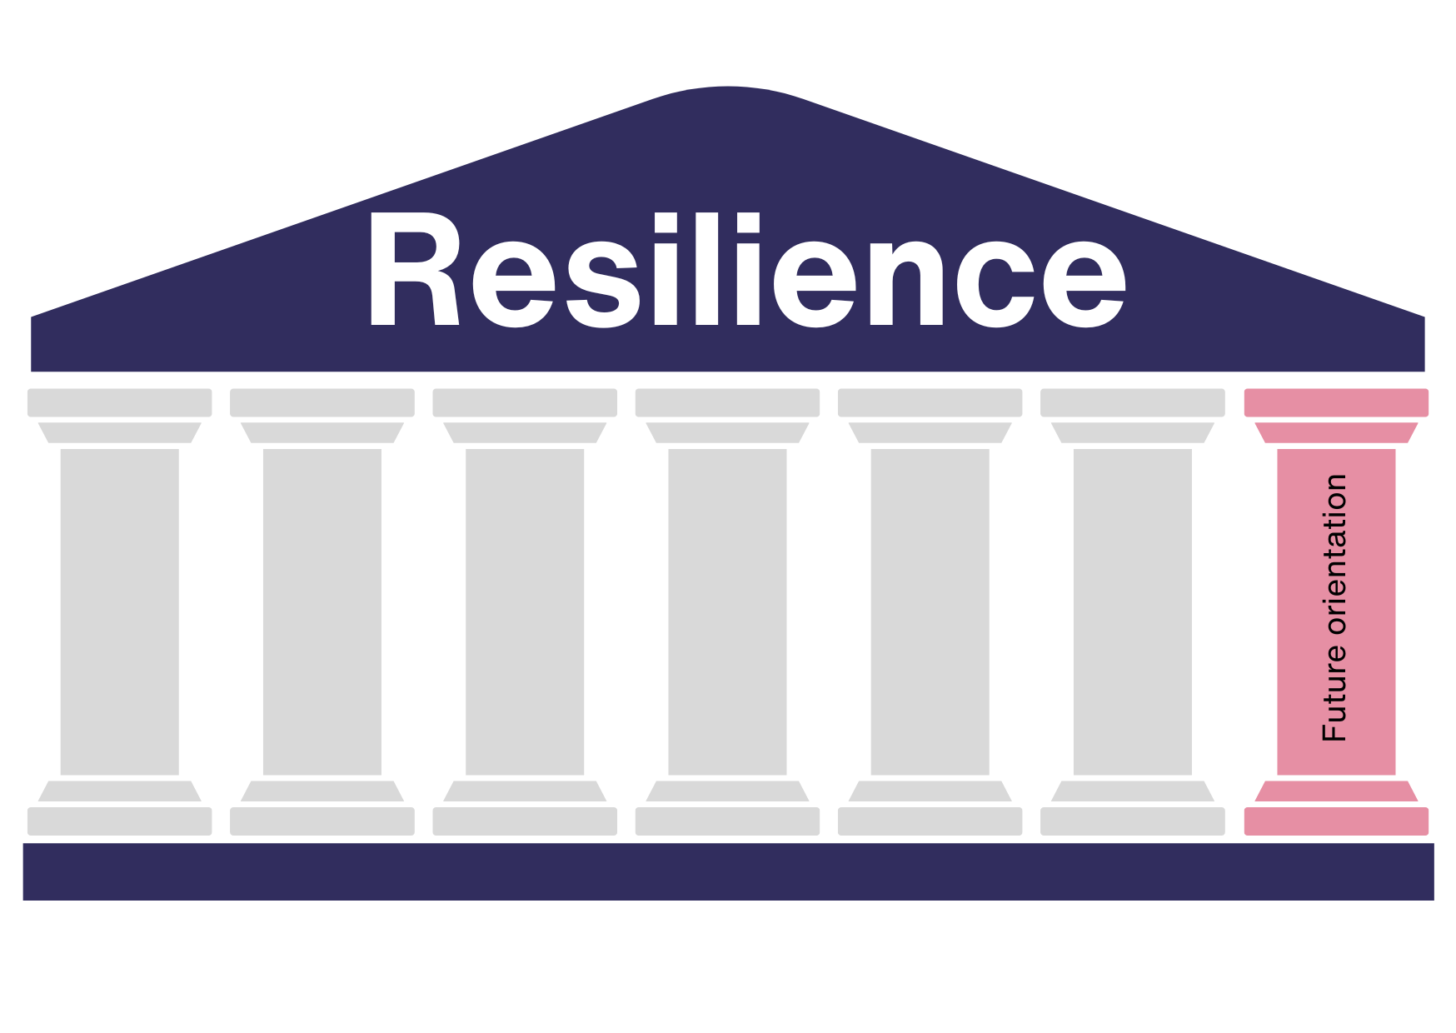
How do you feel about your future? Positive and optimistic? Negative and full of worry? Do you plan your future? Or are you simply waiting to see what comes your way? As you will have understood, this pillar is very interconnected with the one of optimism which, you will remember, has to do with how we read and represent facts and reality.
It is no coincidence that planning for the future is one of the seven pillars of resilience. Even if you obviously can't plan everything that will happen in the future, it is part of resilience to think about the future. What does it mean? It means to imagine the future, having the ability to keep desires and dreams active, developing plans in a creative way, looking at reality as something that we can influence and that we have the possibility of transforming it. It is important to learn how to set realistic goals. These goals should match your own values and abilities.
One way of formulating goals well so that you can achieve them is the SMART method. This involves formulating your goals
- Specific
- Measurable
- Attraktive
- Realistic
- Terminated
The following chapter "The 7 pillars of resilience in practice" describes exactly how this works.
In addition to setting goals, there is one more thing: The ability to be flexible and adaptable. Life doesn't always play out the way you imagine, wish or plan. Especially when you have set yourself goals and planned your life, it can be all the more difficult when something unpredictable happens. When this happens, it is important to be adaptable and to be flexible in shaping your own path so that you can still continue to live well. The pillars of "acceptance", "solution orientation" and "taking responsibility" described above also fit in with this.
Since you have been caring for your father at home, you have realized that you enjoy working in care. You would like to make caring your profession and train as a care assistant. In order to fulfill this plan, you have been saving money for some time so that you can then reduce the hours at your job and have time for the training and still make ends meet.
When you have finally saved enough money, your car breaks down and the repairs are very expensive. So you can't start your training. As you are flexible, you postpone the start of your training for a few months and save up money again in the meantime.
You can achieve your well-planned goal in the end.

Summary
The 7 pillars of resilience are a model that is easy to visualize. Each of the seven pillars carries a part of your resilience. The more you manage to harmoniously develop the different pillars and make them interconnected with each other, the more resilient you are. Each pillar describes a characteristic. You can continue to train these skills as an adult and learn to become more resilient. Being resilient means coping better with everyday challenges and not breaking down. Those who are resilient are better able to deal with difficulties and find a way out of problems.
Here is a brief summary of the seven pillars or seven skills of resilience:
- Optimism: Those who are optimistic believe that all difficulties are temporary and can be overcome. Optimists always try to see the positive side of things and do not focus on the negative. The first step is therefore to learn to look at what happens to us in a functional way: regaining the possibility of acting, of changing what is bad for us and consolidating what makes us feel good.
- Acceptance: Acceptance is about accepting things over which you have no control. You do give up some of your own sense of control, but you can get through life with much less anger and frustration if you can accept that some things are just the way they are.
- Solution orientation: By focusing on possible solutions, you free yourself from the so-called "problem trance". You break through the constant cycle of thoughts surrounding the problem and get into action.
- Self-efficacy / leaving the victim role: With self-efficacy, you assume that you are able to influence things yourself. You don't put up with everything and thus free yourself from the role of victim.
- Take responsibility: Learn to understand that other people or circumstances are not always to blame for difficulties. Some things just happen the way they do. Learn to take responsibility for your own life, because nobody can do that for you.
- Network orientation: The network of friendships and family you have is there to catch you when you need it. You can rely on your network, but it is important to build and maintain this network so that it is stable enough to support you in difficult situations.
- Planning for the future: Don't wait to see what comes at you from the outside, but plan your future actively and take your skills and values into account. If something turns out differently than you expected, be flexible and adaptable.
This chapter has given you the theoretical knowledge of why it is important to train the qualities that lead to greater resilience.
In the following chapter "The 7 pillars of resilience in practice", you can find out exactly how to do this and which exercises you can use to train these qualities.

The 7 pillars of resilience in practice

Introduction
In the previous chapter "The 7 pillars of resilience", you were given a detailed insight into the theory. You learned that the seven pillars are nothing other than seven skills. These seven skills support your resilience, i.e. your resilience, just as the walls of your house support your house. If the seven skills are strongly developed, the pillars of your resilience are stable.
But don't worry: if you thought to yourself while reading "I don't have these qualities" - the qualities can all still be trained and learned in adulthood. So the train has not yet left the station. The chapter "The 7 pillars of resilience in practice" shows you how to do this.
This chapter gives you an insight into the practical implementation and practical benefits of the 7-pillar resilience concept. You will learn how to reflect on your personal resilience and how to do this straight away. You will also read many examples of how resilience can look and be strengthened in your private and professional life. You will learn how you can relate the seven pillars of resilience to your personal challenges.
In order to understand the seven pillars model in practice, it is important that you have read and understood the theoretical part (chapter: The 7 pillars of resilience). If you are unsure, read this chapter or individual parts again before continuing here.

Practical application of the 7 pillars of resilience
We start with a reflection. You will think about a few questions that will show you how your resilience is doing.
Reflection = " thinking, consideration, examining contemplation"
The definition of the word "reflection" shows what is important when reflecting: thinking, examining and feeling. Please be honest with yourself in the following reflection. Only if you're honest and true to yourself, your insight could help you further. Even if you have the feeling that you should actually think differently about a point or a pillar and you don't, please assess yourself honestly. Nobody will know how you have assessed yourself and only if you are honest will you be able to benefit greatly.
Please remember the contents of the chapter "The 7 pillars of resilience" or get the documents to hand. In the following, you will look at each pillar of resilience and think about how this pillar applies to you.
The following reflection has the aim of a self-analysis which can help you to better assess your resilience. The more honest this assessment is, the more this chapter can help you to become more resilient and therefore healthier and happier. Please take the reflection seriously, take enough time and be honest with yourself.
Use the following questions to test yourself. For each pillar you read and answer the questions, choosing the answer that seems most true for you: once you have answered, as truthfully as possible, the questions you can proceed as explained at the bottom of the questionnaire.
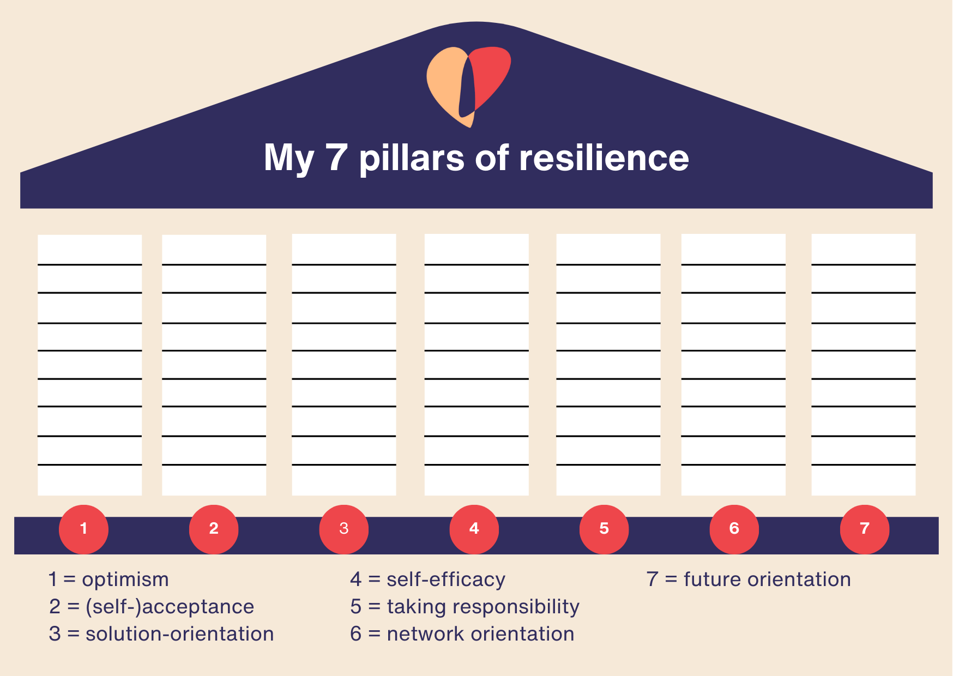

TEST YOUR PILLARS OF RESILIENCE

Optimism | Very much | Quite a lot | A little | Not at all
I am inclined to see challenges as temporary and surmountable
I tend to avoid negative thoughts that cause me anxiety and worry
I quickly focus on the positive aspects of situations

(Self-)acceptance | Very much | Quite a lot | A little | Not at all
A traffic jam in the street or a long queue at the supermarket checkout do not ruin my day
External factors that I cannot influence leave me indifferent
It is easy for me to relinquish control over everything

solution orientation | Very much | Quite a lot | A little | Not at all
I can quickly think of possible solutions when faced with a problem
I can easily think of different solutions to achieve a goal
I usually avoid complaining and having thoughts of recrimination, judgement, accusation, grumbling

self-efficacy | Very much | Quite a lot | A little | Not at all
I believe that my value and role are usually recognised
I tend to avoid judgement on myself
I have confidence in myself, in my strengths and that I can achieve anything I want

taking responsibility | Very much | Quite a lot | A little | Not at all
I consider myself responsible for my life
I can avoid blaming others for situations in my life
I actively deal with problems and take responsibility for them

network orientation | Very much | Quite a lot | A little | Not at all
I have people around me with whom I can talk about difficult situations
I can count on a support network
I invest time and perseverance in maintaining relationships with the people in my network

future orientation | Very much | Quite a lot | A little | Not at all
I like to think about what might happen in the future
I actively plan my future with concrete plans and goals
I think I am flexible and adaptable to manage unforeseen circumstances
Very well. You have thought about and chosen your answers. Now it is a matter of displaying them on the graph: assign a score of 0 for the answers ‘Not at all’; 1 for the answers ‘A little’; 2 for the answers ‘Quite a lot’ and 3 for the answers ‘Very much’. For each answer to each question, colour the levels in the corresponding pillar column (e.g. if to the questions in the Optimism pillar I answered: 2 times very much (score 3+3) and 1 time quite a lot (score 2), I will have scored 8 and will then colour 8 levels); this will result in a bar graph useful for visualising your level for each resilience pillar and for understanding what you need to train more:
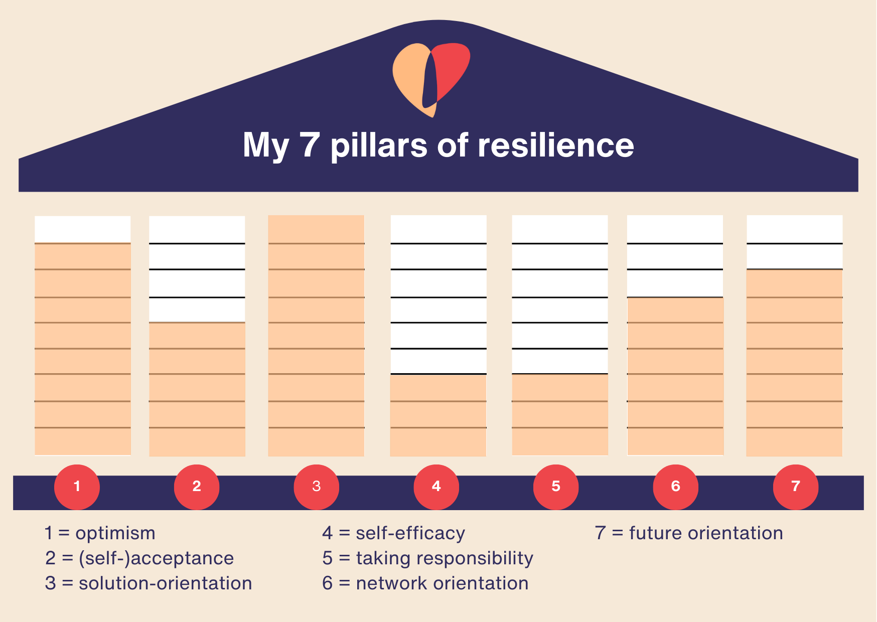
At the end of this task, reflect again on the overall picture: take a look at your pillars: Which ones are well filled? Which ones are less well filled? Are there any that are not filled at all? Is there anything that surprises you when you look at your pillars?
Give yourself a break before you continue. If the the self-analysis task made you feeling exhausting: that is normal. Intense self-reflection can be very exhausting and tiring. But don't give it up - it will help you move forward.
But what does this mean for you and your resilience? Remember: each pillar represents a feature that contributes to resilience: the self-analysis helps you to understand which skills you can strengthen through real training. If the pillars are well filled (you can see this from the fill level marked on them), they are strong and your "resilience house" is virtually standing on stable pillars. If you have the picture of your pillars in front of you, you can see very clearly which characteristics you can still train to become (even) more resilient.
Work primarily on the characteristics that are not yet well developed in you, i.e. whose pillars are very poorly filled. The better the pillars are filled, the more stable your resilience will be.

Integrate the 7 pillars of resilience into your daily life
Now that you know what your personal pillars are and which ones you should strengthen, let's take a look at how you can specifically strengthen the pillars or characteristics that are not yet strongly developed. Below you will find some examples that will show you how you can strengthen your pillars both in your private life and in your everyday care routine.
Through the examples you will read, you will also learn how you can relate the seven pillars to personal challenges and what concrete solutions can be proposed for these challenges.

Strengthen the seven pillars in your private life
Below you will find examples from everyday life in which you can train different characteristics or pillars.

Optimism
Train yourself with one of these exercises:
- buy a small notebook and every evening write down at least three good things that happened to you or that you saw during the day. Fill in the notebook for at least 21 days and then re-read it
- when some unpleasant event happens, even a small one, take three minutes and go in front of a mirror and try to recount to you reflected image the event, trying to bring out the irony and humour
- find an ally (a friend, a relative, a colleague) and ask him/her to be your buddy for a week. During this week, the task is to send him/her a positive thought every day (via message)
Imagine you have had a long day. It was exhausting. You are tired and exhausted. Consciously take a few minutes and think until you can think of three things that were positive about the day. These can be small things, such as the good lunch or your daughter's smile in the morning.
Focusing on the positive helps you to become more optimistic in the long term.

Acceptance
Train yourself with one of these exercises:
- For the next 10 days, every time something happens to you, Imagine that you are a traffic light. Imagine you turn green if the event is totally under your control, yellow if you can only partly exercise control, red if you have no control at all. If you turn on red, let the event pass you by.
- Every morning, for 21 days, try to write on a post-it note at least one thing about the day that is about to begin that you choose not to control and to let go as it goes. Stick the post-it in a visible place.
- For the next week, take on the task of doing breathing exercises as mentioned in the example whenever you are in traffic, receive an unwelcome phone call, or in other unpleasant situations
The next time you are stuck in a traffic jam and get annoyed, stop and ask yourself: "Is there anything I can do to change this situation? What is the point of getting angry about it?". These questions will show you that there is nothing you can do about the situation and that there is no point in getting angry about it - this realization is a good start.
To release the pent-up anger in your body, you can do a simple breathing exercise: inhale for 4 seconds - hold your breath for 4 seconds - exhale for 4 seconds - pause for 4 seconds. Then start again from the beginning. Repeat the breathing exercise ten times - you will see that your anger about the traffic jam has dissipated.
This example shows how you manage to accept things over which you have no influence.

Solution orientation
Train yourself with one of these exercises:
- For the next week, whenever you are faced with a problem, take a blank sheet of paper and start writing down all the possible solutions you can think of to solve the problem. You must come up with at least 2 r 3!
- These days you seem to have problems without solutions? Look for a buddy and tell him that you appoint him as a consultant problem solver for the next ten days. Turn to him whenever you feel like you are at a dead end.
- Do you like drawing? This exercise is for you! When a problem arises in the next week, stop 10/15 minutes, take out a sheet of paper and try to draw your solution instinctively, maybe while listening to your favourite music...have fun!
The next time you realize that you are in a "problem trance" regarding a relationship argument with your partner and have been thinking for days about why your partner said this or that, how mean he/she was to you and how much the argument escalated, do the following.
Take a blank sheet of paper and start writing down all the possible solutions you can think of to make the relationship better again. This way, your thoughts will no longer revolve around the problem, but rather how you can solve it together. Possible solutions could be
- You seek a conversation with your partner and tell him/her that you want to settle the dispute and look to the future
- You suggest three things to your partner that you could do together to strengthen the relationship again
- You want to relive the fun you used to have together and are thinking about a surprise visit to the cabaret
- You google what couple exercises there are so that such arguments no longer occur in the future
- You write your partner a letter in which you give him/her 10 reasons why your relationship with him/her is wonderful and why you love him/her
No matter which solution you ultimately decide on: You have strengthened your solution orientation skills by thinking of different solutions and writing them down.

Self-efficacy / leaving the role of victim
Train yourself with one of these exercises:
- Every evening for the next 21 days, write one of your skills on a post-it: anything you know how to do (cook, drive on the motorway, fix appliances, dye your hair...). Stick the post-its in a visible place and as they increase in number you become aware of how good you are!
- Again, look for an ally, possibly someone who works with you. Ask him to text you every day (for a week) with positive feedback about what you do well. Keep the messages and reread them often
- Every evening, for the next 21 days, before going to sleep think about at least 2 good results you have achieved in your day (in any area of your life)
Perhaps the following situation sounds familiar to you. You have the impression that you have to do everything in the household on your own. Your partner or even your children don't help you with daily chores such as cooking, cleaning, washing, tidying up or childcare. One day it becomes too much for you. Instead of feeling sorry for yourself and thinking about how much work you don't have to do, you can take action and break out of your victim role.
Ask your partner to talk to you and share your feelings and stress with him. Your partner may not even be aware that you need support. Draw up a concrete plan that divides up which activities you will take on and which your partner will take on in the future.
This example shows how you can become self-effective, stand up for yourself and leave the role of victim behind.

Taking responsibility
Train yourself with one of these exercises:
- Keep a daily journal for one week where you document situations where you had to take responsibility. Note what actions you took, how you felt about it, and the outcomes. Reflect on what you could have done differently and how taking responsibility affected the situation.
- Create a "Responsibility Ladder" with different rungs representing levels of responsibility, from blaming others to taking full ownership. Identify where you currently stand on the ladder in different aspects of your lives (work, relationships, personal goals). They create an action plan to move up the ladder.
- Creat two maps for a given situation: one where you took responsibility and one where you avoided it. Map out the short-term and long-term consequences of each choice on yourself and others. This exercise helps you see the broader impact of your actions.
Have you perhaps been suffering from back pain for years? Or do you have a few kg too much on your ribs and realize that you are not feeling well? Or have you wanted to stop smoking for a long time? You may blame these or other similar problems on stress, your job or a lack of financial resources.
But now that you have already learned in this course how important it is to take responsibility for your own life, you can finally do so. See a doctor, check your state of health, get help to stop smoking or tips from a nutritionist.
The conscious decision to take responsibility gives you the impetus to take action. Of course, it won't be easy and your personal problems won't disappear overnight, but you'll see that you'll feel better in the end and you'll be proud of yourself.

Network orientation
Train yourself with one of these exercises:
- Take a sheet of paper and visualize your network for yourself. Draw a circle for yourself in the middle and then give each person who is important to you in your life a place on the paper. Also think about how strong your relationship with this person is and which relationships you should strengthen again. Draw the lines between you and the people accordingly - strong lines for people with whom you maintain close contact, light/bright lines for the people with whom you realize that you would actually like to have more contact. Stick this network sheet in a visible place of your home, with the intention of updating and modifying it as the relational dynamics change
- For the next 7 days, make a commitment to send a message of gratitude every day to some of the people close to you. Gratitude is the best tool for strengthening relationships!
- Next weekend is approaching: plan to go out with someone you haven't seen in a while and who you want to include again in your network of relationships
Now that you know how important your networks are and that it is important to maintain and intensify them, take a sheet of paper and visualize your network for yourself. Draw a circle for yourself in the middle and then give each person who is important to you in your life a place on the paper. Also think about how strong your relationship with this person is and which relationships you should strengthen again. Draw the lines between you and the people accordingly - strong lines for people with whom you maintain close contact, light/bright lines for the people with whom you realize that you would actually like to have more contact.
Now take a look at your network and pay particular attention to the light-colored lines. Now think about what you can do to make these lines strong too. For example, have you not seen your best friend for two weeks but would actually like to see her more often? Then it's best to call her right now, arrange to have coffee together or invite her to your home.
Consciously activate and strengthen your network. You will see: It will do you good!

Future planning
Train yourself with one of these exercises:
- Tonight take 15 minutes and think about what you have already mastered in your life. Think about the situations in which you have been flexible and adaptable. Write down a few examples and stick the list in a visible place.Day by day you can change and update it.
- Ready for the weekend? Invite a friend out with the aim of telling him/her your plans and dreams for the future. To avoid failing in this aim, let him/her know in advance that the topic of the meeting will be future projects!
- Are you always the one who loves drawing? Well: in the next few days, take a large sheet of paper and lots of colors, turn on your favorite music and paint the picture of your future. Free your fantasy, imagination, dreams and everything that instinct brings to paper!
Take 15 minutes and think about what you have already mastered in your life. Think about the situations in which you have been flexible and adaptable. Write down a few examples.
Writing this down will show you that you are capable of taking action, that you are in control of your own life and that you have certainly managed to react well to the unforeseeable on a number of occasions.
Keep this list in a safe place. The next time you are faced with a situation in which you have to react flexibly and adapt to certain situations, you can look up how often you have succeeded in doing so. This will give you the confidence that you will also succeed in the new situation. This confidence is an important part of the future planning pillar.

Strengthening the seven pillars in day-to-day care
The examples from your private life are now followed by specific examples for your day-to-day care work. These also show how you can specifically strengthen the qualities that contribute to resilience. Perhaps one or two of these situations look familiar to you because you are already doing certain things. If not, be brave and implement the new things or tell your colleagues about them to become more resilient as a team!
Also remember that all the exercises we have suggested above can also be applied to your care work: they constitute a real toolbox for training the 7 pillars in your private and working life.
When you get use to train with your toolbox, then try to turn these exercises into habits, into practices, norms and even procedures, just like those you follow when dealing with workflows. This is important as, for any training to become consolidated and ingrained in our lives, it must become a standard.

Optimism
A hospital team starts each team meeting with each colleague saying one thing that has gone well recently. Sandra reports that she has recently been able to switch off well in the evenings after work. Johannes says that his training was very exciting. All 12 colleagues say positive things - you quickly notice how the overall mood in the team is improving.
Could this also be a good way for your team to focus more on the positive things together and thus become more optimistic? Why not give it a try at your next team meeting? Why not fix time in meeting agendas, even as little as 10 minutes, to tell each other what works and to exchange positive thoughts?

Acceptance
In your work in a nursing home, you encounter many different fates every day. It's not always easy not to worry about them and fall into a state of worry or frustration. Here is a practical tip on how you can improve your acceptance pillar:
Use times when you have short rest periods, such as the elevator ride, or when you are sorting care needs to actively think about which cases, which patients and which fates you can and cannot change. For those where you can't change anything yourself anyway, practice acceptance. For example, you could say to yourself: "There's nothing I can do about my colleague Maria's sick leave. But I can accept that this is the case." Or: "I can't do anything about the deterioration in Mr. Maier's health, I can support him as best I can, but I have to accept that his illness is progressing."
The first time you say a sentence like this out loud, it will feel unfamiliar and perhaps even strange. Keep at it, practice - it will get easier and help you to accept things as they are.

Solution orientation
Perhaps you have already experienced the following situation in your team: when scheduling shifts, it must be taken into account that a colleague still has to work off overtime and vacation before the year comes to an end. Some colleagues are upset about this, after all, it's not their problem that he hasn't used up his vacation yet, your boss should have coordinated this better. The complaints about this have been a topic for days and have been discussed repeatedly in the break room, in the corridors and in the elevator.
What can you do in a situation like this? You can either join in the scolding and think negative thoughts, or you can think of solutions. Suggest, for example, that you work together as a team to compensate for your colleague's absence so that a few people don't have to cover for everything. You can also suggest that you make more joint vacation plans for next year so that this doesn't happen again.
Solution-oriented suggestions can get you and entire teams out of the "problem trance". Give it a try the next time you are faced with a challenging situation.

self-efficacy / abandon victim role
Are you caring for a close relative at home? Do you have to manage the care alongside your actual job, household chores and childcare? Then you may be familiar with the feeling that you often feel left alone and overwhelmed.
What options do you have now? You can be content with your role as a victim. Instead of feeling like a victim of your circumstances, you can also decide to take action yourself to improve your situation. Talk openly to your family and friends about your feelings and let them know that you need support. This may allow you to hand over a few tasks and give you a little more time and breathing space.
And rest assured - you are not the only one in this situation. There are certainly enough people around you who are in a similar situation. Search the internet to see if there is a local group for family caregivers in your area that meets regularly. Or look for online groups in social networks that discuss the difficult everyday life with care, job and co. Take a look at the Resil4Care project (https://resil4care.eu/), for example! This project has led to the formation of Facebook groups with carers across Europe who are constantly exchanging information. You can learn a lot from the experiences of others and won't feel so alone in this difficult situation.

Taking responsibility
Put yourself in Christian's shoes - perhaps you have experienced something similar yourself.
Christian works at the hospital. He notices that he has been very weak recently and thinks it is because his working hours have been very different lately. He has recently been working a lot of night shifts and then also long day shifts. He hasn't had several days off in a row for a long time due to sick leave and vacations in the team. Christian decides to take responsibility for himself and his health and seeks a conversation with his boss. He explains to her honestly yet respectfully how stressful the last few weeks have been for him. His boss is sympathetic and arranges his shifts for the next month so that Christian can sleep and rest regularly. He even has five days off in a row, which he uses to go for walks and actively regenerate. In this way, Christian manages to regain his strength. He is well prepared for the following night shifts.
Of course, it's not always that easy and you get a roster that gives you 5 days off in a row and leaves you that much time to regenerate. But the very fact that Christian is seeking a conversation with his boss and talking to her about his situation shows that he is taking responsibility for himself and his situation. Even if he hadn't been given a few days off, he would still have tried to do something about it.
Have you ever been in a similar situation yourself? Have you also taken responsibility for yourself? Or did you keep your feet still even though you were not feeling well?

Network orientation
Do you think you know all the different ways to relax? Or do you know which offers there are in your area that could help you to relax? Such as yoga or Pilates classes? Or joint running groups? Or maybe a singing group is the right thing for you to relax? Even if you think you already know all the options, this may not be the case. Use your network to get information about offers or just to exchange ideas about what helps others to relax. Maybe there's something you don't know yet that you like.
Actively approach colleagues, friends and acquaintances and ask what they do to wind down after a stressful day at work. Perhaps your colleague goes to a yoga class where there is a monthly "bring-a-friend" campaign that allows you to get a taste of yoga. Or maybe your best friend has been thinking for a long time that she needs something to relax but doesn't want to start a creative workshop on her own.
Activate and maintain your network!

Future planning
The future can also be scary in the care context, even if you have been working as a caregiver for years. Sometimes it's not the care itself, but something else in your professional environment, such as a change in your employer's documentation system. It can happen that you are confronted with something completely new from one day to the next and even as an experienced caregiver you still have to learn something new. How do you feel about this? How have you dealt with this in the past?
Take a piece of paper and think about your last few years as a caregiver. There must have been one or two challenging situations, right? And you certainly mastered them well! Write down these challenges and praise yourself!
And now think about the future. What could happen in your working environment that could present you with challenges again? Could you perhaps even imagine driving change yourself? Perhaps through professional development with new training? How do you feel when you think of such situations? If the idea of the future scares you, take another look at the piece of paper with the challenges you have already overcome. You will see that you immediately feel more optimistic.

Summary
Quite an intense chapter, isn't it? The self-reflection at the beginning gave you a lot to think about and "critically review". You have reflected on each of your personal pillars and now have a visible picture of your resilience in front of you. This reflection has taught you a lot about yourself. Perhaps there was something about the finished pillar picture that surprised you or that you hadn't expected.
Reflecting or thinking about yourself can be exhausting and tiring. It's okay if you don't enjoy it or if it's unfamiliar to think about yourself so intensely. It's also okay if feelings come up that are unpleasant or if you are unhappy with yourself in one way or another. After all, you are working on yourself and your qualities. If you keep at it, over time you will be able to strengthen your pillars or characteristics in such a way that you will also enjoy reflecting more. Your whole life will feel easier because you will become more resilient. Keep at it!
By reflecting on your pillars, you know exactly what you can and should work on.
Many examples gave you practical insights into private life and everyday care, showing you how the pillars can be specifically improved and strengthened.
Read the examples over and over again. This will reinforce them in you. Think for yourself: What other examples can you think of from your personal private life or everyday working life? Or can you think of situations in which you could have used something from what you have just read?
You are also welcome to talk to your network about the content and examples in this course. This will strengthen your network pillar and at the same time you will get ideas and examples from the people in your life.

Perspective on fragility in the context of resilience in care

Introduction
You have already read a lot about resilience in care in general, about risks and protective factors, about dealing with stress and much more. However, there is another factor that should not be ignored when it comes to resilience, especially in the care sector: the issue of fragility.
This chapter deals with the topic of fragility and explains why dealing with fragility can be challenging, especially in the care sector. You will also read why you as a carer can also be affected by fragility and how one can learn to manage it so that it can become an opportunity for personal growth and evolution. It will look at how resilience can, through the training of life skills and the 7 pillars, become an opportunity to stand in fragility by making it something good for us and a way to increase our wellbeing.

Understanding fragility
Fragility means " frailty", in a figurative sense also "tenderness". In medicine, the term is used to categorise biological structures (bones, chromosomes, etc.).
Fragility therefore means frailty. Fragility is not a definitive state (nor is it a structural one), but rather a condition that can evolve and change over time. For old people and people in need of care in particular, this specifically means that their health is less stable than that of other people. Internal and external factors play a part in this. Older people and those in need of care often lose body weight, suffer from exhaustion more quickly and experience feelings of weakness more often. Impaired mobility and muscle atrophy are also more likely to occur.
This information should not be new to you. After all, you are confronted with it every day. But did you know that you as a carer can also be affected by fragility? In your case, this fragility means the high level of stress you are exposed to in your everyday work or in your day-to-day caring activities for your relatives.
In 2020, the University of Bremen scientifically analysed data from the care statistics for a current report. The researchers Prof Rothgang, Dr Müller and Mr Preuß came to the following conclusions:
- 92% of carers in the geriatric sector often work standing up - in other professions only 47% often work standing up
- 76% of these carers report frequent heavy lifting and carrying - in other professions 15%
- 45% often work in constrained postures - in other occupations 11%
- 52% reported that they often have requirements in terms of minimum performance or specified time for certain work - in other professions 27%
- 63% are often under deadline and time pressure - in other professions 39%
- 53% state that they often have to work very quickly - 39% in other professions
- 31% state that they frequently work to the limit of their capacity - in other professions 16%
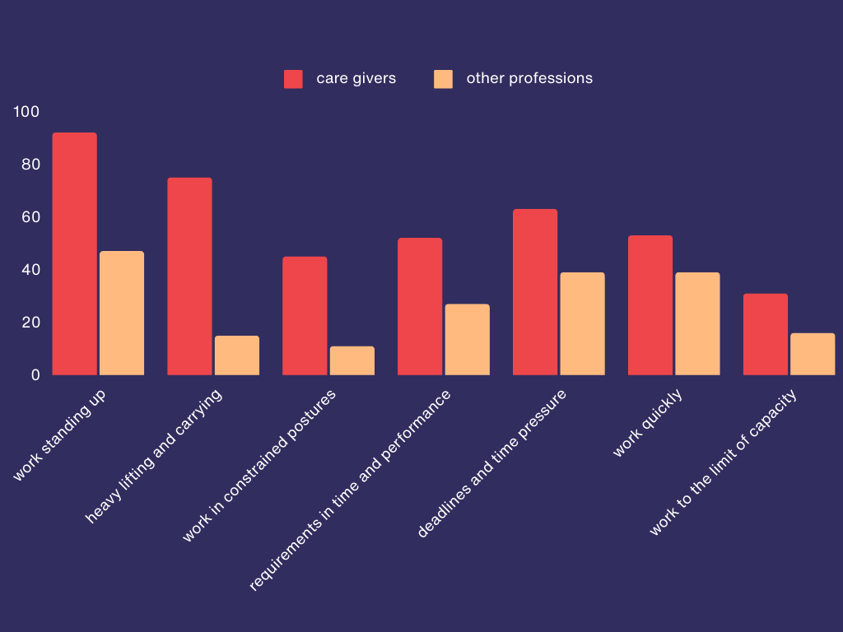
If you look at these burdens, it is no wonder that the data on sick leave in the care sector is also higher than the data for other professions. The researchers analysed survey results as well as hospital stays, absences, outpatient diagnoses and medication prescriptions of people in geriatric care and came to the conclusion that musculoskeletal disorders and mental disorders occur more frequently in this group than in people in other professions.
The musculoskeletal disorders are particularly obvious when you look at the stresses listed above. However, the increased incidence of mental disorders is also obvious when you consider that time pressure and stress, workload, staff shortages, irregular working hours, lack of appreciation and the constant confrontation with illness and death are all part of a carer's everyday life. These topics have been and will be described in more detail in the other chapters of this course.
People who work in the care sector are exposed to higher levels of stress than people in other professions. This involves both physical and psychological stress.

Strengthening resilience and preventing fragility in the care sector
So how can you prevent challenges and stay as healthy as possible in your job? It will no doubt come as no surprise to you that the word resilience comes up again at the point. Resilient people are able to sustain the stressors in a flexible, agile and situationally appropriate way by drawing on internal and external resources and protective factors, to change and transform themselves and to emerge more balanced from crises and use them as an opportunity for personal growth and individual development.
Precisely because your care work is more physically and mentally stressful than other professions, it is particularly important for you to take care of your level of resilience.
How exactly you can strengthen your resilience is described in many chapters of this course (see The 7 pillars of resilience in practice, Exercises to strengthen resilience and self-care, 21-day challenge for resilience). Read these chapters particularly carefully and apply the exercises and methods described in them consistently in your everyday life to train your resilience.
The areas of self-care, social support and mindfulness are particularly important for building your resilience, also in regard to frailty. These are other tools that, together with life skills and the 7 pillars, can implement your 'equipment' to handle fragility and to become more and more capable of turning critical issues into opportunities. This is the key to well-being.That’s why we take one more time a closer look at these three areas.


Self-Care
Self-care means treating yourself with love and appreciation, taking your own well-being and needs seriously and actively contributing to your own wellbeing.
If you look closely at this definition, you can see that self-care consists of two parts. Firstly, your own attitude towards yourself, which should be appreciative and loving. Secondly, self-care also consists of active behaviour. This active behaviour should fulfil the purpose of ensuring one's own physical and mental well-being. By taking good care of yourself you can actively prevent yourself from frailty.

Social support
Social support is the interweaving of relationships with which it is possible to have an exchange on different levels: informative, emotional, and material. It depends on the quality and quality of our relationships.
Social support is therefore what you exchange with your social environment, your network. Friends, family, colleagues, etc. have a positive effect on you by providing you with support that helps you to resolve a particular situation better than without this support.
- Emotional support can be a conversation about feelings, fears and worries.
- Material support would be the sharing or lending of money, tools or household goods, but also support with childcare.
- Informal support includes providing information about resources or giving advice.
It has been scientifically proven that social support has a positive effect on people's wellbeing (including older people or those in need of care). People are better able to overcome strokes of fate or illness and are more likely to survive if they have good social support. In any case, the quality of support is more important than the number of people providing support.
Simone is a carer. Her best friend Anna always has an open ear for Simone. She regularly looks after Simone's son when Simone has to work. The two of them go on holiday together for a weekend every other year and are always there for each other. Simone can always rely on Anna. Their friendship is a quality social support for Simone.

Mindfulness
Mindfulness is both an approach to life and a specific meditation practice centred on awareness of personal present experience. It describes a state of completely conscious presence of mind, i.e. the conscious perception of the present moment - without any judgement.
Being mindful means that you are in the here and now and completely present in your mind. For your everyday life in caring, this means that you concentrate on what you are doing at the moment. Patients can sense when your mind is completely elsewhere and you are only doing your current activity on the side. If you manage to be in the here and now with your thoughts and thus with the person you are caring for, you and the person you are caring for can be calmer and more relaxed.
A mindful attitude leads to a kind of alert serenity that gives you a certain room for manoeuvre. You can decide more clearly what and who you pay attention to and for how long. For example, you can decide to listen to someone for a minute longer. Consciously, without it just happening, but because it is important to you at that moment.
This effect has been scientifically proven. Studies have shown that patients are more satisfied when they are cared for by carers who have completed courses and training on mindfulness. Carers who had attended mindfulness courses suffered fewer falls, made fewer medication errors and had fewer aggressive incidents in the months following the course.
Take a moment to consciously reflect on how you are doing in your life in terms of self-care, social support and mindfulness. Be very honest with yourself. You may want to write down your thoughts.
Only if you know where you still need to catch up can you select and apply specific exercises from the other chapters.
It is important that you do this: once you know in which areas you can still improve, choose from the many exercises in the other chapters those that help to strengthen the respective areas and do these exercises regularly and integrate them into your everyday life.

Health promotion and prevention of physical fragility
You have already read that carers are exposed to greater physical and psychological stress than people in other professions. The previous chapter explained how to strengthen resilience through psychological and social skills.
But there is another issue to be considered: as human beings, we are a whole of body, mind and spirit, connected to each other. This perspective invites us to consider a person's wellbeing in its totality, which is why it is now also important to delve into the aspects related to the physical body.
This chapter focuses on your physical health and the prevention of physical fragility. The buzzword here is "health promotion".
Health promotion is generally understood to mean measures to increase and strengthen people's health potential.
Heavy lifting and carrying, long periods of standing, long shifts and night work. This is all part of the daily routine of carers. It is obvious that these factors can lead to physical complaints and have a negative impact on the health of carers. All of this has already been mentioned above.
It is therefore obvious that people in the care sector should take preventative care of their health. Strengthening the musculoskeletal system is an important part of this. Each of us can reflect on what kind of physical training we are best suited for. There will be those who love walking in nature, those who take a Pilates or yoga class, those who don't miss swimming in the pool or the evening dancing. Whatever your inclination, it is useful to learn to listen to yourself to understand what your body and mind needs.
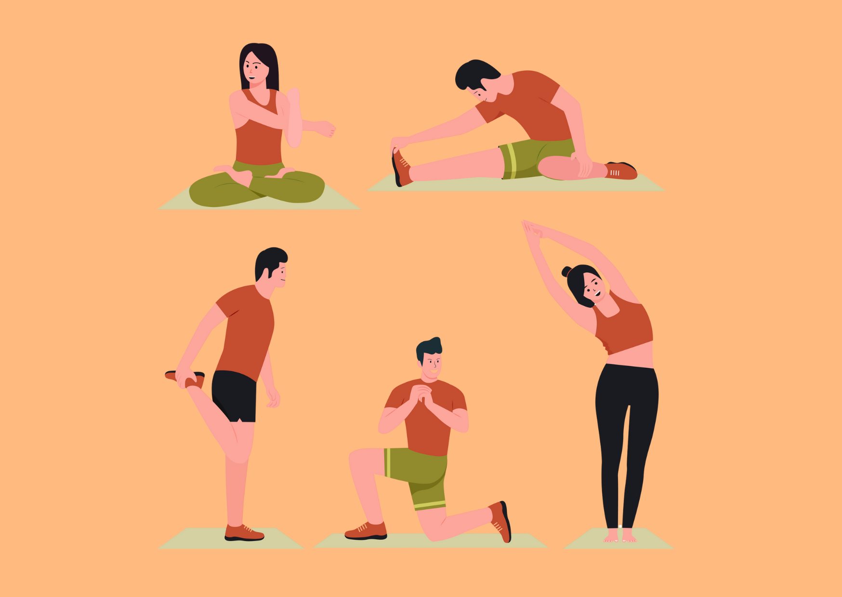

Here below we give some easy hints for those who want to try and have fun with some simple exercises: they can become small habits so that we do not forget to take care of our physical body during our working day!
The following examples can help you to strengthen your body:
- The foot rocker: Stand with your feet hip-width apart and slowly roll from your heels onto the balls of your feet and back again. Do this for about a minute. Advanced users can stand on their toes in between and then roll off again. This exercise stimulates blood circulation and is helpful if you walk a lot during your working day.
- Stand on one leg: Bend one leg and place the foot of the bent leg on the knee of the supporting leg. Try to hold the position for as long as possible. Advanced users can also close their eyes, bring their finger to the tip of their nose or do similar things. This exercise trains your sense of balance and coordination.
- Neck stretch: Stand upright or sit upright. Slowly turn your head to the right as far as possible, then back to the centre and then to the left. Your hips should rest on your thighs or hang quietly downwards. Turn your head three times in each direction. You can alternate by lowering your head to your sternum and then resting it on the back of your neck.
- Relieve the strain on your back: keep stretching out in between, stretch your arms in the air, stand on your tiptoes. Push your pelvis forwards so that your body makes an arch. Bending forwards also has a relieving effect. Stand up straight, first lower your head and then your upper body forwards until your fingers touch your toes. The more often you do this, the easier it will be for you to move forwards.
You can integrate these exercises into your everyday working life. You can incorporate them in the lift, during your lunch break, between two patients or just in between. You will notice a difference after just a few days.
Of course, it is also important that you strengthen your body outside of work. Targeted muscle building, for example with terraband exercises at home or a subscription to a fitness centre, and endurance training, such as Nordic walking, will help you to develop a stable musculoskeletal system and make a significant contribution to your health.
In addition to regular training, time for regeneration is also very important. This includes sufficient sleep, time in nature and time without mobile phones or blue light (also from PC, TV, etc.), especially two hours before going to bed.
Also make sure you eat a healthy and wholesome diet. The importance of healthy food is essential for the health and prevention of fragility of carers.
It may seem like a lot to change in one go. Exercise in between meals, sport outside of work, a healthy diet and giving up your beloved cigarette. However, you know that each of these areas is important for keeping your body healthy.
It's best to start with small changes to your daily routine. Start with a stretching exercise during the working day and a short walk in the evening. Over time, you can change more and more habits and gradually achieve a healthy lifestyle.
This healthy lifestyle will help you to work longer and healthier and is guaranteed to improve your well-being. Also consider that, once healthy habits are established... you will no longer be able to do without them! You just need to be able to activate the virtuous circle, then it gradually feeds itself.

Summary
This chapter has shed light on the topic of fragility. Both what fragility means for older people and those in need of care and why you as a carer are at risk of fragility. You have seen increased stress factors and also the scientific figures on this.
The importance of self-care, social support and mindfulness was explained, as was the importance of physical health as a preventative factor.
You will also be able to take away some exercises for everyday care that will strengthen your body and you will have received some tips for a healthy lifestyle that will help you to avoid fragility.

The importance of resilience in care teams

Introduction
The topic of resilience is no longer new to you. You have already read a lot about the topic of resilience itself in the previous chapters and already know why the topic of resilience is particularly important for you in the care sector. You have looked at risk and protective factors and analyzed the topic of fragility in relation to both the people you care for and yourself.
Up to now, the focus has always been on you as an individual,although you have certainly already understood how the individual dimension is linked to and influenced by relationships and the environment . In this chapter, we will "zoom out" - we will not only look at you as an individual, but also to you as part of a relational context and as a node in a network: we'll talk about teams. After all, resilience is not only relevant for individuals, but for care teams as a whole.In this chapter, you will learn about the importance of resilience in teams. You will learn why clarity of roles and goals plays an important role and we will finally look at an often major source of problems in teams: communication. You will learn about various communication strategies that help to make collaboration more positive and thus contribute to strengthening the resilience of teams and find out why communication is particularly important in multidisciplinary teams.

Strengthening resilience in teams
As a HR-manager, you could answer the topic of resilience for teams simply as follows: "You get a resilient team if you hire a lot of resilient people".
Right?
It's not that simple. A collection of resilient people does not make a resilient team.In general, a team is not the sum of its members, it is something more. It is like an organism made up of different entities working in harmony and in close interaction, forming a whole with its own characteristics and competences. Having said that, then, it's clear that a team is resilient when the team members complement each other as well as possible. And that in the areas of knowledge, competences, values and coping strategies.
A resilient team complements each other in terms of knowledge, skills, values and coping strategies
Research findings show that it is possible to make entire teams more resilient. Before looking at the methods that can be used to make teams more resilient, we will look at why it is not enough for individual carers to be resilient, but why resilient teams are a great benefit.

What are the benefits of team resilience ?
Resilient teams manage to maintain their performance as well as their wellbeing even in difficult situations. They master challenges, even if these have to be overcome under difficult conditions. Resilient teams also cope better with changes or setbacks. They adapt quickly to new circumstances without losing their motivation and productivity.


Thanks to positive team dynamics and effective communication, resilient teams can resolve conflicts and stressful situations constructively without suffering any damage. They manage to acquire new skills as a team in order to overcome not only current but also future challenges. Resilient teams learn from their experiences and use setbacks as opportunities for further development. Thanks to their flexibility and strong sense of community, resilient teams can grow and develop continuously, which enables them to achieve sustainable success.
The following example illustrates how a difficult situation could play out in a resilient team or in a non-resilient team.
An infectious disease suddenly breaks out at the care center. Both the day and night shift teams have to rise to the challenge.
The resilient care team
The day team reacts immediately. Anna, the team leader, calls an emergency meeting. "We have to stick together and coordinate well," she says.
- Communication: The team meets daily for short meetings, shares information and discusses safety measures.
- Support: Jonas takes over tasks from the exhausted Maria. "We can only do this together," he says.
- Flexibility: Everyone adapts quickly to new protocols and is prepared to work overtime.
- Positive mindset: Despite the tension, the mood remains positive. "Our residents need us now more than ever," Anna encourages the team.
- Self-care: Anna makes sure that everyone takes regular breaks and has access to healthy snacks.
Thanks to their cooperation and support, the team keeps the illness under control. The residents of the care home feel safe and the team grows together.

The non-resilient care team
The night shift team has a harder time. Communication is sporadic and the atmosphere is tense. Tom, the team leader, seems overwhelmed.
- Communication: There are hardly any meetings and important information often reaches team members too late.
- Support: Everyone only takes care of their own tasks. Lisa feels overworked and receives little help.
- Rigidity: The team finds it difficult to adhere to the new protocols. "Why do we have to do this now too?" is a common phrase.
- Negative thoughts: Team members are frustrated and feel overwhelmed.
- Neglect of self-care: Breaks are often skipped and there is no support for emotional wellbeing.
The disease continues to spread. The residents are unsettled and anxious, and the staff are exhausted and demotivated. Some call in sick or even resign.
Well, which team would you rather work in? Definitely in the day team, where there is a team leader who ensures communication and structure, a colleague who makes sure that you take breaks and eat healthily in between and a colleague who keeps an eye on your well-being and stands in for you when you reach your limit. In a team like this, you would certainly be more willing to stand in for your colleagues or support them than in a night team.

The transition from the ego dimension to the more structured and dynamic dimension of the we
Resilient teams are those that have built an eco-system. What does it mean?
It is now known that environments characterised by exchange, cooperation, respect and kindness produce a real 'positive energy stock'. This capital can be used to achieve common goals, objectives as well as to meet the most difficult challenges.
The expression of potential, emotional well-being, the ability to cope with stress - in other words, resilience itself - depend on social capital!
How do we cultivate an ecosystem perspective and social capital? As with flourishing gardens, there are indispensable ingredients: role and goals clarity, positive communication, the ability to delegate and ask/receive support, respect of different points of view, a common ground of values and also...having fun together. We'll go through some of these ingredients in the paragraph below.

Resilience in multidisciplinary teams
Resilience is a very important factor, especially in multidisciplinary teams. The more different professions work together and the more different the tasks and views are, the more susceptible teams are to differences of opinion and conflicts. Multidisciplinary teams are sometimes less understanding of each other than teams made up of people with the same education/training and doing the same activities. Resilient teams manage the challenge of multidisciplinary collaboration more easily because they:
Communicate better with each other: Resilient teams communicate more openly and thus reduce misunderstandings
Being able to better accept and develop different perspectives and thus find better solutions
Stick together more than non-resilient teams. Cohesion makes multidisciplinary teams more resilient to challenges.
Resilience is particularly important in multidisciplinary teams!
You now know why resilience is important in teams and that resilient teams cope with difficult situations more easily than non-resilient teams. But how do teams become resilient? As described above, it is not enough to have resilient individuals in the teams.
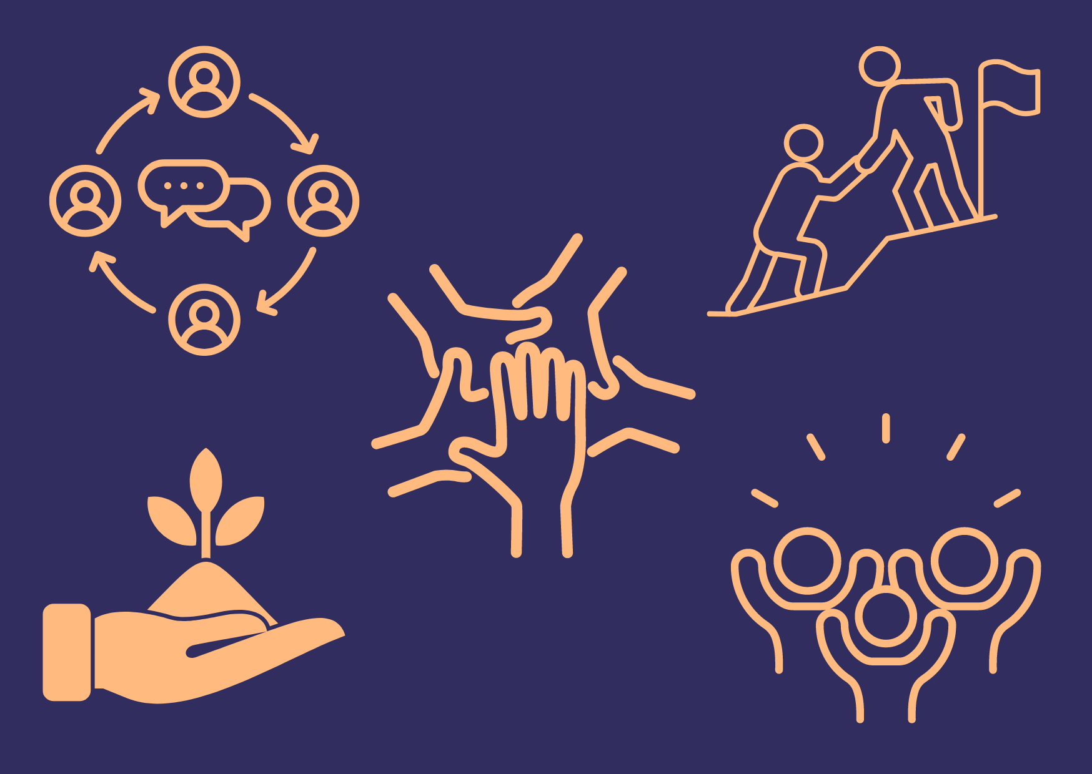

Values common ground
No performance and no challenge is possible without solid internal motivation: the external motivation provided by rewards or salaries is not enough. Internal motivation is based on a conscious and consistent answer to the question: what is our why? Having common values, shared and expressed within teams is fundamental to building solid social capital. The advice is therefore to take a moment together with your team to reflect on your values.
Values are an ethical and moral dimension: They are the whys of our work and actions.
Role clarity
Role clarity means that every employee knows exactly what tasks he or she has to fulfil and what is expected of him or her. This clarity helps people to do their job well and to the satisfaction of others. If the roles in a team are clearly allocated, everyone knows his or her areas of responsibility and can therefore fulfil this responsibility.
To be more specific: In a team in which everyone is aware of their role - and therefore their tasks and areas of responsibility - there are fewer disagreements and misunderstandings. To illustrate this, here is an example of a team in which the roles are not clearly defined.
The Care4Everyone care home recently hired several new carers to meet the growing demand for care and support. Although the team is now larger, there is chaos and dissatisfaction among the staff due to a lack of clarity regarding roles and the allocation of tasks.
Mrs Becker, a new nurse, is not sure whether she is responsible for Mrs Meier's wound care because she has received contradictory instructions from her two superiors. Mrs Schmidt has told her that she should take care of all medical tasks, while Mr Müller has advised her to delegate wound care to the other new nurse. Mrs Becker is unsure and spends a lot of time asking what needs to be done, which leads to delays in care and confuses the residents.
Mr Schulz, who is also new to the team, has not received any clear instructions as to who should guide him in his first few weeks. Mrs Klein, an experienced colleague, believes that she is responsible for his induction, but Mr Weber, who has also been in the team for a long time, also has the impression that this task has been assigned to him. Both give Mr Schulz different instructions, which is why he feels overwhelmed and disorientated.
As a carer, you can imagine how the situation in this example could turn out. All team members have done their best and yet the good care of the residents is at risk.
Role clarity means that each person knows what their tasks are, what their responsibilities are and what is expected of them.
Clarity of goals
What is your goal when you care for a person? To make the person as agile as possible again? To allow them to participate in social life as "normally" as possible? To spare them? Or to activate them?
Clarity of purpose is another important component that makes teams resilient. If all team members are heading in the same direction and want to achieve the same goal, this has a positive effect on a team's resilience.
If members of a team are working towards different goals, this could look like the following example.
Petra, an experienced carer, concentrates on the medical needs of the residents and spends less time on social activities. Tom, a care assistant, on the other hand, believes that emotional support and conversation are the most important things, and occasionally prefers to spend a little longer gossiping with the residents, which often means there is not enough time for bed-making or personal hygiene.
Petra accuses Tom of being lazy, Tom accuses Petra of not caring about people. Tom and Petra don't work well together for this reason.
The aim should always be to agree on common care goals within the team. In this example, this could be like the following:
At a team meeting, the team takes time to look together at what quality care means for each team member. They then discuss together what is important to them all as a team. The team agrees on a common goal: "Ensuring the holistic care and well-being of the residents." This goal includes medical care as well as emotional support and leisure activities. They set aside specific times each day for medical care and leisure activities. Everyone in the team has clear tasks and knows what is expected of them.
Petra and Tom now work as a team. Petra takes care of the residents' medical needs, while Tom focuses on organising social activities, but both support each other.
This example not only shows how you can bring clarity of goals to a team, but again how role clarity contributes to the resilience of a team. Petra and Tom's roles are clearly defined, which leads to greater understanding between the two of them.
Remember that goals should be set up SMART in order to achieve them in the best possible way!
- Specific
- Measurable
- Attractive
- Realistic
- Time based
Ability to delegate
Social support is possible if people know how to delegate. Delegating means being able to exchange tasks and responsibilities, stimulating trust and self-efficacy. However, many people find it difficult to delegate, due to mental patterns, fears, insecurities. Sometimes it can be helpful to put 'delegation plans' in black and white: this will help everyone feel comfortable asking for and giving help.

Communication
Communication is a key factor for resilient teams - that’s why a whole chapter within this content unit is dedicated to this topic. You will find it right after this chapter if you continue reading.

Ability to have fun
Did you know that having fun together is a way to strengthen resilience? We are used to think that fun is not possible at work but there are many examples that show us that contexts where fun becomes part of the daily routine work better. And do you know why? Because fun enhances the centres of learning, problem solving, critical and creative thinking, facilitates emotional management and, in general, makes us feel better. How can it be done? You don't have to go to the fun fair. All it takes is a lighter coffee break, a meal out together now and then, a musical break or something nice to say to each other.

Communication as a key factor for resilient teams
Communication is one of the most important factors for a functioning and resilient team. As mentioned above, multidisciplinary teams in particular need especially good communication . But why is communication so important?



- Different perspectives and expertise: Each team member contributes their own expertise and different perspectives. Due to different training and experience, people's perspectives are always different. Good communication makes it possible to integrate this knowledge and develop holistic and therefore better solutions to difficult problems.
- Coordination of patient care: Patients often receive different treatments and therapies from different specialists. Clear communication is very important to ensure that people are not treated incorrectly, for example by administering medication that is not coordinated. Clear communication ensures that all aspects of treatment are coordinated and that no information is lost.
- Avoid misunderstandings and mistakes: Misunderstandings can easily occur in a team if communication is not clear. This can lead to errors in patient care, such as incorrect treatment decisions.
- Efficient decision-making: Quick and well-founded decisions are often required in order to respond to the changing needs of the people receiving care. Good communication enables relevant information to be shared quickly and decisions to be made jointly.
- Teamwork and collaboration: Teams often work under high pressure and need to be able to rely on each other. Clear and open communication promotes a strong sense of team spirit and supports collaboration across disciplinary boundaries.
To summarize, good and most of all effective communication in (multidisciplinary) teams enables targeted, fast and coordinated patient care, promotes patient safety and strengthens teamwork. It is therefore very important for the success and efficiency of such teams in the healthcare sector.
Good and effective communication is particularly important in multidisciplinary teams.
There are many different strategies for maintaining good communication in care teams. Some of these strategies are listed and explained below.
Regular team meetings
Team meetings at regular intervals, such as once a month, help to improve communication within the team. Duty rosters and holiday times can be discussed at such team meetings. Current information, such as the visit of the regional health councilor to the care home or similar, can also be communicated in a team meeting. In addition, a meeting where you see all your colleagues at once for a change often leads to an exchange about things that are neglected in everyday care work. This strengthens the team structure.
For many colleagues, the monthly team meeting is the only time they can see and talk to each other. They receive new information from the management and can report on their experiences. Goals are discussed together, and successes are celebrated jointly.
At the end of the team meeting, all questions that had arisen in the previous month concerning the staff situation, patients and common goals were discussed.
Clearly defined communication channels
The clearer the way in which information is exchanged, the fewer misunderstandings there will be.
In a hospital, employees are not allowed to have WhatsApp groups with each other. The reason for this is that current information is always communicated to everyone by the ward manager by circular email and many half-truths and rumours were communicated in previous WhatsApp groups, which led to inconsistencies in the team.
Since all employees always receive all information in a circular email, there are far fewer misunderstandings and rumours.
Care protocols
The nursing protocols, which you must certainly know and keep, are also a form of team communication. These protocols provide you with all the important information about a patient's care process, so you know whether medication has already been given, the patient has already been repositioned or the patient's wound needs to be re-dressed, or whether this has already been done.
Maria enters a patient's room. The patient asks her for help, saying that her pain is so severe that Maria should please administer her tablets. A glance at the nursing protocol shows Maria that the patient has already received the highest possible dose of medication and denies it. However, she can help the patient to cope better with her pain by giving her a little time, gentle persuasion and distraction.
Standardized handovers
The handovers you receive from your colleagues or the handovers you make yourself are also a communication strategy. The more standardised these handovers are, the better you can ensure that no important information is lost, that nothing important is forgotten and that the handovers can be carried out as efficiently as possible and therefore do not cost anyone unnecessary time.
Clara is tired from the night shift. The handovers in the hospital are not standardised. Clara passes on all the information from the night to her colleague Matthias. Due to the lack of sleep, she forgets to report that a patient had very fluctuating vital signs during the night.
This lack of information leads to Matthias having difficulties on duty. Matthias is unable to answer the doctor's questions about the patient's deteriorating condition.
If there had been a standardized handover protocol in this team, in which all relevant information such as medication, vital signs, planned examinations, special incidents etc. had to be queried and entered, Clara would not have been able to forget the patient's vital signs despite being tired. Matthias' service would have been easier and the patient's health would have been better safeguarded.
Feedback culture
Good communication within a team is also characterized by a culture of feedback. If a team is able to give each other constructive feedback in an appreciative manner, this leads to better overall team performance and good teamwork. You can then rely on receiving feedback if there is room for improvement in your own work or in the way you work together, and you don't have to fear gossip behind your own back.
"Maria, I really appreciate how caringly you look after the patients. However, when administering medication, it is important to check the instructions carefully to avoid mistakes. Perhaps you could use the checklist in future to make sure everything is correct."
Constructive feedback is a type of feedback that aims to promote positive change by addressing both strengths and areas for improvement in a respectful and specific way. It is designed to help improve performance and behaviour by providing clear, actionable recommendations without discouraging the recipient.
Case discussions
Case reviews are a good opportunity to discuss individual patients and their health and medical history. In a case discussion, all relevant information on the course and background is discussed. Particularly in the case of serious diagnoses and illnesses, such case discussions can be used to analyse and discuss together. This promotes joint learning and finding good solutions.
A hospital team meets to discuss the case of patient Müller, an elderly patient with chronic breathing problems. The head of nursing encourages everyone involved to describe their observations of the last two weeks. One professional describes that she often observes breathlessness at night and that Mrs Müller has difficulty lying down. A colleague has observed that the patient is eating less and suspects swallowing problems. The patient's physiotherapist reports that the patient's breathing exercises are making little progress. The doctor in charge decides to adjust the patient's positioning and diet on the basis of the patient's description and instructs the physiotherapist to intensify the breathing exercises. The team will meet again in a week to discuss further developments with Mrs Müller.
Communication strategies alone are not a miracle cure. Regardless of the communication strategy, they all have one thing in common: they require cooperation at eye level, mutual appreciation and respectful interaction.
All the practices suggested above are nice and useful. But one key piece is missing: they do not work if conducted with non-effective communication!

The basics of good communication
We are used to considering communication something spontaneous and natural. And, indeed, it is: unfortunately, however, especially when we are in difficult situations and under stress, it can be useful to have skills to direct our communication, managing it in the best possible way so that what we want to convey reaches the recipient without misunderstandings, distortions and emotional stress.
We will explore below three broad theoretical-practical frameworks that can be useful in structuring good communication.
The basics of effective communication
The function of communication is to express a need, but often the message does not get through. Has it ever happened to you to have an intention and then start talking ending up saying something else? Or how many times you ended up having the impression that the original message did not get through at all? This happens because we mess up: our emotional side makes confusion and generates emotions in the listener. The load of emotions creates disorder and so communication gets jammed.
When you need to express something effectively, it can be useful to learn a very practical method to direct the expression of your need and make communication neat, clean and thus more effective. This method consists of four simple steps that we recommend you keep in mind: it can guide your communication whenever you need to convey something important. Here’re the four steps and their description:
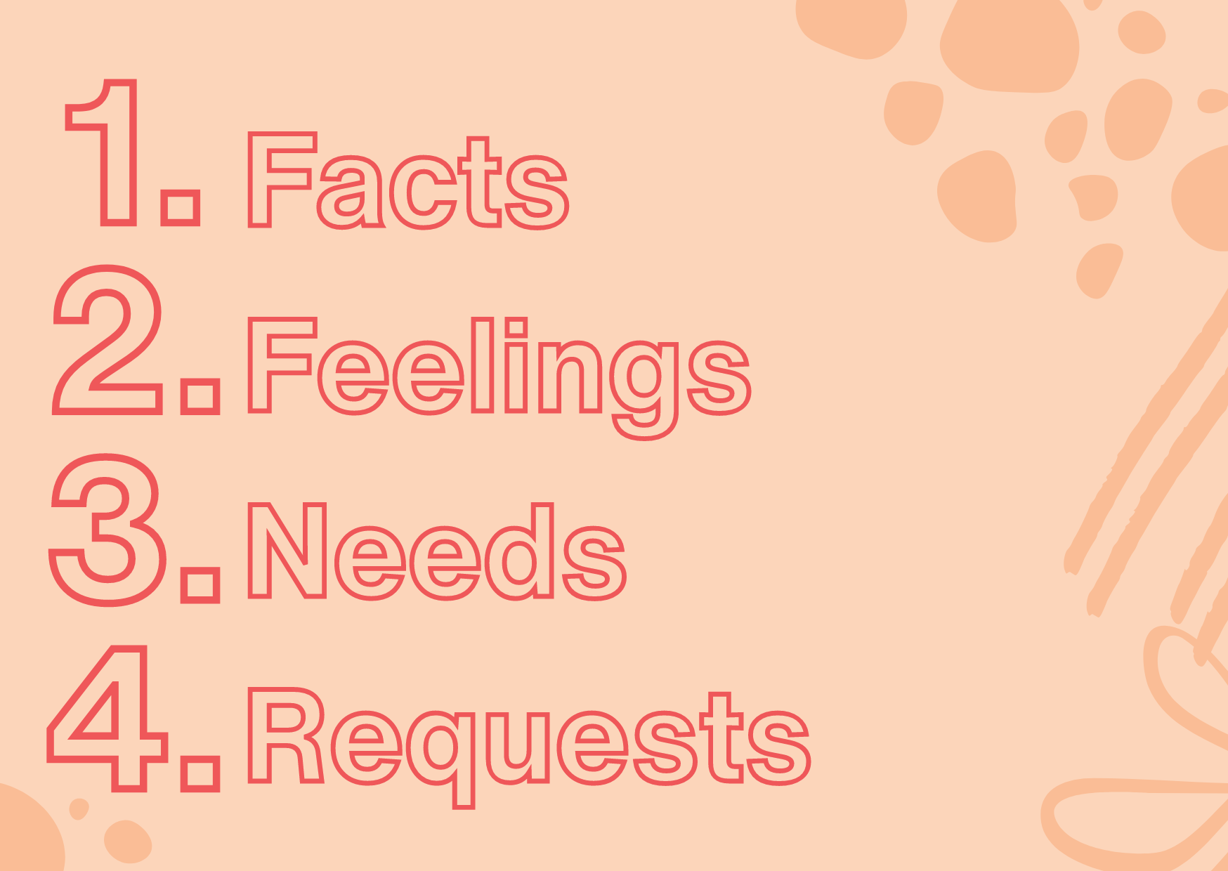

Let’s use an example to let you better understand. Helen is taking care of an old man, George. The situation is getting worse day by day day and Helen feels she can no longer cope with the workload alone. She needs to ask Georgs family for help and for a solution.
First step: Facts. Stop for a second, take a deep breath and analyze the situation, the facts for what they are, so that you are clear about what the starting point is.
In Helen's case, it is helpful for her to line up the various problems that are emerging in her care work and the difficulties she encounters. It is important at this stage to stand on facts, without judgements or interpretations. Returning to the example, it would be helpful for Helen to be clear about what facts she wants to introduce:
‘The situation with George has become very complex: he is no longer self-sufficient in any of the daily tasks, he needs night-time assistance and on top of that, he now needs medical assistance. This means that it is no longer possible to leave George alone even for a few minutes…’
Second step: Feelings. Each event or situation arise feelings and emotions. If we do not express them with awareness, coherence and clarity they come out in a dysfunctional way.
The second step answers the question: what do the observed facts arouse in me? In Helen's case, they may be fatigue, tiredness, fear of not being able to cope, anger at not having more free time. It is important that Helen, after exposing the facts, explains their fallout:
“… Consequently, I am very tired and feel I can no longer cope: I don’t have any time for me, often this generates anxiety and sometimes anger. I don't feel I have the resources to continue my own and this also generates fear in me…'
It is important that feelings are expressed cleanly, without accusations, complaints and taking the role of victim. Do you remember the part of the course where we talked about the 7 pillars of resilience? These concepts are linked...if you don't remember, go back to modules 5 and 6.
Third step: Needs. Feelings and emotions are important because they suggest what we need. That is why it is important to be aware of what we feel and express emotions, without denying or judging them. It is important to stop for a moment and ask ourselves: what needs are the emotions I am feeling related to? In Helen's case, the needs could be
- To have less load
- To get back to having time to herself and working hours well defined and respected
- To ask for help ‘…I believe, therefore, that I need help: I would like to be able to return to working hours that allow me time off to recharge my energy...'
The expression of needs is often a critical point: we are inclined to judge our needs and thus repress them. This happens to us from the time we are babies! How many times do we tell a crying child that he/she is capricious and tell him/her to stop? Hardly ever we take the time to ask him with empathy ‘what do you need?’. So when we feel the need for help our mind may go back to that experience, telling us (in the subconscious) that we are cowards, selfish or wimp...with the result that we stifle our needs. The problem is that repressed needs then act as a volcano: they boil like lava below the surface and then explode!
Fourth step: Requests. Needs must be transformed into demands...without being afraid of demands! If needs remain unexpressed and unsatisfied, we will feel continually misunderstood, dissatisfied, frustrated and the needs will continue to act just like the lava of the volcano...sooner or later we will explode!
We have to be aware that this last step is the only one that can (and sometimes has to) be revised with those around us: this is where the compromises and bargaining with the needs of the other person lie.
Helen here will have to deal with George's family to see:
- if the family can give a concrete help to her (i.e. taking care of George at least two hours a day)
- whether they can provide her with another support figure may be for the nighttime
- whether George can have nursing care.
Now that you are clear about the steps to follow for effective communication, try to apply this method every time you need to communicate something important. In doing so, you may need to set the 4 steps described above in positive communication framework. So, let's go through it!

The basics of positive communication
When you have to communicate anything, be it facts, feelings or needs and requests, how do you do it?
Expressing each of them in an aggressive style will not be ideal! Neither is it if we communicate them by assuming the role of victim.
When faced with situations that put us in a difficult situation, we often communicate instinctively, with a pattern that is sometimes out of control and that harms us. Instead, we could choose the pattern that can improve the quality of our relationships. The way we communicate in care work but also as parents, spouses, siblings, friends or colleagues is a choice and has a direct impact on the quality of relationships around us.
So, what are the patterns for communication we can choose to be truly positive in expressing ourselves? To be able to choose them, we need to understand which are the most common patterns we can act and which are their effects.

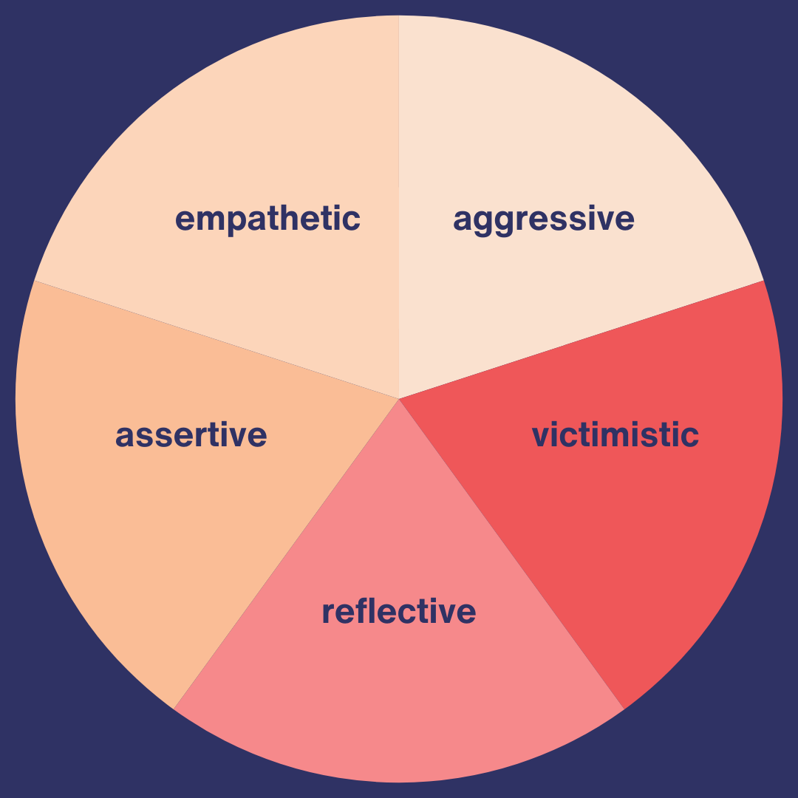
First pattern: aggressive. This is the one we use when we attack, when we raise our voices, taking a judgmental attitude.
Let's take an example: a colleague criticizes a job that Sylvia has taken great care to do. Because she feels offended, threatened, treated unfairly, instinct and lack of control can drive Sylvia to attack. Exactly as animals do when someone or something threatens them, Sylvia will analyze the facts and communicate her feelings, needs and demands with aggression, attacking her colleague to eventually be able to say ‘I am right’.
Let's be clear though: is it more important for us to be right or to preserve and perhaps strengthen the relationship with our partner? Always remember that being right serves no purpose ... except to remain equal to oneself!
Second pattern: victimistic. This is the typical pattern of those who take on the role of victim: we act it out when we feel very vulnerable. We tend to close in to protect ourselves. The victim pattern is one of criticism of ourselves and insecurity that leads us to look for what is wrong with us. When we adopt this pattern, it is because there is a voice inside us that says: ‘it is all my fault, I am a mess’. According to this pattern, Sylvia, when listening to her colleague's criticism, would start to feel guilty, to tell herself that she has really done everything wrong and to question her abilities: her sense of self-efficacy and self-confidence are affected.
Third pattern: reflective. This is the pattern of reflective people, who are self-aware and are able to analyze situations lucidly. Adopting this pattern often means taking a break, a few moments of reflection to avoid reacting immediately. The ability to take time is a key competence in communication: it is needed to become able to analyze the facts, observe what is happening inside and outside of us and evaluate what is the best strategy to communicate. In this case Sylvia, after listening to her colleague's criticism, would take some time before responding, try to take a moment of calm to analyze the situation and make assessments on what may be the best strategy to communicate her disappointment to her colleague.
Fourth pattern: assertive. This pattern is typical of one who has developed good assertiveness, i.e. the ability to be able to communicate one's needs and to assert them, perhaps through negotiation. Who is endowed with the assertive pattern has a good awareness of needs and request to ask. In this dimension, we can act like a detective to try to understand where our malaise and frustrations originate and seek a solution by managing emotions well. Sylvia, if she were assertive, would be able to communicate to her colleague her need for recognition and the desire to implement a calm confrontation to analyze not only errors and responsibilities, but also solutions and possibility for improvement. This pattern has a lot to do with problem solving and the solution-oriented approach: you can review these parts in the relevant paragraphs.
Fifth pattern: empathetic. This is the pattern that allows us to look at things from a wider perspective: it is crucial to be aware of our own needs, but it is equally important to be attentive to the other person's needs as well. It is the empathic, loving approach that asks us the questions: what is the other person feeling, what is going on inside them, what do they need? We put ourselves in the other person's shoes, try to understand them and see everything with a broader view. We become sympathetic and accept diversity in full connection with the other person, no matter what happens, even if we disagree and even if the confrontation turns out to take two different paths. It is clear that this is the most difficult pattern to implement: but it is the one we should train in care work because it helps us and the others feel better.
In reality, we can all manifest all of these behaviors in the course of a day, depending on the circumstances in which we find ourselves. Some people may have greater tendencies towards a pattern: this may depend on many factors: upbringing, personality, behavioral conditioning, life circumstances, situational elements, stress factors, etc.
But if we know them and try to understand which ones, we are more prone to, we can have more conscious control over our communicative behavior, orienting communication not only towards effectiveness but also towards positivity.
This framework comes from the studies of Louise Evans, a well-known transformational coach and behavioral trainer. If you want to learn more, you can watch this nice video in English:
https://www.youtube.com/watch?v=NHduBeFdyns

The 4 languages of empathy
Have you ever said, after an argument with someone, ‘we don't understand each other, we speak two different languages!’?
We have now realized how important it is to try to adopt an empathic communication pattern: in care work, this is a fundamental knot of relationships. Yet sometimes, even when we try our best, we seem to fail to make those around us feel our understanding and empathy.
This often happens because not everyone communicates and interprets empathy in the same way. There are, in fact, four different languages with which people prefer to express feelings of closeness and affection: each person uses his or her own language to express and receive care.
Each of us possesses one or more of these languages, with specific aptitudes. Often an individual has a preferred “mother language” of empathy and has difficult to understand those that do not belong to them.
What are these 4 languages?
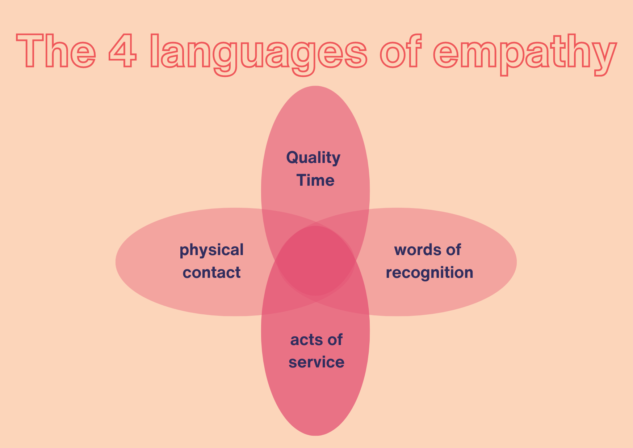
Let’s go through them with an example.
Brenda works every day with Leo, a highly competent nurse who is going through a difficult time: he is often very tired, stressed and at times even seems to be in a depressed state.
Brenda has also trained her resilience by trying to become aware of effective and positive communication methods and does her utmost to convey her affection and empathy to Leo. How can she do this? She can use different languages:
- Physical contact: people who speak this language communicate empathy through handshakes, hugs, caresses, massages or any gesture of physical closeness.
- Act of service: people who speak this language believe that the most important act of empathy is to help the other person. This is a typical dynamic between colleagues. People who speak this language offer their help, take on practical tasks and often offer their concrete cooperation.
- Quality Time: people who speak this language need specific moments dedicated to the relationship. They feel the need to be together, often without others around: having tea and a chat, taking a walk, listening to music together and in general sharing moments.
- Words of recognition: for people who speak this language, words speak louder than actions! Expressions of gratitude, compliments, phrases of incitement, positive feedback are what make speakers of this language feel understood and loved.
If Brenda communicates with, for example, physical language but Leo is sensitive to the language of words of recognition, empathy and affection will not reach him; indeed, he may perceive Brenda's physical contact as annoying and intrusive. If, on the other hand, Leo and Brenda speak the same language, then the caresses and hugs will be a source of well-being and a sense of mutual understanding for both. It is therefore important to train one's ability to decode the other's language to tune in. It sounds difficult but, in reality, it is simple. Just be curious and observe: the way others try to show their attention reveals to us what their language is. Just as one does in a foreign language, which is learnt precisely through listening and confrontation. Thus Leo, whose predominant language is words of recognition, will be inclined to point out to Brenda how good she is at her job, compliment her and often give her feedback of gratitude. If Brenda observes him and becomes aware of this, she will realize that the best way to take care of Leo will be to use the same language as him.
Now that you have acquired some more knowledge and skills to communicate in a positive and effective way, all you need to do is train. You will see how your relationships will improve and your resilience will benefit!

Summary
In this chapter, you have read how important resilience is not only for individuals, but also for entire teams. You have learnt that it is not enough to make resilient individuals into a team, because this does not mean that the team is also resilient.
They are familiar with the concepts of role and goal clarity and know why it is very important for teams that all team members know their role and that teams need common goals in order to work well and satisfactorily.
At the end of the chapter, communication strategies were presented that can improve communication in teams. This is particularly important in multidisciplinary teams in order to work well together.
In the next chapter, you will find specific exercises to strengthen your resilience and self-care.

Exercises to strengthen resilience and self-care

Introduction
You have already learnt a lot about resilience and self-care. You know what is meant by both terms and why it is important to be resilient and look after yourself. In the care sector in particular, resilience and self-care are two very important skills that will help you to carry out your work in a long and healthy way. In the previous chapter, you also learnt why resilience is not just a matter for individuals, but is also relevant for entire teams.
However, it's not always easy to work on your resilience and practice self-care. We know that! That's why we've put together some exercises for you in this chapter that will help you to strengthen your resilience and self-care.
Reading and understanding the exercises is a good start. However, to really strengthen your resilience and self-care, it is very important that you actually try out the exercises and take them seriously.
If you don't like an exercise, please try it more than once. Sometimes it takes a little while to recognise the positive benefits of an exercise. Don't give up too quickly.
We have put together the following exercises for you:
- The optimism diary
- The importance of daily goals
- Learning acceptance
- Mindfulness meditation
- Acting instead of waiting
- Turning away from bad habits

The optimism diary
Writing in your diary brings back dusty memories: writing down everything that happened with the opening sentence "Dear diary..."? Understandable if that's not something that brings you joy.
But optimism diaries are currently experiencing a lot of hype. They are on everyone's lips, can be seen on numerous social media feeds and for good reason: they work!
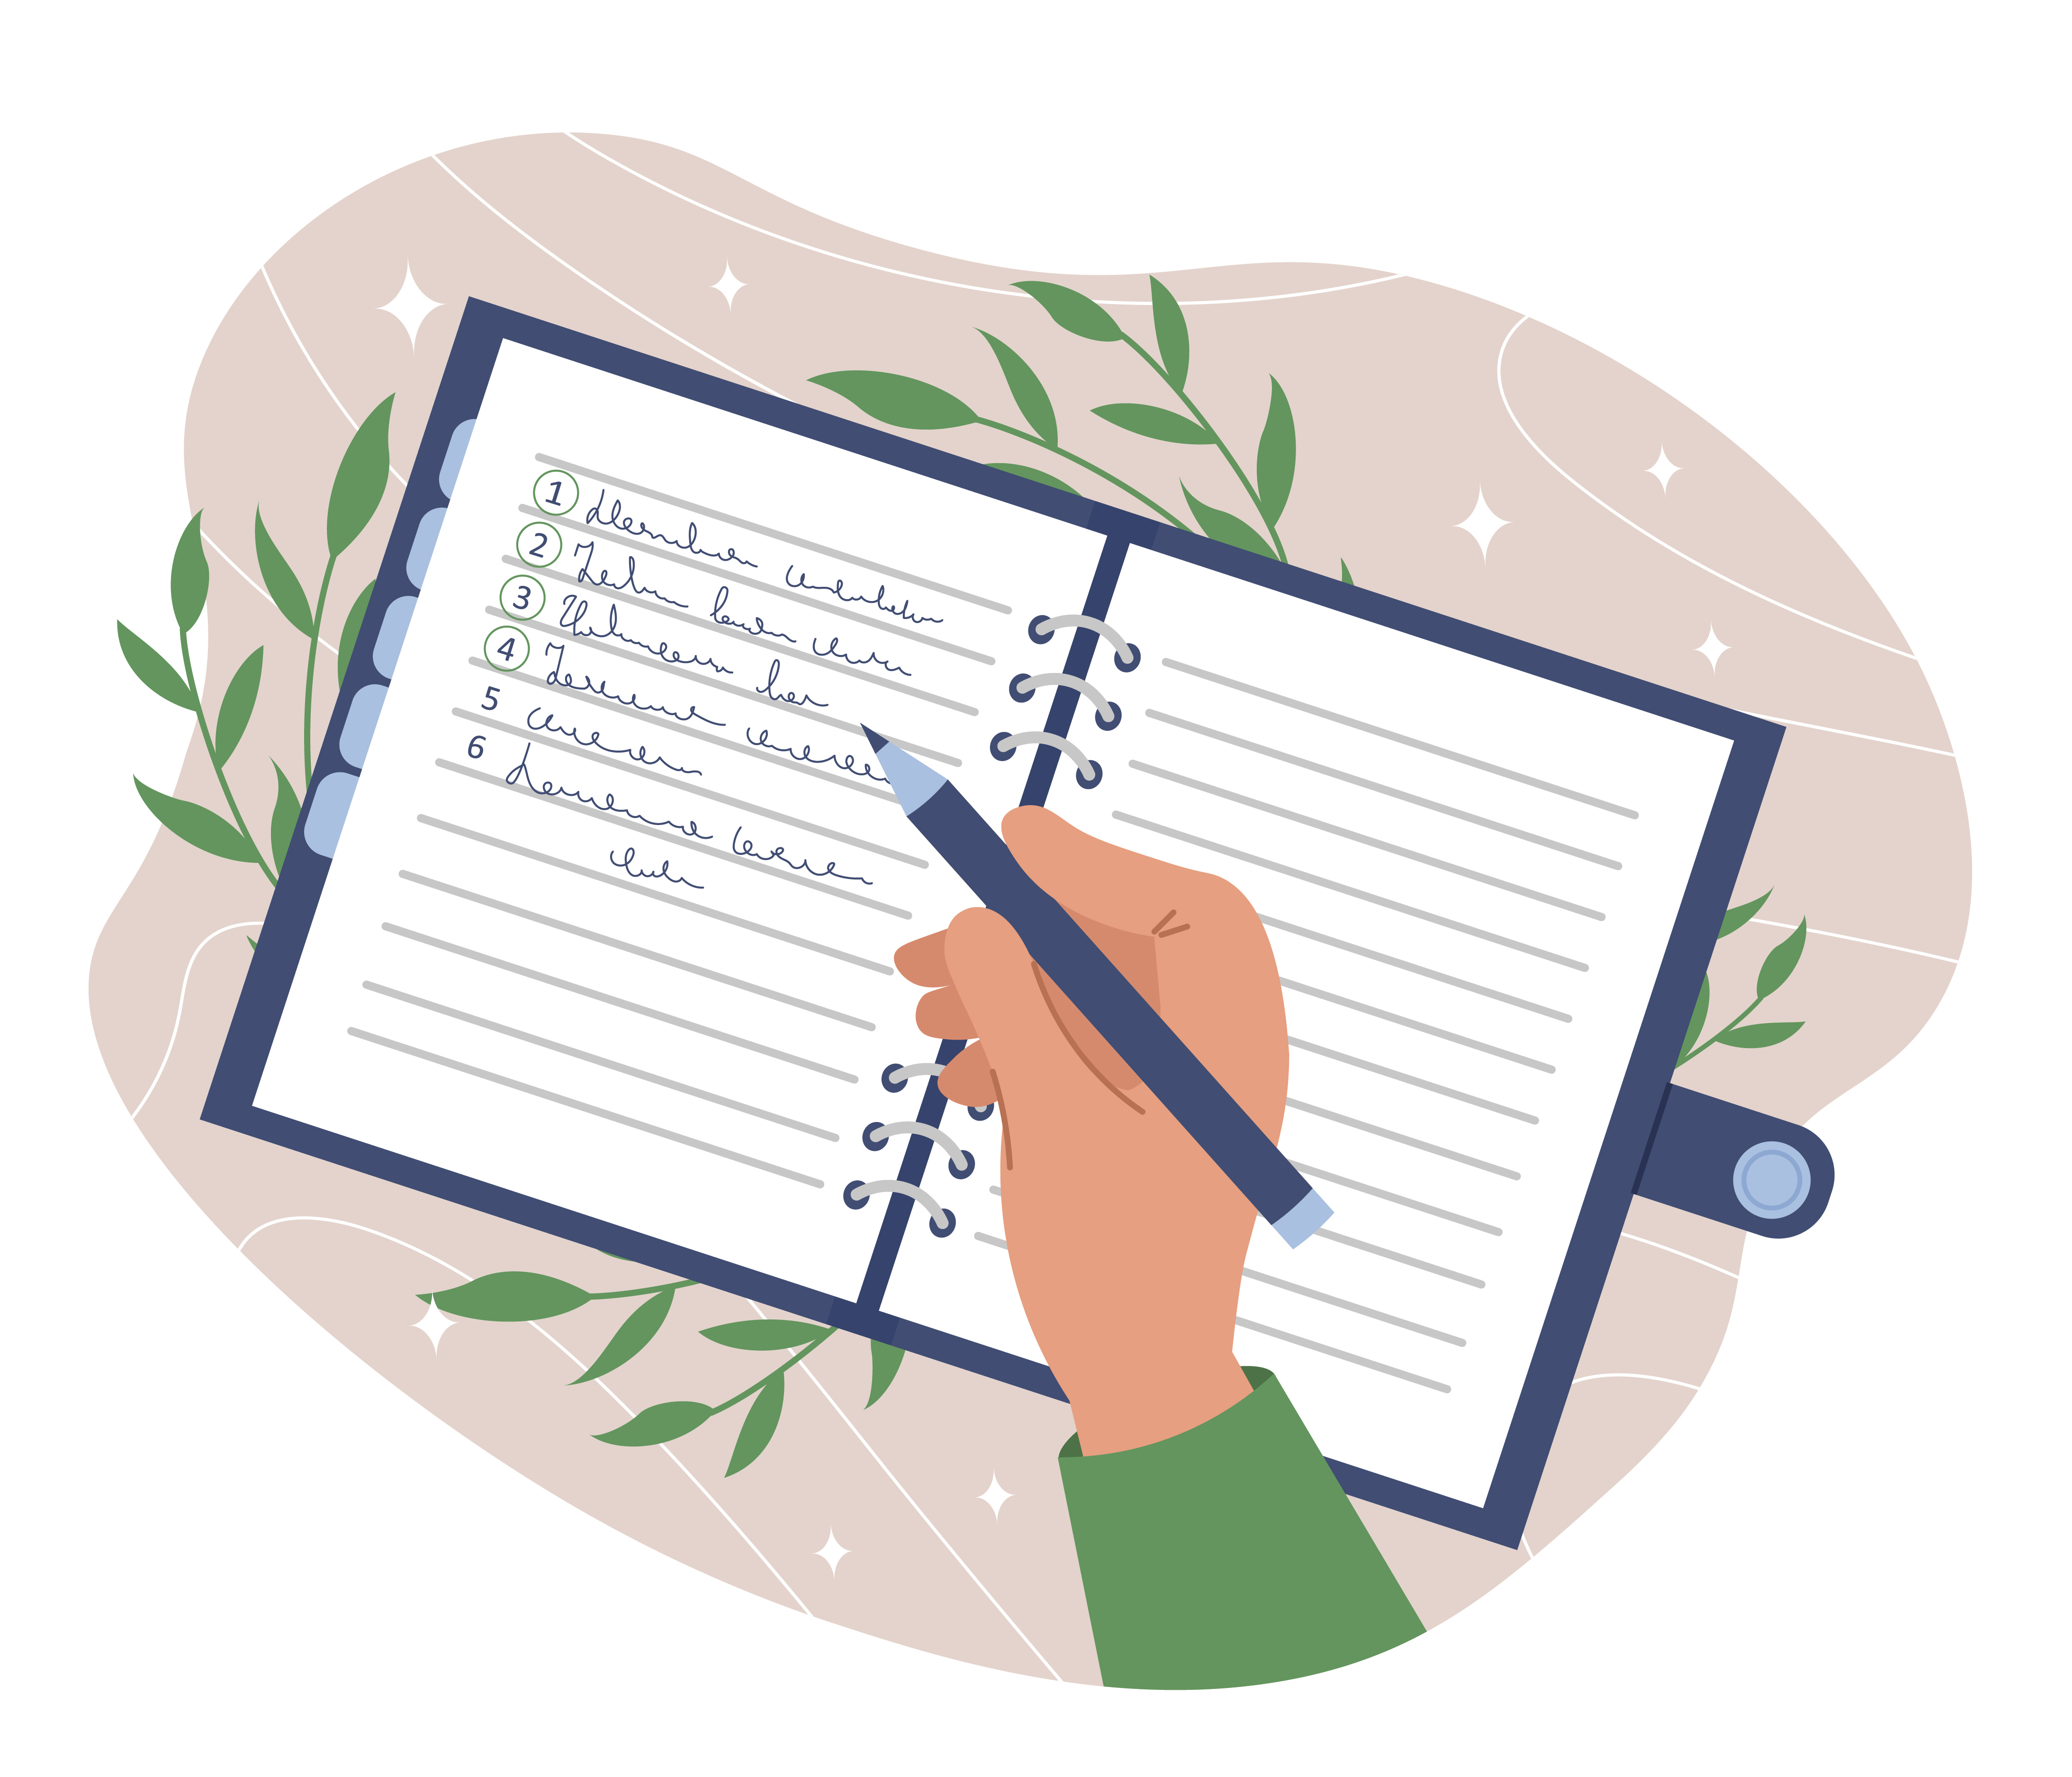
What is an optimism diary?
In general, putting feelings, emotions and experiences of your day in writing in a diary can make you feel better. That is why the practice of journalism (the systematic writing down of thoughts, emotions and habits) is also used in psychological therapies.
The optimism diary can therefore, with good reason, be a good tool to promote positive feelings. In such a diary, you record every day what went well, what was positive and what you are grateful for.
It is important that you don't see anything "extra" positive, but that you think about it until you can think of things that were actually good and then write them down. These can also be small things, such as the friendly bus driver. The important thing is that the situation was positive for you.
Thinking about and writing down positive things helps you to focus on the good and positive and not just think about negative things. Our brain is not used to retaining positive events. It tends to focus on dangers, bad events and bad news. You will all have experienced that it is easier to be affected by bad news than by good news! Our brain behaves like this way because of the "negativity bias", which has served to protect us and survive as a species since we have been on earth. The problem is that, even though we are no longer primitive men having to defend ourselves against the lion, the negativity bias is (unfortunately) still active. The optimism diary serves precisely to train our brains to focus on the positive.
If you keep this optimism diary over a longer period of time, you will notice that you are increasingly noticing little things. Subsequently, you will notice these little things not just when you are writing in your diary, but at that very moment. Perhaps you will then consciously feel the tailwind when cycling and be happy about it at that moment.
04th of December 2023:
- I'm glad that I'm healthy again and have completely cured my cold.
- My colleague Anna invited me for a mulled wine, which made me feel appreciated. I'm looking forward to spending the evening together at the weekend.
- This morning, a nice gentleman at the supermarket let me in at the checkout and gave me a friendly smile. Thanks to his kind gesture, I wasn't late for work.
- My mum, who needs care, had a rare clear moment today and thanked me for everything I do for her. She told me that she loves me. I had tears in my eyes.

The importance of daily goals
"Only those who know their destination will find the way." (Laotse)
Do you actually have goals? Where are you heading in life? In the chapter "The 7 pillars of resilience" and "The 7 pillars of resilience in practice", we have already discussed why planning for the future is important. So you already know that it is good to actively plan your future and set yourself goals. However, the pillars of resilience were more about long-term goals - about the future.
This chapter focuses on small goals. Those that want to, should and can be achieved in one day - the so-called daily goals. Set yourself daily goals - this will lead to greater satisfaction.
But how is that supposed to work? Aren't daily goals just more to-do's on an already long list? No - in fact, you could almost say that it's the exact opposite. Set yourself daily goals instead of working through a to-do list. The difference lies in the achievability. Daily goals are easier to achieve than the end of the to-do list. Or have you ever really finished your to-do's? No, have you?
Daily goals are goals that you can achieve within one day.
But why is it good to set yourself daily goals? There are several reasons for this. The first reason is that it helps you to learn to better estimate your available time. For example, if you set yourself the goal of reading 50 pages of your current book, exercising for an hour and preparing meals for the next three days, before you have even finished writing your list of daily goals, you are bound to be perplexed and perhaps think to yourself: "Wait a minute - I can't do all that today". This thought is important because it means that you set yourself more realistic goals and are therefore more likely to achieve them. This time estimation is easier to do for a day than for a whole month, for example.
Another reason in favor of setting daily goals is that you have a good feeling every evening when you have achieved your goals. You go to bed satisfied and proud of yourself. With big goals, on the other hand, it usually feels like you haven't achieved anything and you may go to bed disappointed in yourself. As you can see, it makes a big difference how big your goals are.
In addition to these two reasons, there is another reason why setting daily goals is important: you learn to say "no" better. The example below shows you exactly what this could look like:
You have set yourself three goals for today:
- Go for a walk during your lunch break
- Cooking fresh for your family in the evening
- Do a short meditation before going to bed, as this always helps you sleep better
You are determined to achieve your goals. In the morning, a colleague comes and asks you if you would like to go for lunch with him during the lunch break. You struggle with yourself - after all, you would feel like it somehow, but you know that you will feel better if you have gone for a walk. You decline and ask your colleague if you can postpone lunch until tomorrow. He agrees. You go for a walk during your lunch break and have achieved your first goal for the day.
Of course, this doesn't mean that you shouldn't have big, long-term goals. These are just as important. But small, easily achievable daily goals will help you achieve more satisfaction and good feelings and therefore also help you achieve your big goals.
In contrast to the end of a to-do list, daily goals are actually achievable. They help you to better estimate the time required, make it easier to say "no" and lead to good feelings when you have achieved your goals.
In order to plan daily goals well, it is important to be able to work on prioritization. A useful, simple and concrete tool for doing this is the Eisenhower diagram.
The Eisenhower Principle, also known as the Eisenhower Matrix or Urgent-Important Matrix, is a time management tool attributed to President Dwight D. Eisenhower. It helps prioritize tasks by categorizing them based on their urgency and importance. The matrix consists of four quadrants:
- Urgent and Important: Tasks that require immediate attention and have significant consequences. These should be addressed first.
- Important but Not Urgent: Tasks that are crucial for long-term goals but do not need immediate action. These should be scheduled for later.
- Urgent but Not Important: Tasks that require immediate attention but are not critical to long-term goals. These should be delegated if possible.
- Not Urgent and Not Important: Tasks that have little impact on your goals and do not need immediate action. These should be minimized or eliminated.
The principle encourages focusing on important tasks to improve productivity and achieve long-term objectives, while avoiding the trap of constantly reacting to urgent but less important tasks.
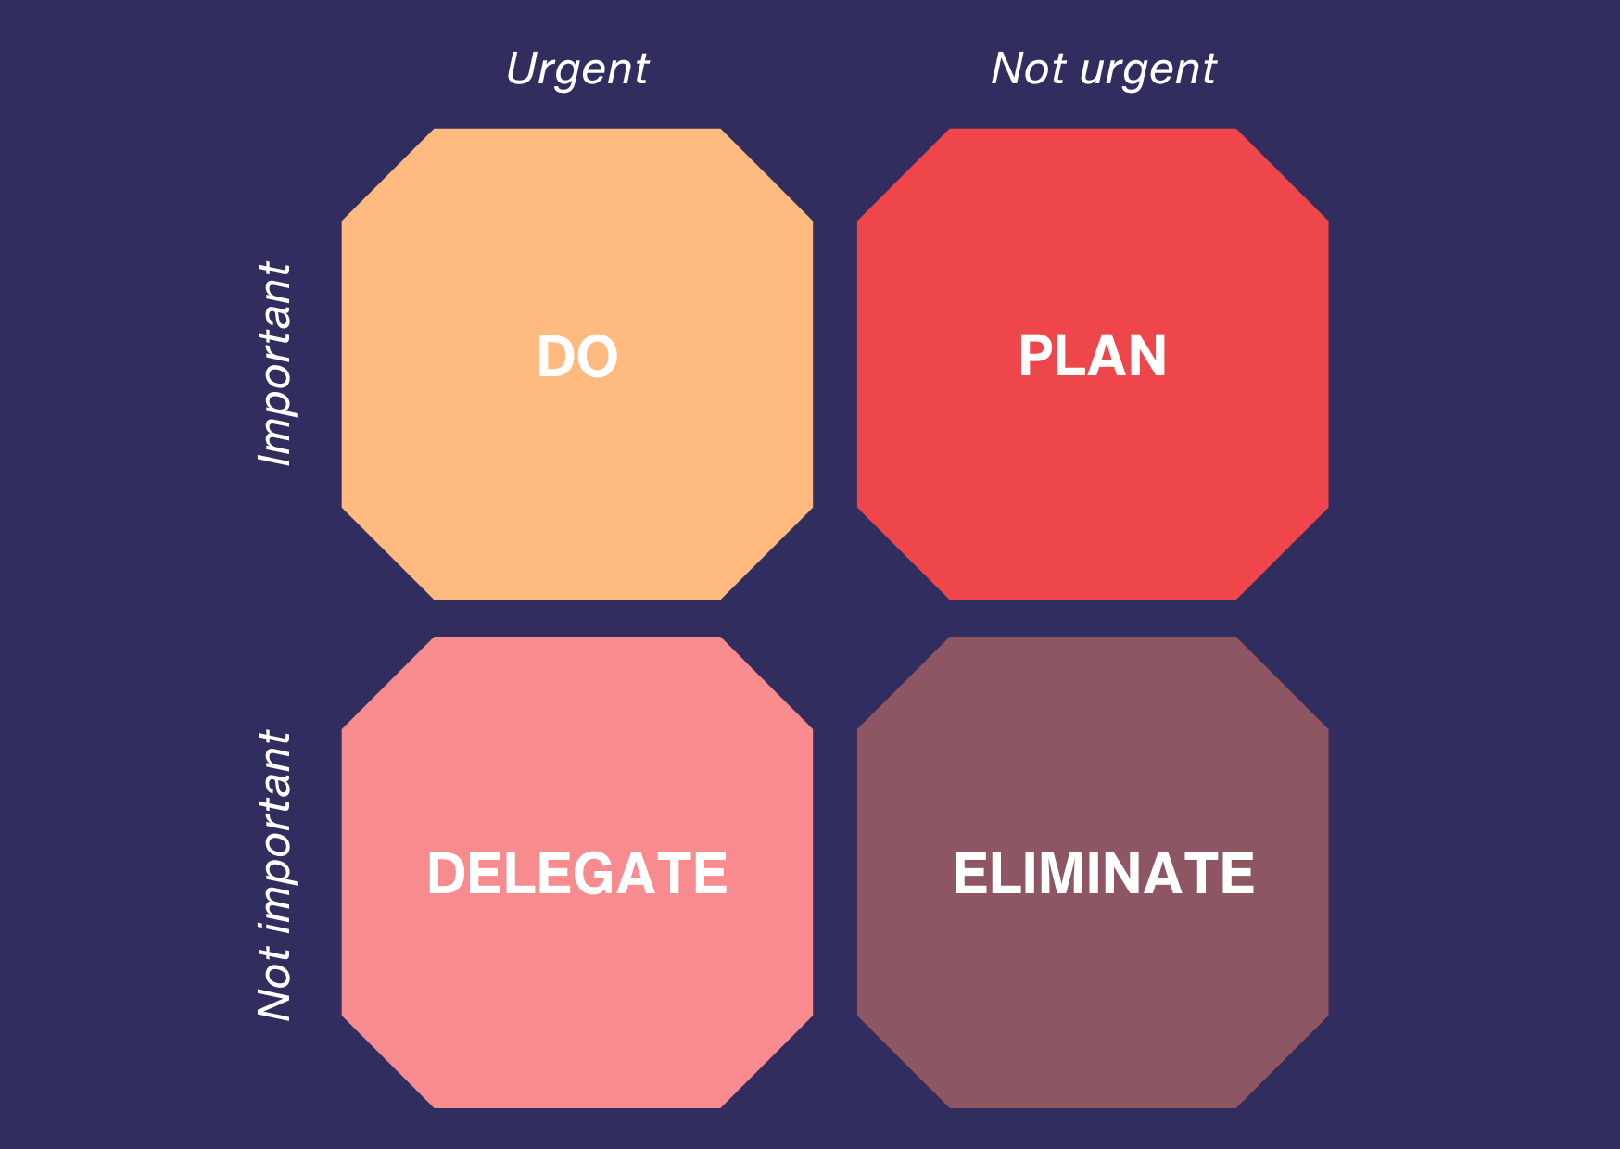

Give it a try!

Learning acceptance
You will also be familiar with the topic of acceptance from the chapters "The seven pillars of resilience" and "The seven pillars of resilience in practice". One pillar is dedicated to this topic in each of these chapters.
So you already know that it is important to be able to accept certain circumstances in life instead of getting angry about them. In the following, we will go into this again and provide another perspective on the topic.
You are probably familiar with the situation when you open a website on the Internet and a box opens that blocks your entire view. You have a choice: accept cookies and continue, or reject them and leave the site. In life, you are often faced with the same decision. It is up to you how you want to proceed.
It is not the circumstance itself that is decisive, but how you deal with it.
To be a little more specific about what this can mean, please read the following example.
You are asked to attend a meeting with your line manager. She informs you that the care home where you have been employed for years is being closed and that you will unfortunately have to be dismissed for this reason.
Many feelings arise in you: Anger, sadness, disappointment, rage, helplessness and and and..... Of course, these feelings are justified.
After a few days, however, you have a choice: you can continue to dwell on your feelings, curse your job and your boss, feel sorry for yourself and mope. Or you can decide to accept the situation. This acceptance helps you to look forward. It leads to the thought: "Okay, that's the way it is now." "And what do I do now?" This thought leads you to look ahead and make new plans, write job applications and ultimately find a new job.
Of course, it is not always so easy to accept negative events or circumstances. It is by no means "just like that". Nevertheless, accepting a circumstance is the only way to regain your ability to act. Only when you come to terms with it do you have the reins in your hands again and can actively shape your life. And this is particularly important in such a demanding field as nursing.
One tool, that could be used for personal reflection and growth in terms of self-acceptance is the SWOT-analysis.
By evaluating your Strengths, Weaknesses, Opportunities, and Threats, you can gain deeper insights into your experiences and use this understanding to foster self-acceptance and resilience.
The SWOT Analysis is a strategic planning method that helps you assess different aspects of a situation or experience. By breaking down an event into four categories, you can better understand its impact on you and how you can use it to your advantage:
- Strengths: Positive attributes and resources you possess.
- Weaknesses: Areas where you struggle or lack resources.
- Opportunities: External factors you can exploit for your benefit.
- Threats: External challenges that could cause problems.
Here's how you can apply SWOT Analysis to reason about the opportunities and resources from a significant event in your life:
When something significant happens in your life, using SWOT Analysis can help you make sense of it, identify growth opportunities, and develop self-acceptance. Here’s a step-by-step guide:
Strengths:
- Identify Personal Strengths: Reflect on how your skills, talents, and positive traits helped you handle the event.
- Questions to Ask: What did I do well in this situation? What personal qualities did I rely on?
Weaknesses:
- Acknowledge Areas for Improvement: Recognize any weaknesses or limitations that affected your response to the event.
- Questions to Ask: What could I have done better? Where did I feel underprepared or lacking?
Opportunities:
- Discover Growth Opportunities: Look for ways the event can lead to personal development or new possibilities.
- Questions to Ask: What can I learn from this experience? How can this event open new doors for me?

Threats:
- Assess External Challenges: Identify any external factors that posed a challenge or threat during the event.
- Questions to Ask: What obstacles did I face? How can I prepare for similar threats in the future?
By applying SWOT Analysis to a personal event, you not only gain valuable insights into your own responses and capabilities but also reinforce self-acceptance by acknowledging all aspects of yourself. This holistic approach helps you grow from your experiences, becoming more resilient and self-aware.

Mindfulness meditation
This headline may make some of you roll your eyes. After all, you hear the words "mindfulness" or "meditation" in every second Instagram reel. Here, the two words are even linked. What is mindfulness meditation and what are its benefits? This will be discussed in the next few lines. Please be sure to read on, even if you were part of the group that rolled their eyes. It's worth it!
- Mindfulness meditation is the form of meditation that has. Various studies have shown the following effects:
- Mindfulness meditation relieves stress and inflammation in the body caused by stress
- Mindfulness meditation can reduce feelings of anxiety and the resulting discomfort
- Mindfulness meditation can extend the attention span
- Mindfulness meditation can alleviate pain
- Mindfulness mediation leads to faster falling asleep and better sleep quality
Well? Are you interested? Continue reading.
Mindfulness helps you to concentrate on an object of your choice. This is usually your own breath. This concentration helps you to distance yourself from your own thoughts. The aim is to observe your own thoughts as if "from the outside", without finalizing or judging them.
In everyday life, we are very often lost in thought. We plan the next weekend trip, think about the parent-teacher conference at our child's school, consider why our partner was in such a strange mood in the morning, how stressful the summer will be when many colleagues are on holiday and the staff shortage becomes even more present, etc. I'm sure you're familiar with this and could immediately name five examples of your own. Mindfulness tries to allow the thoughts and feelings you have, but not to get lost in them.
Imagine your thoughts like clouds in the sky. They float in the air above you and come closer or float further away. Mindfulness meditation tries to let the clouds of thoughts pass you by for a short time. Although you see the thoughts (clouds), you send them on in your mind without responding to them.
So far, so good. You can now roughly imagine what mindfulness meditation can and wants to achieve. Below you will find an example that shows you how mindfulness meditation can work.
Find a relaxing posture. For example, you can sit on a chair with your spine straight or lie on your back with your limbs stretched out on the floor. If you wish, you can close your eyes.
Observe your breath. But do not influence it. Feel how the air flows through your nose and throat into your chest, how your chest rises and then falls again and how the air leaves your body again through your nose. To make it easier for you to stay with your breath in your mind, you can also count the breaths. At the beginning, try to concentrate solely on your breath for ten breaths. If your mind wanders, simply start again from the beginning without judging yourself.
Practise your mindfulness. The crux of mindfulness meditation is precisely the point at which you realise that your thoughts have wandered. How do you react to yourself? Are you annoyed? Are you scolding yourself? Are you disappointed? The art of mindfulness lies in coming back again and again and focussing only on your breath while remaining calm and not judging yourself.
Conclusion. After about 5 minutes (you are welcome to set an alarm clock), slowly return to your daily routine. Start moving your fingers and toes, blink your eyes open. Feel for yourself: How are you feeling? How does your body feel? Take this feeling with you into your everyday life. Gradually try to extend the duration of the mindfulness meditation.

Acting instead of waiting
Well? What are you waiting for? For so-called "better times"? For a better state of health? Until your unloved colleague finally retires and you have some peace and quiet? We often tend to want to "sit out" certain problems. After all, some things solve themselves over time. It's not for nothing that "Everything will be fine again by the time you get married" is still a favorite comforting phrase.
Of course, it is true that some problems resolve themselves over time. If an unloved colleague retires, the communication problem that exists with him will be over when he retired. So why should we, as the headline says, "Act instead of wait?"
The answer to this is quite simple: because of the time in between! This can be significantly shortened if you take action.
As with "learning acceptance", you can also make an active decision when it comes to "acting instead of waiting". In this case, the decision to act instead of waiting for the problem to solve itself or for someone else to solve it for you. By deciding to act, you become active and capable of acting.
Let's stick with the example of the unloved colleague. Let's assume this colleague grabs every window day, is always the first to sign the holiday list and is not willing to talk about this topic. Spontaneously swap shifts? Impossible with this colleague. It's a shame that this colleague is the one you have to work most closely with, as you work on the same ward.
You have two options:
You wait until your colleague retires. After all, that's only two more years, you'll be able to put up with it.
You decide to act rather than wait and see. You seek a dialogue with your colleague and demand not to be ignored by him again when planning your holiday. When this doesn't help, you seek a dialogue with your line manager. She was not aware of the problem and changes her approach to holiday approval. From now on, decisions will no longer be made according to the time of the holiday request, but will instead ensure that window days and popular holiday periods are allocated fairly.
With option 1, the problem is solved in two years. These two years are exhausting for you. You are often annoyed and don't have the days off that you would like. With option 2, the problem is solved in two conversations. By being proactive, you will no longer be annoyed in the two years until you retire and will have fairly distributed holidays.
As you can see: Taking action can lead to problems being solved more quickly. If you apply this approach to several areas of your life, you can bring about a noticeable improvement.
Even if you don't succeed in shortening the time it takes to solve the problem through your actions, you will still feel better. You have tried to find a solution and it has not worked. This is where the decision starts all over again. Act or wait?
Do not hesitate. Become active. Act instead of waiting.
Here is a short exercise you can try on your own to train to act proactively:
Step 1: Identify Opportunities
- -Daily Routine: List five common situations in your daily routine where you tend to wait or react passively. Examples might include:
  - Waiting for someone to respond to an email.
  - Waiting for traffic to clear up before leaving for work.
  - Waiting for a colleague to remind you about a meeting.
  - Waiting for a problem to escalate before addressing it.
- Potential Actions: For each situation, brainstorm a proactive action you could take. Examples:
  - Sending a follow-up email if you haven't received a response within a certain timeframe.
  - Leaving a few minutes earlier to avoid traffic.
  - Setting personal reminders for meetings.
  - Addressing minor issues before they become major problems.
Step 2: Implement and Record
- Act Proactively: Over the course of a week, consciously choose to act proactively in the situations you identified. Implement the actions you brainstormed.
- Journal Your Actions: Keep a journal to record: The situation, the proactive action you took, the immediate outcome or feedback from your action, how you felt after taking action.
Step 3: Reflect and Adjust
- Weekly Review: At the end of the week, review your journal entries. Reflect on:
  - How acting proactively affected the outcomes of the situations.
  - Any improvements in your stress levels or feelings of control.
  - Any patterns in the types of situations where proactive actions were most effective.
- Adjust and Plan: Based on your reflections, adjust your approach. Identify any additional situations where you can apply proactive actions. Plan for the next week with these adjustments in mind.
Step 4: Build the Habit
Repeat the Exercise: Continue this exercise for several weeks, each time expanding the range of situations and refining your proactive actions.

Turning away from bad habits
Don't worry - this chapter is not about pointing a finger and telling you not to do things that are unhealthy. It's not about telling you that smoking is bad and that too little exercise is unhealthy. You already know that. This section is intended to show you why it is important to take a look at your bad habits and how you can break bad habits.

How do bad habits develop in the first place?
The human psyche is designed in such a way that the reward system plays a major role. The brain always wants stimuli that make us feel positive quickly. The reward system does not initially care whether long-term effects may be negative.
Smoking is cited as an example because the number of people who smoke is still very high and many people are aware of the motives of smokers.
Birgit is a nurse in an accident and emergency department. The outpatient clinic has a large catchment area, so it's always busy. Birgit has a lot to do and doesn't often have time for a break. She has got into the habit of going out for a cigarette whenever a small window of opportunity opens up. As soon as she walks out into the smoking area and takes the packet out of her bag, she feels a sense of anticipation. Even the first puff on the cigarette brings her relaxation. The reward system in her brain kicks in. Birgit is doing well.
The fact that Birgit has a very high probability of developing cancer and much more doesn't matter to her at this moment. In this situation, all that matters is the brief relaxation and getting away from the stress of everyday life in the outpatient clinic.
As you can see, our brain plays a key role in habits. Other examples could be mentioned: The piece of chocolate after every dinner, the time spent on social media on the way home, lying on the couch right after work and many more. I'm sure you can think of other habits.
If you break bad habits, you are doing something good for yourself, your mind and your body. Because bad habits have one thing in common: as the name suggests, they are bad for us. The bad effects vary. Some habits promote addiction and the associated illnesses (smoking), others lead to obesity (chocolate) or lack of sleep (using a mobile phone in bed). I'm sure you can think of many more examples and their negative effects.

So how can you break a bad habit?
Just like getting into a habit, breaking a habit doesn't happen overnight. It takes time and a strong will. Here is a model you can follow as an exercise when you feel trapped in a habit:
- Realise what purpose your bad habit fulfils. In Birgit's example above, the purpose of smoking would be to have a break. Behind this is the need for relaxation and rest.
- Find alternatives: It is easier to replace one activity with another than to stop doing it. Instead of smoking a cigarette during the break, Birgit could do a short mindfulness meditation.
- Think of a reward and reward yourself. Perhaps treat yourself to that T-shirt you've been eyeing for a long time if you don't do the bad habit for 10 days. This helps you stick with it and motivates you.
- Tell your friends about your plan. The more people know what you are planning and what behaviour you want to reduce or stop altogether, the more likely it is that someone will ask you how your plan is going. This will also motivate you to continue.
- Be kind to yourself. If you don't always manage to give up that piece of chocolate, still be kind to yourself. Self-condemnation will only lead to you ultimately stopping your endeavours altogether. Simply start again from the beginning.
Now it's your turn: think about which bad habit you've always wanted to get rid of and take care of yourself, your mind and your body.

Summary
Your work in the care sector demands a lot from you every day. Nursing is physically and mentally demanding. For this reason, it is particularly important that you take good care of yourself and strengthen your resilience and self-care. After all, you want to stay healthy and in good spirits so that you can lead your life the way you want to.
This chapter has shown you six exercises to help you take more care of yourself, strengthen your resilience and look after yourself.
As mentioned at the beginning of the chapter, it will not help if you simply read on after reading through these pages without trying out the exercises. The exercises only work if you actually do them.
Give the exercises a chance and do them more often. Sometimes it takes a little while to find favour with one exercise or another. These exercises are also habits that you first have to get used to.
You are welcome to choose one of the exercises that appealed to you the most while reading. It is best to try out this exercise today or tomorrow. Slowly work your way through all the exercises and find out what suits you and what helps you.
The next chapter is dedicated to a major exercise: the 21-day challenge.

21-day challenge for resilience

Introduction
The following chapter is the one that will take you the most time - no matter how fast you read. It's all about implementation. But this chapter is full of added value for you.
This chapter contains a 21-day resilience challenge.
Note:
We all want to acquire new, healthy and positive habits that allow us to lead happier and more comfortable lives. But in many cases, we lose motivation within a few days and stop trying.
Creating a habit requires effort, every day. It requires our body or our rhythms to adapt to the new routine, the new way of thinking. The elements needed to create a habit are constancy and perseverance. It is precisely these characteristics that will counteract the temptation to give up.
But how long does it take then?
In 1960, plastic surgeon Maxwell Maltz defined the duration of at least 21 days to create a habit. Maltz had noticed a recurring pattern among his patients: after an operation, it took them about 21 days to get used to their new appearance. He also observed that patients who had undergone an amputation still felt the amputated limb for the same amount of time. This led him to think that it takes a minimum of about 21 days for an old mental image to dissolve and a new one to solidify. That is why below you will find a training programme of 21 challenges!
You will find 21 small or larger tasks that you carry out for 21 days in a row. Each of the tasks will make you a little more resilient. This happens in different ways: some exercises take you out of your thoughts and bring you back to the here and now, making you more relaxed. Some exercises allow you to reflect and learn more about yourself and your strengths. Some encourage you to adopt a healthier lifestyle, or let you practice sensible abstinence (such as from your smartphone). You know from the previous chapters that all of these components are important key skills for resilient people.
For this challenge to work for you and for you to really get something out of it, or even get a taste for such exercises, one thing is very important: get involved! Take part, take your time and don't do the exercises half-heartedly - otherwise you will get less or no results at all.
Day 1 is ideal for getting ready for the challenge and getting fully involved - you'll see.
Here are some tips to make the challenge a success for you:
- Read the challenge of the day either the evening before or first thing in the morning - in that way you can plan your time betterand think about when you want to do the exercise that day as you read it.
- Take notes - some exercises include reflection questions. You are less likely to forget what you have written down and you can read back later to see how you did. You may want to keep a small notepad or notebook in which you can record your thoughts.
- Talk about it - If you tell people around you that you are doing a 21-day resilience challenge, the whole thing becomes more engaging. People might (and probably will) ask how it's going - and you certainly don't want to have to say that you didn't stick with it.
- If you are not motivated, remind yourself why resilience is important - read the relevant chapters again to explain the background and find the motivation to do the exercise again.
- When reading through some of the exercises, you may think to yourself: "this is not for me" - that's normal - but keep an open mind and try to do the exercise may be in another time or asking help to someone you're confident. Maybe it will be something for you in the end and you will be surprised at how much it can do for you and how well you feel during or after it.
Structure of the 21-day challenge
The challenge is structured so that you read an exercise every day and do it on the same day (or the next - depending on when you read the daily exercise). The exercises are designed so that they can be done in one day or even in a shorter time. You will find the exercises first in overview form and then explained in detail one after the other.
The exercises are divided into the following categories:
Thoughts / Reflection
Activities
Physical health
Mindfulness

Overview

Day | Category | Excercise | Duration
1 | Activity | A letter to myself | approx. 20 minutes
2 | Thoughts / Reflection | Beliefs | approx. 20 minutes
3 | Physical health, thoughts / reflection | Walk without a smartphone | approx. 30 minutes
4 | Mindfulness | 5-4-3-2-1 Exercise | approx. 10 minutes
5 | Physical health | A day full of movement | one day
6 | Mindfulness | Body scan | approx. 20 minutes
7 | Physical health, thoughts / reflection | A smile for me | approx. 10 minutes
8 | Thoughts / Reflection | My success story | approx. 30 minutes
9 | Mindfulness | 4-7-8- Breathing | approx. 10 minutes
10 | Thoughts / Reflection | Gratitude reflection | approx. 20 minutes
11 | Activity | Creating a daily schedule | approx. 20 minutes
12 | Activity, thoughts / reflection | Adhere to schedule and reflect | one day
13 | Mindfulness | Mindfulness walk | at least 30 minutes
14 | Physical health, thoughts / reflection | Social media detox | one day
15 | Mindfulness | Fantasy journey | approx. 20 minutes
16 | Mindfulness, Activity | Apartment check | approx. 30 minutes
17 | Mindfulness, Physical health, Thoughts / Reflection | Personal hit list | approx. 30 minutes
18 | Activity, Physical health | Healthy eating day | one day
19 | Mindfulness, Physical health | Doing without a smartphone before sleeping | approx. 3 hours
20 | Mindfulness, Physical health | Mindful eating | approx. 30 minutes
21 | Thoughts / Reflection, Physical health, Mindfulness, Activity | Resource box | approx. 45 minutes
Really get involved with the exercises. Give each exercise the chance to become your new favorite exercise.

The 21-day challenge for resilience - Week 1
Day 1: A letter to myself
Task: Write yourself a letter. Address it to your future self, who you will be in 21 days, 6 months or a year. Write down what changes you hope the resilience challenge will bring about. Then you can follow what suggested in the box below. In this way you will be sending the letter to you having the possibility, once you receive the letter back, to look back at your current self and realize that something has changed in the 21 days of the challenge or in your life and that you have developed further.
There is a useful website: www.futureme.org
You can write your letter to yourself directly on this website and enter your e-mail address. You can then specify when you want to receive the letter. For this challenge, this can be after 21 days, on your birthday, after 6 months or however you prefer. The website will then send the mail to you automatically.
Of course, you can also write a classic letter or card and ask someone close to you to give you this letter after the time has expired or to send it by post.
Dear [your name],
Today is the first day of our 21-day resilience challenge. Even though it seems strange to write a letter to myself, I have resolved to do the exercises seriously. I'm starting this challenge because I know it's time to become stronger and more resilient. Over the last few months I have often felt overwhelmed and stressed, often feeling totally drained after work and I want to change that. This challenge is a chance to learn new strategies and find my inner balance and find myself again.
I hope that after these 21 days I will be more aware that incorporating small wellness actions into my life can help me manage stress better. This challenge can be the first step in a 'wellness training' that helps increase resilience.I want to feel more confident, calm and optimistic and be able to put the theoretical knowledge I have acquired into practice.
Stay strong and keep at it!
Kind regards,
[Your name]
The "letter to myself" helps you to concretize what you want to achieve. Because you have to write it down, you have to think carefully about how you formulate what you want. This creates clarity and helps you to achieve your goals - in other words, to persevere with this challenge. When the letter arrives, you are sure to be delighted.
You can, of course, write such a letter or email to yourself at any time. For example, you could write yourself an email to arrive at Christmas, on your birthday, saying what you are grateful for and what you want for yourself. Take a moment to think about the occasion for which you would like to write yourself a letter.

Day 2: Beliefs
Beliefs are deeply rooted convictions that influence our thoughts, feelings and actions. Positive beliefs are important because they strengthen our self-image, motivate us and help us to face challenges in an optimistic and solution-oriented way. We can reinforce such positive beliefs in ourselves by constantly reminding ourselves of them and saying them to ourselves again and again.
Task: Choose one of the following beliefs. Take the one that appeals to you most spontaneously
- I'm a good and nice person
- I manage everything with ease
- I usually have a good level of energies
- I manage to deal with the challenges of everyday life
- I am proud of the person I am
- I am normally a self-sufficient person
Write down the belief you have chosen on at least 10 pieces of paper (e.g. sticky notes) and place them around your home so that you see them several times a day.
Julia often feels drained by her job. She is almost always tired and barely manages to motivate herself for other things. She takes the belief “I usually have a good level of energy” and writes it on sticky notes. She sticks these notes
- on her bathroom mirror
- on the tiles in the WC
- on your chest of drawers
- on her bookcase
- on her desk
- on the wardrobe box
- on the refrigerator
- on the front door
- on the edge of the TV
- next to her car radio
You may not believe this sentence at first. But the more often you read it, the more often it will be in your thoughts. And people believe what they think. So if you often think "I usually have a good level of energy" over a long period of time, this sentence will become a natural part of your thoughts and at some point you will actually feel this energy.

Day 3: Walk without smartphone
The smartphone often distracts us from what's going on around us. It cleverly captures our attention and doesn't give it back so easily. We often don't even realize how fixated we are on our smartphone and how difficult it can be to spend some time without it. However, time without a smartphone is good for us in many ways: it's relaxing when you don't have to be available, don't feel the urge to check social media or google the first question that pops into your head.
Task: consciously take time for a walk today (at least half an hour). Leave your smartphone at home. Just go out and observe your surroundings and yourself.
Ask yourself the following reflection questions:
- How easy or difficult was it for me to leave my smartphone at home?
- How often did I want to reach for my smartphone while walking?
- What did I want to do when I wanted to reach for it?
- What was different about the walk?
- What did I notice, precisely because I didn't have my smartphone with me?
- How do I feel after the walk?
- In which everyday activities would it do me good not to have my smartphone with me?

Day 4: 5-4-3-2-1 Exercise
Today's exercise is a mindfulness exercise that helps you to be in the here and now and step out of spinning thoughts. It is easier to think about something else than to stop thinking.
Task: Take a quiet moment, go for a walk or just sit quietly in your house. Then pay attention to your surroundings and search consciously:
- 5 things you see
- 4 things you hear
- 3 things you can feel
- 2 things you can smell
- 1 thing you can taste
Take another 5 minutes at the end of the day to think one more time about what you saw, heard, felt, smelled, and tasted. Write it down on a piece of paper to deal one more time with your five senses intensively.
I sit on the balcony and contemplate my surroundings:
- 5 things I see: Trees, birds, the neighbor's dog, clouds, the watering can
- 4 things I hear: the siren of a fire engine, the neighbors talking, a dog barking, traffic on the street
- 3 things I can feel: the light wind on my skin, the wristwatch pressing a little, the tension in my shoulder
- 2 things I smell: the grilled meat that will soon be ready, the neighbor's cigarette smoke
- 1 thing I can taste: the coffee I drank 10 minutes ago

Day 5: A day full of exercise
You know that exercise is good for you and incredibly healthy for body and soul. Today is a day full of movement.
Task: Focus on everyday movement today. Think in advance about when and where you can incorporate more movement into your day and then do it.
You can incorporate more exercise into your everyday life:
- Take the stairs instead of the elevator: This is an easy way to get more movement into your day.
- Walk or cycle: If possible, make short journeys on foot or by bike instead of by car or public transport.
- Park further away: Park your car further away from the entrance to collect extra steps.
- Take a walk during your lunch break: use your breaks for short walks to get some fresh air and exercise.
- Get off one stop earlier: If you use public transportation, get off one stop earlier and walk the rest of the way.
- Do housework: Activities such as vacuuming, mopping and gardening are great ways to stay active.
- Take short exercise breaks: do short exercises such as squats, lunges or stretching exercises during the day.
- Make appointments for active meetings: Meet friends or colleagues for walks, bike rides or other active pursuits instead of coffee or dinner.
- Stand on one leg when brushing your teeth. In the morning on the left, in the evening on the right.
This task requires more perseverance than the previous ones because it takes a whole day. Go through with it anyway!
Reflect in the evening: How often was I able to incorporate exercise? How am I feeling? How do I feel? How does my body feel?
It is normal if you are more tired than usual in the evening - after all, you have moved more. However, your body will quickly get used to this if you make sure you move more often in everyday life.

Day 6: Bodyscan
This exercise is particularly suitable today because you moved more yesterday. You may feel that your muscles are tired from yesterday. During the body scan, you focus your attention on your body and become aware of your body.
Task: Take about 20-30 minutes to do this exercise at your leisure.
- Preparation:
  - Find a quiet place where you will not be disturbed.
  - Lie comfortably on your back, either on a mat, a bed or another soft surface. Alternatively, you can also sit on a chair if this is more comfortable for you.
  - Close your eyes and take a few deep breaths to relax.
- Concentration on the breath:
  - Start by concentrating on your breath. Feel how the air flows in and out through your nose. Breathe calmly and evenly.
- Focus on the body:
  - Now start to focus your attention on the different parts of your body. Start at your feet and slowly work your way up. Stay with each part of your body for a few moments to feel how it feels.
  - Feet: Feel your toes, the soles of your feet and your heels. Notice whether you feel tension or relaxation there.
  - Lower legs: Move on to your lower legs. Feel the calf muscles and the bones underneath.
  - Knees: Focus your attention on your knees. Observe how they feel without judging them.
  - Thighs: Feel the muscles in your thighs and the connection to your hips.
  - Hips and pelvis: Notice how your pelvis feels on the support. Feel any tension or pressure points.
  - Lower back and abdomen: Move on to your lower back and abdomen. Observe how your abdomen rises and falls with each breath.
  - Upper back and chest: Feel the muscles in your upper back and chest. Notice how your chest moves when you breathe.
  - Shoulders and arms: Move to your shoulders and arms. Feel your upper arms, elbows, forearms, wrists and hands.
  - Neck and throat: Focus your attention on the neck and throat area. Feel any tension.
  - Face and head: Finally, concentrate on your face and head. Feel your forehead, eyes, cheeks, jaw and scalp.
- Conclusion:
  - Take a few more deep breaths and feel how your whole body feels.
  - Slowly open your eyes and take a moment to fully return to the room.
The order of the body parts can be varied. The order from bottom to top along the body has proved successful. However, the effect is the same if you choose a different order.

Day 7: A smile for me
After two extensive exercises, today's is very short and quick. The effect is nevertheless good.
Task: Stand in front of the mirror and smile at yourself. Keep smiling until the fake smile has become a real smile.
Normally you smile because you are happy or have experienced something funny. The message goes from the brain to the mouth - simply put.
But it also works the other way round - when you smile, at some point your brain assumes that you are happy - you are smiling. The brain then releases the same substances and this leads to you really being happier and actually smiling.
Plus, smiling at yourself in the mirror can be so silly that you really just have to laugh at yourself.
This exercise may seem trivial but it can be very powerful. In fact, when you force a smile, your brain receives signals from the muscles involved in the action of smiling. These signals can trick the brain into thinking that you are happy, leading to an actual improvement in mood.

The 21-day challenge for resilience - Week 2
Day 8: My success story
Reminding yourself of what you are good at or what you have done well strengthens your confidence in yourself and therefore your resilience. Today it's about recalling a success story.
Task: Take your time and sit down with a piece of paper and a pen in a place where you are undisturbed. Think about it:
- When was the last time I did something really well?
- What am I proud of?
- What am I good at?
Think of a specific situation and write it down as precisely as possible. Write down what you did well, why you acted so well, how it felt and how it feels to think about it.
Last week I organized my daughter's birthday party and it turned out really well. I'm proud of how I planned and implemented the details to make it an unforgettable day. The days before I made invitations, got decorations and prepared everything in a unicorn theme. On the day of the party, everything went smoothly: I greeted the little guests, organized games and made sure there was lots of fun. My daughter's beaming eyes and the positive feedback from her parents made me very happy and proud.
My thorough preparation and organizational skills helped to ensure that everything went perfectly. I felt fulfilled and satisfied during the party. Now, when I think back on it, I am still proud and motivated because I can see that my efforts brought so much joy. This success gives me self-confidence and shows me that I am capable of creating beautiful experiences for my family.

Day 9: 4-7-8 Breathing
4-7-8 breathing is a simple breathing technique that helps to reduce stress and promote relaxation. It can be done anytime and anywhere, including at work, on the way to the supermarket or while cooking dinner. The breathing technique helps you to calm down or relax.
Task: Stand, sit or lie down comfortably. Keep your spine straight. Relax yourself. If possible, close your eyes. Place the tip of your tongue gently against the roof of your mouth, directly behind your upper front teeth. Maintain this position throughout the exercise.
Breathing rhythm: Repeat the following breathing rhythm seven times:
- Inhale: Breathe in quietly through your nose and count to 4.
- Hold it: Hold your breath and count to 7.
- Exhale: Breathe out completely through your mouth, making a soft "whoosh" sound as you count to 8.
This exercise is most effective if you practice it twice a day. The more often you do the exercise, the more effective it is and the faster it will help you to relax.

Day 10: Gratitude reflection
Negative thoughts are often so much "louder" and more present in our minds than positive . For this reason, it helps to consciously concentrate on positive things and focus on them. Today's exercise is similar to the optimism diary presented in the chapter "Exercises to strengthen resilience and self-care.
Task: Take a few minutes in the evening and write down everything you are grateful for today. The following questions may help you:
- Who brought joy to my day today and how?
- What did I do well?
- What went better than expected?
- To whom am I grateful?
- What am I grateful for?
Today I am grateful for:
- The beautiful weather: the sunny, clear day allowed me to take a wonderful walk in the park. The fresh air and the sun's rays revitalized my spirit and gave me new energy.
- Supportive colleagues: During a challenging project at work, my colleagues' helpfulness and positive attitude played a key role in ensuring that we were successful together.
- A delicious dinner: My partner cooked a delicious dinner that was not only tasty, but also gave us a great time together.
- A nice encounter: On the way home, I bumped into an old friend I hadn't seen for a long time. I really enjoyed our brief conversation.
- Good news: I found out today that my application for further training has been approved, which opens up new career prospects for me.
This exercise is even more effective and enjoyable if the thought of gratitude is addressed to someone: a friend, a colleague, a relative. Once you have become aware of the feeling of gratitude towards this person, you can try to write to them by message. This way, gratitude will be good for you twice: for you and also for the person receiving the message!

Day 11: Create a daily schedule
Structure and planning helps you to achieve your goals, it helps you to say no and to realistically assess what you can do in a day. It also allows you to actively schedule things that are important to you and that you would otherwise often not be able to fit into your daily routine.
Can you remember the Eisenhower matrix from the other content unit? In organising the daily schedule, it is useful to reason and prioritize in order to avoid scheduling becoming an endless and anxiety-inducing to-do list!
Jump back to unit 8, Exercises to strengthen resilience and self-care, to refresh your mind about the Eisenhower principle!
Task: Take a piece of paper and a pen and write down your daily routine for tomorrow. Start with the fixed points, such as your working hours, pick-up times for your children or other tasks that are scheduled. Then fill in the remaining time with other things that need to be done. Think about how much time you realistically need for shopping and what you absolutely want to include in your plan tomorrow. Make time for the things that are important to you.
When creating your daily schedule, you notice that you can't find a time slot for the planned running lap. The 30 minutes for running and the subsequent 30 minutes for stretching, showering and getting dressed again simply don't fit in.
You take a close look at your daily schedule and think about what you can adjust. You realize that you have a time slot in the morning that could possibly be used. You would have to get up half an hour earlier. As the running session tomorrow is important to you, you decide to go to bed earlier tonight in order to get enough sleep and set your alarm clock half an hour earlier tomorrow. Without a daily schedule, you would not have taken this opportunity and would not have found time for your hobby.
A realistic assessment of your own to-do's, including the time required, is sometimes not so easy. It's better to plan buffer times than to end up with too little time.
If you have your daily schedule for tomorrow in front of you, you can consider whether you could prepare things today that could save you time tomorrow. This could be, for example, preparing lunch for tomorrow, getting your sports clothes ready for your morning run or something similar.

Day 12: Keep to the schedule and reflect
Yesterday you took your time and structured your day. Today is Implementation day .
Task: Stick to the schedule you have drawn up. Don't let anything get in the way, say "no" to spontaneous offers that don't fit in with your plan and put your plans into action.
Take time in the evening to reflect:
- How well was the allotted time per to-do planned? Was it enough, too much or too little?
- What was it like to stick to a pre-prepared plan? Relieving, because you had to think less, or stressful, because the schedule allowed little spontaneity?
- How many of your planned activities have you completed?
- If you have changed your schedule: Why did you do this?
- How do you generally feel after your structured day?
A schedule is designed to help you make better use of your day. The aim is for you to find time for the things you enjoy doing and that are good for you. A schedule is not there to help you fit more work or tasks into your day. It should not stress you out, but show you possibilities.

Day 13: Mindfulness walk
After the planning and execution of the last two days, it's time for another relaxing exercise today. A mindfulness walk. This involves focusing your attention on a specific topic. This quickly brings you back to the here and now and directs your thoughts away from the stress of the day.
Task: Take time for a walk today. This should take at least 20 minutes, the longer the better. Focus on certain things today, such as animals, trees, bodies of water, etc. Depending on what brings you joy and where you take your walk. Go outside with your chosen "theme" in mind and observe your surroundings carefully. For example, try to find as many animals as possible and remember which ones you have already seen.
Maria goes for a mindfulness walk and has resolved to pay attention to all the animals she sees.
Along her path in the city and along the city park, the first thing she notices is the neighbor's cat sunbathing on the street. Next, she sees a bird above her head, flying up a tree. On closer inspection, she sees a lot of birds in the tree. She tries to count them, but there are too many. Once in the park, she sees four dogs doing different things. She sits down on a bench and sees a salamander crawling up a large rock. She notices an ant hill that she has never noticed before, even though she often walks along the path. After a few minutes, she continues on her way. She sees a spider and lots more birds. When she returns, the neighbor's cat is still sitting in the sun. Maria feels just as relaxed as the
cat looks.

Day 14: Social media detox
This day will be one of the most difficult for some of you. For others it will not be a problem. Which group do you belong to?
Social media has a special effect on us. It casts a spell over us and, thanks to the sophisticated algorithm, sometimes doesn't let us go for hours. The brain is very active when processing all the videos and photos - there is no trace of relaxation here. If you spend a long time on social media, you put yourself and your body under stress, which you need to reduce in a targeted manner. Today we want to show you what it feels like when you don't experience this stress in the first place.
Task: Go without social media completely for one day. This refers to all apps that fall into this genre: TikTok, Instagram, Facebook, Twitter, etc.
It is best to deactivate all push notifications from these apps on your smartphone for this one day so that you are less tempted. If you are normally very active, it can also be a good idea to let friends know that you won't be online for a day to avoid unnecessary worries.
As with all exercises, this is not about perfection. If you are unable to do without social media for the whole day, start by minimizing your time on social media, for example by only spending five minutes on the channels during your lunch break and nothing else. The goal should still be to be able to do without social media at least some of the time.

The 21-day challenge for resilience - Week 3
Day 15: Fantasy journey
Imaginary journeys are real resilience boosters. They contribute to greater resilience in several ways. Imaginary journeys give you a mental break and help you to relax. They strengthen your inner resources and self-confidence through positive inner images. Many people succeed in letting go of their negative emotions and finding inner balance in fantasy journeys.
Task: Take some time today for a fantasy journey. Find a comfortable place and make yourself at home there. You should be able to spend a few minutes in this place undisturbed.
A walk on the beach
Close your eyes and breathe in and out deeply.
Imagine you are standing barefoot at the beginning of a wide, golden sandy beach. It is a beautiful, sunny day. The warm sun is shining on your skin and a gentle, pleasant wind is blowing through your hair.
You start to walk slowly and feel the warm sand under your feet. With each step, your feet sink gently into the soft sand. Listen to the gentle sound of the waves lapping against the shore. The rhythmic sound of the waves calms your mind and relaxes your body.
In the distance, you can see seagulls circling over the glistening water and sending their cheerful calls into the air. The salty scent of the sea fills your nose and you breathe in deeply, feeling refreshed and revitalized.
You walk on until you reach a spot where the waves gently wash over your feet. The water is pleasantly cool and leaves your skin feeling refreshed. You stand still for a while, enjoy the calming effect of the water and let all your tensions and worries drift away with the waves.
Now find a large, flat stone and sit down on it. Close your eyes and feel the soothing warmth of the stone beneath you. Listen to the calming sound of the sea and the gentle sounds of nature around you. Let this feeling of peace and security flow through you.
Stay in this peaceful scene for a moment and absorb the deep relaxation. When you are ready, breathe in and out deeply and slowly open your eyes. Bring this feeling of calm and serenity back with you to the present moment.
There are many fantasy journeys on YouTube or similar channels. There you can choose one that appeals to you and also choose from fantasy journeys of different lengths.

Day 16: Apartment check
The environment in which we find ourselves has an influence on our well-being. We can relax more easily in rooms in which we feel comfortable than in rooms in which we are not comfortable. Cleanliness, order, decoration, colors, etc. have an influence on the spatial environment and how we feel in this environment.
Task: Look around your home. In which room or in which corner do you feel comfortable? In which corner do you feel least comfortable? Why don't you feel comfortable there? What would have to change in the corner so that you would like to spend time there? How could you feel more comfortable there?
If there are small things that need to change (such as putting away the pile of laundry in the corner or doing a quick tidy or dusting) - do these things today.
If major adjustments are necessary, take the time to think them through today. Do you need a cozy chair in the corner? Then browse through sales platforms. Are you missing personal items? Then choose photos from your last vacation and plan a wall design with them.
Planning alone also has a positive effect on you. Focusing on something that will make you feel good makes you happier. If possible, put your plans into practice - you will be doing yourself and your well-being a world of good.
Day 17: Personal hit list
Music liberates, relaxes and is fun. Everyone has songs that remind them of certain situations, memories, emotions or thoughts and that they always enjoy listening to. Some songs put us in a good mood for no reason. These are the songs we are talking about today.
Task: Create your own hit list with at least five songs that put a smile on your face. You are welcome to have more than five. Listen to these songs at full volume. Enjoy singing and dancing along. Feel what this does to you and how you feel after your personal hit list.
Save this list somewhere so that you always have it to hand when you're in an extra good mood!

Day 18: Healthy eating day
A healthy diet leads to a vital and fit body. Nevertheless, it is often not so easy to eat healthily in everyday life.
Task: Eat only healthy food today. It's best to plan your meals in advance so that you don't find yourself in stressful situations where you can only choose between McDonalds and ready-made pizza. Make sure you get enough protein, carbohydrates and fiber and skip the cake today.
Breakfast: Oatmeal with fresh fruit, nuts and yogurt
Lunch: Quinoa salad with vegetables and chicken
Afternoon snack: Vegetable sticks with hummus
Dinner: Grilled salmon with sweet potatoes and broccoli

Day 19: Avoiding smartphones before going to sleep
Most people have a lot of time in the evening to be on social media, do some quick research for work, text with friends on WhatsApp or do whatever else on their cell phone. In the evening in particular, however, the head should slowly come to rest. The blue light from the smartphone prevents the brain from releasing melatonin - the hormone that makes us sleepy - and therefore keeps us awake. This leads to less sleep and therefore less regeneration for the brain and body.
Task: Put your cell phone away tonight. Give up your smartphone completely three hours before your normal bedtime. So no phone calls, no social media, etc.
Reflect before you go to sleep:
- How did I feel about giving up my smartphone?
- What did I do that I might not have done otherwise?
- Has going without affected my tiredness or anything else?
- Did the renunciation do me good or not?
If you feel bored, this is normal and even desirable. This feeling of boredom will make you think of other things you can do and other hobbies that you may have forgotten about recently.

Day 20: Mindful eating
In everyday life, there is often little time for enjoyable eating. We eat in between meals, sometimes even on the way from A to B or in front of the PC or TV. As a result, we don't even realize what or how much we are eating. Enjoyment suffers.
Task: Choose a meal today that you would like to eat particularly mindfully. Consciously take time for this meal and eliminate all disruptive factors. Switch off your PC or TV and put your smartphone to one side. Take in your meal with all your senses. What does it look like, how does it smell, how does it feel in your mouth, how does it taste? Chew consciously and take your time when eating.
You are also welcome to use mindful eating with a dessert. The well-known chocolate exercise is given as an example, which you are welcome to try out.
Take a piece of chocolate and sit down in a quiet place. Place the chocolate on a plate in front of you.
- Look at it: Take a moment to look closely at the chocolate. Note its shape, color and texture. Are there any patterns or unevenness on the surface? How does the light reflect on the chocolate?
- Touch: Take the chocolate in your hand and feel its texture. Is it smooth or rough? Does it feel cool or warm?
- Smell: Hold the chocolate under your nose and inhale deeply. Notice the different aromas. Can you smell nuances of cocoa, vanilla or other ingredients? How intense is the scent?
- Listen: Break the chocolate in two and listen to the sound it makes. Is it a soft cracking or a sharp breaking sound?
- Taste: Place a small piece of chocolate on your tongue, but don't bite into it yet. Let it melt slowly in your mouth. Which taste sensations do you perceive first? How does the taste change the longer the chocolate is in your mouth? After a while, chew the chocolate slowly and pay attention to the texture and the intensifying flavors. How does the chocolate feel on your tongue and palate?
- After the chocolate has melted and you have swallowed it, take a moment to feel it. How do you feel now? What flavor residue is still in your mouth? How has the experience affected your mood and well-being?

Day 21: Resource box
You have reached the last day of the challenge. Over the past three weeks, you have done many exercises that have certainly helped you to strengthen your resilience. Each person has to find the exercises that are particularly good for him or her. Not every exercise is equally popular or effective for everyone. The last exercise is aimed at collecting the exercises or resources that have done you good and continue to do you good so that you have them available when you need them.
Task: You will need a pen, small pieces of paper and a container in which you can put the pieces of paper, such as a small box.
Take a look back over the last three weeks:
- Which tasks of the Resilience Challenge have been particularly good for you?
- What was fun?
- What has helped you to relax or let go of negative thoughts?
Then think beyond that:
- What is generally good for you?
- Who can you call if you need someone?
- What are your hobbies?
- What do you enjoy?
Write everything you can think of on the small pieces of paper and place them in the box. The result is your personal resource box, which you can find a good place for in your home. You can also decorate the resource box artistically if you wish. When you come home after a long day and don't know how to help yourself get back in a good mood or relax, take the box and get ideas from the resources you have collected.
In stressful situations or in moments when you're not feeling well, you often can't think of anything that could help you. Your brain feels empty and you are almost trapped in the negative emotion. If you have made yourself a resource box, you have made provisions for such moments. You have already done the mental work that you don't have time for in a stressful situation. In a stressful situation, all you have to do is think about your box and you can select the resources you have collected that are most suitable for the situation and implement what is on the list.

Summary
Congratulations!
You have reached the end of the 21-day resilience challenge and have completed all the exercises. That's a good feeling, isn't it? Over the last three weeks, you have put yourself first for at least a few minutes every day and actively worked to strengthen your resilience.
You have not only learned about a wide variety of exercises, but have also tried them out and noticed what works for you. With the resource box at the end, you will have laid a valuable foundation for your future mental health, self-care and resilience.
Now think about which exercises you want to do regularly, which ones you would like to integrate into your daily routine? What has done you so much good that you no longer want to do without it? What would you like to do at least once in a while? Write down your thoughts somewhere - what you write down can be recalled and is more likely to stay in your mind.
Although the 21-day resilience challenge was an important foundation stone for your resilience, completing the challenge does not mean you are finished building your resilience. The reason for this is that you are never finished. Resilience and self-care are a life concept whose importance and impact you have felt yourself. Keep at it and keep going!

Importance of self-care, especially for informal caregivers

Introduction
This chapter focuses exclusively on informal caregivers and the importance of resilience and self-care for these caregivers.
Informal caregivers are all those who take on activities for people who are no longer able to do these activities themselves without help. The term ‘informal carers’ is often used synonymously with the term ‘family carers’. This is because they are people who are part of the family or, if they are outsiders, live in the family or carry out care within the home. Informal caregivers have no formal training in the care sector.
Informal caregivers also include those people who are paid without training to supplement care at home.
So we also include the large target group of domestic carers and not just family members.
However, informal carers also include people who have completed training in another country - i.e. who are actually professionals - but whose training is not recognised in the country they live in now. It also includes people who are paid without training to supplement care at home, such as 24-hour carers.
This chapter will focus on the challenges and burdens that particularly affect informal carers and the emotional and physical effects that go hand in hand with this. As part of the Care4You4Others project, a survey was carried out to identify the challenges faced by carers and what would be needed to strengthen carers. In order for informal carers to remain efficient and healthy, self-care is needed above all.
This chapter once again focuses on the importance of self-care and explains strategies that informal caregivers can implement to maintain their own well-being. It also discusses the role of social support and the importance of building a support network.

Understanding the challenges of informal caregivers
As an informal carer, you (sometimes) don't have a long period of training behind you that you can refer to. You don't have a team that can stand in for you if necessary. In addition, you are probably in a close relationship with the person you are caring for, or build up such a relationship because you spend a lot of time with the person you are caring for. Depending on the background of the informal carer, some of the care work is unpaid - this is usually the case for family carers. All of this makes caring even more difficult.
Let's take a closer look at the particular challenges faced by informal carers. The following list, including explanations, does not claim to be exhaustive. Just as each family and individual is unique, so too are the challenges and burdens, and the challenges vary depending on whether the informal carers are relatives or trained carers without recognised training. The following challenges are particularly common in the context of informal care.

Unprepared takeover of the care activity
This challenge mainly affects family carers. Most people provide care for relatives without being able to prepare for it. An accident or the progressive illness of the person being cared for can sometimes mean that support and care activities have to be taken on quickly. Many may have no choice but to take on the care, caring is now part of their everyday life and also their job. Reasons for this could be moral and social obligations to provide care, or the lack of formal care options, for example because care facilities are at full capacity or too expensive.Sometimes there is simply a lack of information about what care options are available.
For informal caregivers living within the home of the patient 24 hours, 7 days a week,, it is a job that is often chosen out of necessity. Sometimes they are also not really prepared for the situations they are facing.
Susanne's mother dies unexpectedly at the age of 81. As Susanne's father is unable to care for himself, Susanne has to stand in for her mother. From one day to the next, she has to do her father's housework alongside her own, cook for her father and help him with showering and personal hygiene - tasks that Susanne's mother had done until her death.
There is a care home in the community where Susanne lives, but it is fully occupied. In addition, her father does not want to live in a care home under any circumstances. These are the reasons why Susanne has to take over her father's long-term care.

Hidden costs
This again is a challenge that relatives, taking care for family members face quite often. If you are caring for your mother at home, or your husband is taking care of your sick daughter you might think that informal care is free - after all, you don't have to pay anyone directly to look after your relatives, but do it yourself or share it with your family. However, providing informal care leads to hidden costs. Many family carers have to cut back on their employment sooner or later - in other words, they can work fewer hours - in order to have enough time to provide care. Their income is therefore reduced. As a result, career opportunities are minimized and pension entitlements are reduced.
Other costs that informal care may include are for example costs for barrier-free home modifications, special aids for care or similar. Although financial support is available for such aids, this is sometimes not enough to cover the actual costs.
Susanne worked full-time until her mother died. However, caring for her father means that she has to spend at least 2 hours a day on it. He lives 15 minutes away from her by car, and keeping the apartment clean, cooking and providing physical care takes at least 1.5 hours every day.
Initially, Susanne manages this alongside her full-time job, but she soon realizes that it is not possible in the long term to devote 2 hours to care work after an 8-hour working day. So she reduces her work to 30 hours. As a result, she earns several hundred euros less per month. In addition, she will receive less pension and will be passed over for promotion from the moment she reduces her working hours, because her company believes that only full-time employees can have managerial responsibility.
Susanne therefore suffers multiple financial losses as a result of caring for her father.

Financial exploitation and unfair remuneration
Informal caregivers without training or without recognised training coming from foreign countries frequently face the dual challenges of low wages and exploitation. Despite the demanding nature of their work, which often involves long hours and emotionally taxing responsibilities, they are typically compensated inadequately. This financial strain is compounded by the lack of formal employment protections, making them vulnerable to exploitation, including unpaid overtime, lack of health benefits, and job insecurity. The absence of regulatory oversight and advocacy further exacerbates these issues, leaving many informal caregivers struggling to make ends meet while providing essential care.

Social isolation and exclusion
Providing informal care takes time and costs a lot of energy and often also a lot of nerves. No wonder that many informal caregivers have less time and desire to meet up with friends or family members. They need the remaining free time to recuperate. This often leads to social isolation in the long term.
Social isolation is a major challenge, especially for informal carers who are foreigners and work in the 24-hours care and live with the patients. Sometimes there are few or no family members or friends of the patient who come round for visits and they also have no friendships in the area they work and live in, which is a huge challenge for an appropriate social life. Loneliness in this case also stems from the fact that, since these informal carers have to carry out care work around the clock, they do not have time to integrate themselves into society and build a social network in the area they live and work at.
Since Susanne has been caring for her father, she rarely comes to her fortnightly meeting with her friends. She simply doesn't have the strength to make the journey in the evening. She also realizes that she has fewer topics to discuss with her friends because it feels like her life now only revolves around her job and her family.
It also happens again and again that her friends no longer invite Susanne to spontaneous meetings. The friends want to spare Susanne from having to cancel or having a guilty conscience - but Susanne feels worse and worse. She has the feeling that her friends are excluding her.
Marta is a 24-hour carer in Austria. She is originally from Romania and her family still lives there. Marta works in a small village and looks after Mrs. Gruber, an elderly lady with dementia, around the clock.
Marta starts her day at 6 o'clock every morning. She helps Mrs Gruber get up, washes her and prepares breakfast. Marta is busy throughout the day: she cooks, cleans and makes sure Mrs Gruber takes her medication. Marta is always on duty with Mrs Gruber for two weeks and then alternates with her colleague.
Although Marta does her work lovingly, she often feels lonely. The neighbors hardly know her and usually only see her as ‘the carer’. The family of Mrs. Gruber also doesn’t come round very often. She has little opportunity to make friends or socialize
Maintaining social relationships is particularly important for informal caregivers. Later in this chapter, we will return to why you should definitely have a social network.

Communication and cross-cultural problems
One major reason that also fires up the problem of social isolation is that informal caregivers from abroad often face significant communication challenges that stem from insufficient language proficiency and the complexities of cultural mediation. Limited knowledge of the local language can impede their ability to understand and follow medical instructions, communicate effectively with healthcare professionals, and navigate bureaucratic systems. This language barrier and missing knowledge about local traditions can also hinder their interactions with the care recipients and their families, potentially leading to misunderstandings and reduced quality of care. Moreover, cultural differences can complicate caregiving as these caregivers must mediate between their own cultural norms and those of the people they care for, which can create additional stress and conflict in their day-to-day interactions. Furthermore, missing language skills and therefore limited communication makes it difficult to integrate in society, which generates isolation and often solitude. These communication-related issues not only impact the caregivers' effectiveness but also their overall well-being and job satisfaction.

Lack of recognition
Generally speaking, the recognition that informal care workers receive is very low. The value of the work they do is unfortunately not sufficiently appreciated by society. It seems as if no one sees that informal caregivers fill the prevailing gaps in care provision. They are co-providers of social services and have acquired a great deal of know-how and knowledge through their experience. Yet this view is lacking in society.
Susanne often feels this lack of recognition. When friends tell her what they do in the evenings after work, they often receive words of praise or appreciation, even if it's just for regular runs or games of chess. When Susanne says that she cares for her father every day, she only occasionally receives supportive or appreciative feedback.
Marta looks after Mrs Gruber day and night. She cooks fresh meals, cleans the house and makes sure Mrs Gruber is always clean and tidy. Marta works tirelessly, without a break.
But Mrs Gruber's family see things differently. They rarely come to visit and when they do, they just nag her. ‘Why isn't the window cleaned?’ asks the daughter, without even giving Marta a glance. ‘She could spend more time with mum,’ mumbles the son as he looks at his mobile phone. One day, as Marta is putting Mrs Gruber to bed, she hears the family in the living room. ‘It's her job, she gets paid for it,’ says the son-in-law loudly.
Marta stops for a moment, tears welling up in her eyes. Despite all her efforts, no one seems to notice how much she does.

Incompatibility of care, employment and private life
Care is often time-consuming. This inevitably means that time has to be saved somewhere else. As mentioned above, family carers often solve this situations by minimizing their employment or giving it up altogether. Private life is also often cut back, this is a major challenge for informal carers from abroad living far away from home. There is often a lack of time to fulfill their own needs, they do not have a private life to find social contacts simply because they do not have time for it. Sometimes they do not even have time to videochat or phone their families at home. It is often not only the carer's private life that suffers, but also that of their family.
Susanne often doesn't have time to go shopping for fresh food after work and after caring for her father. Her husband takes on this task and cooks for the family. This means a restriction for both of them because Susanne's husband does the laundry and cleans the floor during the time that Susanne would otherwise have spent shopping and cooking. This means more time for both of them. They both lack the time to read a book in peace, go for a walk or relax in the bathtub.
Marta's everyday life is packed with tasks: from personal hygiene in the morning to looking after Mrs Gruber at night. She often puts her own needs second.
One Sunday, Marta has planned an afternoon off to go for a walk with a friend from the neighborhood. But just before she can leave the house, Mrs Gruber's daughter calls and demands that Marta stay because she can't manage to visit her mother herself.
With a heavy heart, Marta cancels the meeting and stays at home. While she looks after Mrs Gruber, she thinks of the many missed opportunities: Birthdays, family celebrations and simple everyday moments with her loved ones. Her phone lies silent on the table, messages from her family go unanswered because she simply can't find the time.

Lack of support services to ease the burden
In some cities and municipalities, there are services that support informal caregivers when needed. One example of this in Austria is for example the provision of short-term care when informal carers are unable to attend. Services like this must be available, accessible and affordable and should ideally be tailored to the individual needs of the people in need of care. If such support services are not available, this means that informal carers cannot be absent. Illness or a well-deserved break, such as a vacation, are then not possible, which naturally results in a particularly high psychological burden.
Marta is sick. She does not feel good, has fever and a bad cough. Marta calls Mrs. Grubers daughter and asks for help, but the only answer is that this is too short sighted and she is not able to leave the office any earlier than in 6 hours.
As there is no care service offered in the city Mrs. Gruber lives in, Marta does not really have any other option, then working although she is sick. In the afternoon, Mrs. Grubers daughter finally comes round, but the first thing she days is that she is not able to stay longer than 2 hours.
Marta feels frustrated, but she knows, she does not have any choice. She takes a two hours break and hopes that she feels better afterwards.

Information and training needs
Especially when people unexpectedly become caregivers, it is necessary to obtain comprehensive information and exchange information about the support systems available in their environment, in their community and from the legislator. If there is a lack of a public office capable of acting as a reference point for all information needs for family caregivers or informal caregivers, the search for these support systems can be very time-consuming and complicated. It can also happen that you get contradictory information on the internet and then don't know what to do.
When Susanne took over the care of her father, she wanted to apply to her employer for care leave. Her line manager informed her that this was not possible because Susanne did not live in the same household as her father. This misinformation meant that Susanne had to use up vacation days, even though she would have been entitled to care leave for this time.
Informal caregivers often also do not have the opportunity to exchange ideas with specialist colleagues and school colleagues who work in formal care - i.e. in hospitals or care homes. Providing platforms that enable such an exchange would be helpful, especially for people who have no previous experience in the care sector.
Informal caregivers also often encounter significant bureaucratic challenges in their daily lives. These problems include navigating complex healthcare and social service systems, dealing with paperwork and managing communication barriers with various people within the care team of their patient.
One must also not forget the bureaucratic problems in relation to the fact that many of these informal carers are from abroad and have to arrange things such as arrival and departure, registering a business, paying tax on income, etc. If someone does not have enough information about all these things, organizing everything may become a burden.

Effects on health and well-being
Informal care can also be very challenging for the body and mind. Heavy lifting and carrying, anxiety and insecurity, as well as the close relationship with the person being cared for, often make it difficult to cope with deteriorating health conditions. Informal caregivers therefore need support more often, fall ill themselves more frequently or have musculoskeletal complaints than people who do not work in care.
Susanne's father weighs over 100 kilograms. He finds it increasingly difficult to stand up. Susanne also supports him when he walks. Susanne is not used to these physical activities, she lacks the muscles and the necessary fitness. She notices that she is increasingly suffering from back pain.
Informal caregivers face a large number of challenges and burdens. These are both emotional and physical in nature.
So if you sometimes can't choose whether or not you become a caregiver unexpectedly, because events that lead to the need for care are often unpredictable or you just do not have any other option because you need to earn money for your family, and you are under social and moral pressure to provide care, or there are no formal care services available, you're in a bad position, aren't you?
If you look at the list and explanation of the challenges on an emotional, physical and also financial level, it looks at first glance as if you will inevitably be worse off as soon as you take over care for relatives, or work as an informal caregiver at a patients home.
But there is good news: it is very possible to take care of yourself and maintain your own health and well-being, even if you are an informal caregiver. The key word here is self-care.

Practical approaches to self-care for informal caregivers
If self-care is the key to staying healthy despite being a carer, then it is worth taking a closer look at what self-care is and how it can be achieved.
You may have already read it in one of the previous chapters, but if not, we'll start here with a brief recap. What actually is self-care?
Self-care is when you take care of your own health on a physical and mental level. This includes diet, exercise and sport, personal hygiene, sleep, social interaction and relaxation.
Is it that simple? The answer to this question is: yes - and no.
You have probably also experienced for yourself that it is not so easy to keep your needs in mind and fulfill them when you have a stressful day or a stressful time in general. Sleeping for eight hours, eating healthy, fresh food and finding time for exercise is often difficult even without multiple responsibilities such as caring for someone. Nevertheless, this is the key to health and well-being. You probably also know the other side: when you simply feel good, when you do something for yourself, when you go for a walk and eat healthily. When you have energy because you have had enough rest and how relaxing an evening with friends can be.
The following section looks at strategies that can help you to integrate more self-care into your everyday life - especially if you are caring for a loved one in addition to your work and private life

Scheduling
Plan your available time and stick to your schedule. It's best to do this in advance, i.e. on Sunday for the whole week or the evening before for the following day. If you have planned when you are going to do what, there will be no time spent thinking and not knowing what to do.
Make sure that you plan enough time for individual activities. It doesn't help if you plan too much for one day and then don't have enough time again.
Last night you took the time to plan your day in detail.
- 06:00 - Get up and go for a short walk
- 06:30 - Prepare breakfast and lunch
- 07:00 - Way to work
- 07:30-13:30 - Work
- 13:30-14:00 - Break including lunch and short meditation
- 14:00 - 17:00 - Travel time to the home of the person requiring care, care and journey home
- 17:00-18:00 - Household, cooking dinner
- 18:00-20:00 - Dinner and quality time with the family
- 20:00 - 20:15 Create schedule for tomorrow
- 20:15-20:30 - Clean up the kitchen and switch on the laundry
- 20:30 - 21:00 - Stretching exercises
- 21:00 - Get ready for bed and hang up the washing
- 21:30 - read
- 22:00 - Cell phone off, sleep
This plan ensures that you can keep to your planned activities because there is enough time available for them. You increase your efficiency and still have time for yourself and things that are good for you.
Also plan time for relaxation, exercise and essentials such as housework.

Breaks during care activities
Breaks are important - to regenerate, to take a deep breath and to take a short break. Take active breaks during the time you are nursing. Allow yourself to do so!
How you spend your breaks is also important. Five minutes of deep breathing in and out, watching the neighbor's cat or really consciously enjoying a coffee are much more relaxing than five minutes of scrolling on social media.
Even if social media is a good distraction and takes you out of a stressful situation for a short time, social media is not a good way to relax or clear your head. The rapidly changing images and videos and the many impressions in a short space of time are very exhausting for the brain and further drain a stressed person.
After a break, you are better able to provide good care. This means that not only you, but also the person you are caring for, will feel better if you take care of yourself and take breaks.
Andreas cares for his mother. He spends between three and four hours a day doing this. Since taking active breaks, he no longer finds caring for his mother as strenuous as he used to.
Andreas has bought a special book that he only reads at his mother's house when he takes a break from caring activities. When he takes a break, he sets an alarm clock for 10 minutes. He takes two breaks a day and really enjoys his reading time.
By immersing himself in the world of the book, he is taken out of his real life. When the alarm clock rings, he reads until the next paragraph and then gets back to work.
The book motivates Andreas to do his work well and efficiently, he looks forward to spending time with his mother more and doesn't forget to take his breaks.

Incorporate exercise into everyday life
It's difficult to get enough exercise. Who can manage the much-advertised 10,000 steps a day? Nevertheless, you know that exercise is not only good for the body, but also has many psychological benefits. So it is definitely advisable to move more.
A good tip for getting more exercise is to incorporate it into your daily routine. Here is some advice:
- Take the stairs instead of the elevator whenever you have the opportunity.
- Go shopping on foot instead of driving.
- Get off public transport one stop earlier and walk the route.
- Take the parking lot furthest away from the entrance.
- Turn up the music while cleaning - you will automatically dance along and make your cleaning work so dynamic.
- Arrange to go for a walk with friends instead of drinking coffee. Coffee-to-go is a good solution here.
- Do some exercise in front of the TV. This could be stretching exercises or a workout. This way you get some exercise and still don't miss out on your favorite series.
Many small changes go a long way! Keep at it - even if you don't enjoy walking at first, you'll see that after a while you won't be able to imagine it any other way.

Healthy diet
It makes a big difference whether you feed your body fast food or healthy, nutrient-rich food. Healthy food makes your body healthier. Studies have also shown that healthy food has a positive effect on the psyche. This is because the gut has a good connection to the brain. We also absorb messenger substances through our food, which can trigger certain feelings.
A healthy diet has a positive effect on the body and mind.
Many people find it easier to eat healthily if they plan their meals in advance. If you have already packed a wholemeal sandwich with spread and vegetables in the morning, you won't find yourself in the situation of having to quickly grab something to eat at lunchtime. Hungry impulse purchases are more likely to lead to an unhealthy diet.
Remember the following tips if you want to eat healthier:
- Lots of fiber - Provide your body with sufficient carbohydrates, choose whole grain varieties of cereal products and opt for side dishes such as potatoes, vegetables and salad.
- Lots of vegetables, pulses and fruit - Eat three portions of vegetables or salad and two pieces of fruit a day - this way you get enough vitamins and minerals.
- Low-fat dairy products - Dairy products are healthy and important for the body - give preference to products with a low fat content, such as skimmed milk, skimmed curd cheese or yoghurt.
- Low animal protein - meat or sausage should not be eaten more than three times a week. Go for lean meat and low-fat sausages.
- Use fat sparingly - Avoid cooking methods that require a lot of fat, such as deep-frying.
- Reduce sweets - consciously eat less pastries or other sweets.
- Drink a lot - Drink at least 1.5 liters a day - make sure you drink water or unsweetened tea. Avoid soft drinks and alcohol.
- Eat more fish - Fish is very healthy, but is often not eaten enough in our region. Local, low-fat fish is the right choice.
- Conscious eating - Do not eat alongside another activity, such as watching television. Concentrate consciously on eating. This will help you notice when you are full more quickly.
- Plan your shopping - Don't go shopping hungry and without a plan - this will lead to you buying more and unhealthier food. Write a shopping list and stick to it.

Relaxation techniques
If you have stressful and long days, you need to actively bring relaxation into your life. The increasingly fast-paced world is not geared towards relaxation - so it's not possible to "wind down" on your own.
Focus on breathing exercises, meditation or yoga - you can actively reduce stress and stay healthy.
Choose the relaxation technique that suits you best and try practicing it for a few days. There is no point in forcing yourself to do yoga if you are actually more of a meditation type. Find the right one for you.

Sufficient sleep
Sleep is important for regeneration. You face major challenges every day and need to be well rested in order to cope with them. With a few adjustments, you can improve the quality of your sleep:
- Create a good sleeping environment: Your bedroom should be as well ventilated as possible, as darkened as possible and not too warm. Design your bedroom so that you feel comfortable in it. Clear away things that may end up on your bed during the day (clothes, etc.) before you go to bed.
- No caffeine before bed - caffeine stimulates brain activity and therefore has a negative effect on sleep. Avoid coffee, cola or other caffeinated drinks four hours before going to bed.
- Less excitement before going to bed - avoid action movies, exciting computer games or cell phone content that excites you. Stressful conversations can also keep you awake for longer and should be held earlier.
- Avoid alcohol - Although alcohol makes you fall asleep faster, it negatively affects the quality of your sleep. You wake up early and sleep less deeply. Alcohol should therefore be avoided.
- Blue light filter - use the filter on your smartphone to reduce the amount of blue light on the screen. Blue light inhibits the release of melatonin - but this is important because it ensures that we become tired.

Social Support
Those who experience social support from their environment stay healthier and more productive for longer. Social support is therefore an important part of self-care, especially for informal caregivers who are often exposed to high levels of physical and emotional stress. Interaction with other people helps to reduce stress, provide emotional support and promote a sense of belonging.
Social support is not a one-way street, but a give and take. Be there for your friends and family, support them and they will support you when you need it. The topic of social support was also discussed in more detail in the chapters on the seven pillars of resilience. You are welcome to read it again there.
Actively look after your social environment in order to receive social support.
Concrete measures to promote social support are:
- Regular meetings: Plan regular get-togethers with friends and family, whether it's dinner together, a walk or a short visit. These social interactions provide emotional support and a welcome break from everyday care. If you are working abroad, away from your family, organize video calls with all your beloved ones!
- Open communication: Share your feelings and challenges openly with your loved ones. Often, simply talking out worries and frustrations can be a great relief.
- Joint activities: Do relaxing or joyful activities together, such as game nights, sports or outings. These activities help to refresh the mind and create positive experiences.

Development of a support network
Even if it may sometimes feel like it, you are not alone! An important part of self-care is to build up a network that supports you. This can be through emotional support or by taking on specific tasks.
Building up a support network is certainly one of the most important success factors for being able to provide good long-term care while remaining physically and mentally healthy.
A support network has many advantages:
1. relief and help - Caregiving is a demanding task that can be both physically and emotionally challenging. A support network can help to share the burden:
- Sharing the tasks: family members, friends or volunteers can take on certain care tasks. This can range from daily care to occasional relief.
- More time for yourself: Regular breaks are important to avoid exhaustion and burnout. A network can ensure that the carer has time for themselves to recover and recharge their batteries.
2. emotional support - caregiving can be very emotionally draining, especially if you feel solely responsible:
- Conversation and exchange: A network offers the opportunity to exchange ideas with others who are going through similar experiences. This can be comforting and reduce the feeling of loneliness.
- Empathy and understanding: Friends and family members can offer emotional support, listen and show understanding, which is particularly important when you feel overwhelmed.
3. practical tips and advice - A support network can be a valuable source of information and advice:
- Share experiences: Other caregivers or professionals can share their experiences and best practices, which can help overcome challenges more effectively.
- Access to resources: A network can provide information about available resources and assistance, such as financial support, care aids or training.
4. emergency assistance - In emergencies, it is crucial to get support quickly:
- Fast response: A well-established network can quickly step in and help in emergency situations, whether in the event of a sudden illness of the caregiver or an unexpected need of the person in need of care.
- Security and support: Knowing that help is available in an emergency provides security and reduces the stress that the caregiver may feel.
5. avoiding isolation - care can have an isolating effect as it often requires a lot of time and attention:
- Social interaction: A network helps to maintain social contacts and make regular contact with other people.
- Mental health: Social support is important for mental health and can counteract depression and anxiety, which can be exacerbated by isolation.
6. promoting one's own health - The caregiver's own health is crucial to being able to provide good care in the long term:
- Physical health: Regular relief through the network enables the caregiver to take care of their own health, be it through visits to the doctor, exercise or sufficient sleep.
- Mental health: Emotional support and social interaction promote mental well-being and help to reduce stress.
Search the internet to see if there is a local group for family caregivers in your area that meets regularly. Or search social networks for online groups that discuss the difficult everyday life with care, job and co! Take a look at the Resil4Care project (https://resil4care.eu/), for example! Through this project, Facebook groups have been formed with carers across Europe who are constantly exchanging information. You can learn a lot from the experiences of others and feel less alone in this difficult situation.
A support network therefore not only offers practical and emotional help, but also contributes to the long-term health and quality of life of the caregiver. It ensures that they are better able to cope with care tasks without becoming too burdened themselves in terms of health or emotion.

Be active!
For informal caregivers from abroad it is especially important to be active and act active! You can significantly improve your well-being and integration by taking proactive steps to connect with your new community. Enrolling in language courses is a crucial first step, as it enhances communication skills, boosts confidence, and makes daily interactions smoother. Understanding the local language also helps caregivers access information and services more easily. Additionally, seeking support from cultural mediators can be invaluable in navigating cultural differences, overcoming bureaucratic hurdles, and accessing the right resources. Cultural mediators can bridge the gap between the caregiver's native culture and the new environment, providing guidance and support.
Attending community centers and participating in local events or support groups offers a sense of belonging and reduces feelings of isolation. These centers often provide opportunities to meet others in similar situations, share experiences, and receive emotional support. Moreover, engaging with local organizations or volunteer opportunities can further enhance integration, as it allows caregivers to contribute to the community while building meaningful relationships. By taking these steps, informal caregivers from abroad can better manage the challenges of their role, enrich their personal lives, and become more integrated into their new surroundings.

Summary
This chapter has taken a close look at the challenges faced by informal carers. These include the mostly unprepared assumption of the work (in the case of family carers), which is often not voluntary, the necessity of working in home care due to the lack of recognition of a care qualification, the hidden costs, social isolation and exclusion, lack of recognition and the incompatibility of care, employment and private life. In addition, there is often a lack of support services to ease the burden and carers often need information and training. In addition, informal carers often face negative effects on their health and well-being.
Staying productive, healthy and happy despite these pressures requires a great deal of self-care. The chapter has outlined the importance of self-care and collected concrete strategies for more self-care. These include: Scheduling, taking breaks, exercise in your daily routine, healthy eating, relaxation, getting enough and good sleep and social support. One of the very important messages of this chapter was: Build a support network. You are not alone!

The importance of self-care, especially for (formal) caregivers

Introduction
This chapter addresses the stresses and strains faced by care professionals. It will look at the challenges and stresses that particularly affect care professionals and the emotional and physical effects that go hand in hand with this. In order for nurses to remain productive and healthy, self-care is essential.
This chapter explains the importance of self-care in detail and explains strategies for self-care that caregivers can implement to maintain their own well-being. It also discusses the role of social support and the importance of building a support network.

Understanding the challenges of care professionals
It is common knowledge that working in the care sector is no walk in the park. Time and time again, various media outlets report on the stressful nature of working in the care sector. High workloads, shift work, poor pay and low recognition are common buzzwords. Self-care can be a way to manage different stress factors; so we need to take a closer look to stress factors to understand how self care can be declined as a resilience toolLet's take a closer look at the particular challenges faced by nursing staff. The following list, including explanations, does not claim to be exhaustive. Just as each person and situation is individual, so are the challenges and stresses. The following challenges are particularly common in the care context.

High workload / shortage of skilled workers
The number of people in need of care is rising continuously. Older people are on the rise, people who need care are increasingly lonely, psychiatric illnesses are on the rise: in general the care system is in crisis. All the while, it is increasingly difficult to find families able to care for their loved ones or informal caregivers to take care of them at home. At the same time, there are too few people working in the care sector. The keyword here is: shortage of skilled workers. The nursing staff that do exist have to take on more and more tasks because there are simply not enough staff.
There is often not enough time to carry out good care work, care has to be done quickly. Nevertheless, it is important to everyone that the care is of good quality. Nobody wants to be dealt with quickly in an emergency situation in which they are dependent on the help of others. According to a survey conducted by a chamber of labor in Germany, "More time for care" is the number one priority when care professionals are asked for better working conditions.
Constantly compensating for a lack of specialist staff leads to high levels of stress and pressure. Nursing staff work many hours a week and have to be fully present at all times. It is not possible to take it easy for a day, as is perhaps sometimes possible in other professions.

Confrontation with suffering and death
Working with people is always characterized by experiencing and sometimes witnessing their emotions. When working with people in need of care, you also experience issues such as suffering, grief and death on an almost daily basis.
Delivering bad news, the suffering on the faces of relatives, the despair of people who have lost a loved one - none of this simply passes nursing staff by without a trace. After all, professionals also build up a certain relationship with patients when they spend a certain amount of time with them.Dealing with the existential dimension of death and grief means being subjected to continuous and profound psychological and emotional stress: there are often no support figures for this and carers are left alone to deal with this kind of stress.

Interpersonal conflicts
Many people with whom care professionals have to deal are in an emotional state of emergency. When a loved one has an accident, falls seriously ill or dies, many different reactions and emotions come to the surface. Caregivers may be confronted with accusations, experience despair, fear and uncertainty on various levels. It is not uncommon for nursing staff to be aggressively assaulted. That's why it's so important to strength emotional management and communication skills.
But relatives are not the only potential source of interpersonal conflict. Interactions within the team can also be difficult, because all colleagues can also suffer from all the stressful circumstances and be at the end of their tether. When the workload in a team is high, disputes become more frequent, which is an additional burden for everyone. The topic of teams and team resilience was discussed in more detail in the chapter "The importance of resilience in care teams".

Competition within the team and generational conflicts
Do you know that one colleague who always wants to excel? The one who always has the answer, provides the best care, understands the patients best and also always has time to fill in? Or the colleague who always knows everything better because of her many years of experience or because she has just finished her studies? Do you perhaps even have a colleague like this?
Then you know the difficulties of internal competition and generational conflicts. Both have one thing in common: people place themselves above others in some way. Precisely because they have ‘more’ or ‘better’ knowledge, because they do ‘more’ or are always available. It can be quite a challenge not to jump on this bandwagon and respond with your own knowledge and availability.

Lack of appreciation
Generally speaking, the recognition that care workers receive is very low. Unfortunately,. The fact that care workers sacrifice their time and sometimes their own health to be there for other people is often taken for granted.

Shift work and overtime
Care is needed around the clock. People in need of care do not follow the clock, they do not tolerate a 9-to-5 job. For this reason, people in the care sector usually work in shifts, have long days, night shifts and have to split holidays and weekends between them.
These working hours are often not family-friendly - if you think about Christmas, for example, or other holidays when most people have time off and spend time with their family. Shift work also makes it harder to maintain a social life, especially when social contacts have "normal" working hours.
Due to the shortage of skilled workers, there is often a lot of overtime because colleagues have to compensate for sick leave or have to fill in because positions are not filled. However, overtime can then often not be reduced by means of compensatory time off and there is no long-term recovery.
Overtime and shift work also have an impact on sleep patterns and therefore on physical health.

Physical exertion
It's not just the disruption to day and night rhythms and the quality of sleep that carers feel on their bodies. Heavy lifting and carrying is often on the agenda for care workers. They help people to get up, reposition bedridden people and are often in unnatural forced postures when carrying out care activities. All of this has an impact on the muscles and musculoskeletal system.
Carers face a large number of challenges and stresses. These are both emotional and physical in nature.
If you look at the list and description of the challenges on an emotional and physical level, at first glance it looks as if you are bound to be unwell if you work in the care sector. But is that the case?
There is good news: it is very possible to take care of yourself and maintain your own health and well-being, even if you are a caregiver. The key word for this - as you may already be able to imagine if you have already read through other chapters of this course - is self-care.

Practical approaches to self-care for care professionals
If self-care is one of the key aspects of resilience and can be seen as a skill that helps us feel better both physically and psycho-emotionally, then it is worth taking a closer look at what self-care is and how it can be achieved.
You may have already read it in one of the previous chapters, but if not, we'll start here with a brief recap. What actually is self-care?
Self-care is when you take care of your own health on a physical and mental level. This includes diet, exercise and sport, personal hygiene, sleep, social interaction and relaxation.
Is it that simple? The answer to this question is: yes - and no.
You have probably also experienced for yourself that it is not so easy to keep your needs in mind and fulfill them when you have a stressful day or a stressful time in general. Sleeping for eight hours, eating healthy, fresh food and finding time for exercise is difficult for most people. Yet this is the key to health and well-being. You probably know the other side too: when you simply feel good, when you do something for yourself, when you go for a walk and eat healthily. When you have energy because you have had enough rest and how relaxing an evening with friends can be.
The following section looks at strategies that can help you to integrate more self-care into your everyday life:
Scheduling
Plan your available time and stick to your schedule. It's best to do this in advance, i.e. on Sunday for the whole week or the evening before for the following day. If you have planned when you are going to do what, there will be no time spent thinking and not knowing what to do.
Make sure that you plan enough time for individual activities. It doesn't help if you plan too much for one day and then don't have enough time for each activity.
Creating a schedule helps you to get a better overview of the day or week and you can also plan shifts well.
Last night you took the time to plan your day in detail.
06:00 - Get up and go for a short walk
06:30 - Prepare breakfast and lunch
07:30-17:30 - Work
13:30-14:00 - Break including lunch and short meditation
18:00-19:00 - Household, cooking dinner
19:00-20:30 - Dinner and quality time with the family
20:30 - Create schedule for tomorrow
20:30-20:45 - Clean up the kitchen and switch on the laundry
20:45 - 21:00 - Stretching exercises
21:00 - Get ready for bed and hang up the washing
21:30 - read
22:00 - Cell phone off, sleep
This plan ensures that you can keep to your planned activities because there is enough time available for them. You increase your efficiency and still have time for yourself and things that are good for you.
Also plan time for rest, sleep, exercise and necessities such as housework. Give self-care time the same importance as the other tasks of the day, treat it as a task and a necessity on a par with shopping, cooking meals, walking the dog…

Breaks during care activities
Breaks are important - to regenerate, to take a deep breath and to take a short break. Take active breaks during the time you are nursing. Allow yourself to do so!
How you spend your breaks is also important. Five minutes of deep breathing in and out, a short break in the park next to the hospital or really consciously enjoying a coffee are much more relaxing than five minutes of scrolling on social media.
Even if social media is a good distraction and takes you out of a possibly stressful situation for a short time, social media is not a good way to relax or clear your head. The rapidly changing images and videos and the many impressions in a short space of time are very exhausting for the brain and further drain a stressed person.
After a break, you are better able to provide good care. This means that not only you but also the people you care for will feel better if you take care of yourself and take breaks.
Sebastian has just completed an intensive round in which he looked after several patients, administered medication and helped with mobilization. He looks at his watch and sees that he still has five minutes before the ward round starts.
He goes into the break room, grabs a cup of coffee and sits down for a moment. With his eyes closed, he takes a deep breath and enjoys the moment of peace. In these brief minutes, he lets the stress fall away and gathers new energy.
The radio on his belt remains silent, signaling to him that it's okay to take this little break. After 5 minutes, Sebastian stands up, stretches briefly and feels a little refreshed.
With renewed strength and a clear head, he returns to the ward, ready to take full care of his patients again.
Breaks can also be very short - close your eyes briefly during an elevator ride from the 1st to the 3rd floor of the hospital and imagine standing in a forest clearing and watching birds.
Even a few seconds can have a recovery value.

Incorporating exercise into everyday life
It's difficult to get enough exercise at . Who can manage the much-advertised 10,000 steps a day? Nevertheless, you know that exercise is not only good for the body, but also has many psychological benefits. So it is definitely advisable to move more.
A good tip for getting more exercise is to incorporate it into your daily routine. Here is some advice:
- Take the stairs instead of the elevator whenever you have the opportunity.
- Go shopping on foot instead of driving.
- Get off public transport one stop earlier and walk the route.
- Take the parking lot furthest away from the entrance.
- Turn up the music while cleaning - you will automatically dance along and make your cleaning work so dynamic.
- Arrange to go for a walk with friends instead of drinking coffee. Coffee-to-go is a good solution here.
- Do some exercise in front of the TV. This could be stretching exercises or a workout. This way you get some exercise and still don't miss out on your favorite series.
Many small changes go a long way! Keep at it - even if you don't enjoy walking at first, you'll see that after a while you won't be able to imagine it any other way.

Healthy diet
It makes a big difference whether you feed your body fast food or healthy, nutrient-rich food. As a health professional, you don't need to be told this. Healthy food makes your body healthier. What's more, studies have shown that healthy food has a positive effect on the psyche. This is because the gut has a good connection to the brain. We also absorb messenger substances through our food, which can trigger certain feelings.
A healthy diet has a positive effect on the body and mind.
Many people find it easier to eat healthily if they plan their meals in advance. If you have already packed a wholemeal sandwich with spread and vegetables in the morning, you won't find yourself in the situation of having to quickly grab something to eat at lunchtime. Hungry impulse purchases are more likely to lead to an unhealthy diet.
Remember the following tips if you want to eat healthier:
- Lots of fiber - Provide your body with sufficient carbohydrates, choose whole grain varieties of cereal products and opt for side dishes such as potatoes, vegetables and salad.
- Lots of vegetables, pulses and fruit - Eat three portions of vegetables or salad and two pieces of fruit a day - this way you get enough vitamins and minerals.
- Low-fat dairy products - Dairy products are healthy and important for the body - give preference to products with a low fat content, such as skimmed milk, skimmed curd cheese or yoghurt.
- Little animal protein - meat or sausage should not be eaten more than three times a week. Go for lean meat and low-fat sausages.
- Use fat sparingly - Avoid cooking methods that require a lot of fat, such as deep-frying.
- Reduce sweets - consciously eat less pastries or other sweets.
- Drink a lot - Drink at least 1.5 liters a day - make sure you drink water or unsweetened tea. Avoid soft drinks and alcohol.
- Eat more fish - Fish is very healthy, but is often not eaten enough in our region. Local, low-fat fish is the right choice.
- Conscious eating - Do not eat alongside another activity, such as watching television. Concentrate consciously on eating. This will help you notice when you are full more quickly.
- Plan your shopping - Don't go shopping hungry and without a plan - this will lead to you buying more and unhealthier food. Write a shopping list and stick to it.

Relaxation techniques
If you have stressful and long days, you need to actively bring relaxation into your life. The increasingly fast-paced world is not geared towards relaxation - so it's not possible to "calm down" on your own.
Focus on breathing exercises, meditation or yoga - you can actively reduce stress and stay healthy.
Choose the relaxation technique that suits you best and try practicing it for a few days. There is no point in forcing yourself to do yoga if you are actually more of a meditation type. Find the right one for you.

Sufficient sleep
Sleep is important for regeneration. You face major challenges every day and need to be well rested in order to cope with them. With a few adjustments, you can improve the quality of your sleep a little, despite working shifts:
- Create a good sleeping environment: Your bedroom should be as well ventilated as possible, as darkened as possible and not too warm. Design your bedroom so that you feel comfortable in it. Clear away things that may end up on your bed during the day (clothes, etc.) before you go to bed.
- No caffeine before bed - caffeine stimulates brain activity and therefore has a negative effect on sleep. Avoid coffee, cola or other caffeinated drinks four hours before going to bed. Especially if you have irregular bedtimes, it is important to pay attention to your caffeine intake.
- Less excitement before going to bed - avoid action movies, exciting computer games or cell phone content that excites you. Stressful conversations can also keep you awake for longer and should be held earlier.
- Avoid alcohol - Although alcohol makes you fall asleep faster, it negatively affects the quality of your sleep. You wake up early and sleep less deeply. Alcohol should therefore be avoided.
- Blue light filter - use the filter on your smartphone to reduce the amount of blue light on the screen. Blue light inhibits the release of melatonin - but this is important because it ensures that we become tired.

Social Support
Those who experience social support from their environment stay healthier and more productive for longer. Social support is therefore an important part of self-care, especially for care workers who are often exposed to high levels of physical and emotional stress. Interacting with other people helps to reduce stress, receive emotional support and promote a sense of belonging.
Social support is not a one-way street, but a give and take. Be there for your friends and family, support them and they will support you when you need it. The topic of social support was also discussed in more detail in the chapters on the seven pillars of resilience. You are welcome to read it again there.
Actively look after your social environment in order to receive social support.
Concrete measures to promote social support are:
- Regular meetings: Plan regular get-togethers with friends and family, whether it's dinner together, a walk or a short visit. These social interactions provide emotional support and a welcome break from everyday care.
- Open communication: Share your feelings and challenges openly with your loved ones. Often, simply talking out worries and frustrations can be a great relief.
- Joint activities: Do relaxing or joyful activities together, such as game nights, sports or outings. These activities help to refresh the mind and create positive experiences.

Development of a support network
Even if it may sometimes feel like it, you are not alone! An important part of self-care is to build a network that supports you. In other words, surrounding yourself with people and cultivating relationships with these people who will help you in difficult situations and stand by your side.
Building up a support network is certainly one of the most important success factors for being able to provide good long-term care while remaining physically and mentally healthy.
A support network has many advantages for care professionals:
- Emotional support: Dealing with illness, suffering and death on a daily basis can be emotionally draining. A network of colleagues, friends and family provides a platform to talk about experiences and find emotional relief.
- Coping with stress: Nursing staff are often under a lot of pressure and have to make decisions quickly. By exchanging ideas with other carers, they can get tips and strategies for coping with stress and looking after themselves.
- Practical support: A network can help to overcome practical challenges in everyday working life, be it by sharing resources, information or by taking over tasks in emergencies.
- Professional development: Colleagues and mentors in the network can provide valuable advice and feedback regarding professional development and further training opportunities. If you ever want to look for another job, a network is worth its weight in gold.
- Minimizing the likelihood of burnout: Regular exchange and support can help to identify signs of burnout at an early stage and take countermeasures. A network can motivate people to take breaks and look after their own health.
- Resource sharing: A network enables access to important information and resources, such as current research results, best practices and training opportunities.
- Mental health: Regular conversations and support can promote mental health by reducing feelings of isolation and increasing feelings of belonging and appreciation.
A support network therefore not only offers practical and emotional help, but also contributes to the long-term health and quality of life of the caregiver. It ensures that they are better able to cope with care tasks without becoming too burdened themselves in terms of health or emotion.

Summary
This chapter has taken a close look at the challenges faced by nursing staff. These include the high workload and the shortage of skilled workers, the regular confrontation with suffering and death, the high potential for interpersonal conflicts, the lack of appreciation from society, a lot of overtime and shift work and the associated physical strain, as well as additional strain on the musculoskeletal system due to heavy lifting, carrying and forced postures.
In order to remain productive, healthy and happy despite these pressures, a large portion of self-care is required. The chapter has outlined the importance of self-care and collected concrete strategies for more self-care. These include: Scheduling, taking breaks, exercise in your daily routine, healthy eating, relaxation, getting enough and good sleep and social support. One of the very important messages of this chapter was: Build a support network. You are not alone!

